Notes on literature related to assimilationist hegemony:

<https://www.democracynow.org/2022/10/25/headlines/ex_minneapolis_cop_pleads_guilty_to_aiding_and_abetting_manslaughter_of_george_floyd>

# Ex-Minneapolis Cop Pleads Guilty to Aiding and Abetting Manslaughter of George Floyd

**HEADLINE**OCT 25, 2022

In Minnesota, former Minneapolis police officer J. Alexander Kueng accepted a deal Monday that will see him plead guilty to aiding and abetting second-degree manslaughter in the killing of George Floyd in May of 2020. In exchange, state prosecutors agreed to drop a murder charge against Kueng, who faces a likely 42-month prison term at a future sentencing hearing. On Monday, another former officer, Tou Thao, waived his right to have a jury decide his fate, and will instead have a judge weigh existing evidence against him in a stipulated bench trial. Thao and Kueng are already serving federal prison terms after they were convicted of depriving George Floyd of his constitutional rights.

Cite cultural Bereavement scholar:

# Missing the Home You Needed to Leave

There is a name for the specific type of grief that both refugees and migrants experience. It’s called “cultural bereavement.”

Tamara Plieshkova reunited with her granddaughter in Colorado after escaping the war in Ukraine in September.Credit...Theo Stroomer for The New York Times

* Give this article
* 20

Top of Form

Bottom of Form

[](https://www.nytimes.com/by/alisha-haridasani-gupta)

**By**[**Alisha Haridasani Gupta**](https://www.nytimes.com/by/alisha-haridasani-gupta)

* Oct. 22, 2022

The things Nataliya Pleshkova misses most about her childhood home in central Ukraine are the smells.

In 2011, Ms. Pleshkova, 42, moved to Estes Park, Colo., with her daughter, seeking better work opportunities, and, in September of this year, her mother followed, fleeing their war-torn homeland.

“Mama packed some of the clothes I had left in Ukraine, and the first thing I did was bury my head and nose into the pile because it smelled like home,” she said. “Memories of my childhood rushed through my head. I remembered playing hide and seek in the wardrobe where these clothes hung.”

For her mother, Tamara Plieshkova, it is her husband’s grave in the cemetery back home that she knows she’ll miss, and her pets — a dog and a cat — that she had to leave with a neighbor.

“She said she feels like she’s an old, mature tree being replanted into new soil,” Ms. Pleshkova said, translating for her 69-year-old mother who does not speak English, and was fresh off a 96-hour journey from Ukraine to the United States, via Poland and France.

Feeling uprooted is something many immigrants are familiar with, split between the here and the back there, between the push to assimilate and the pull to preserve parts of themselves and their culture. And it is often the intangibles from home — the smells and sounds, the metaphors and jokes in a native tongue that can’t be translated, and cherished rituals — that they long for.

Image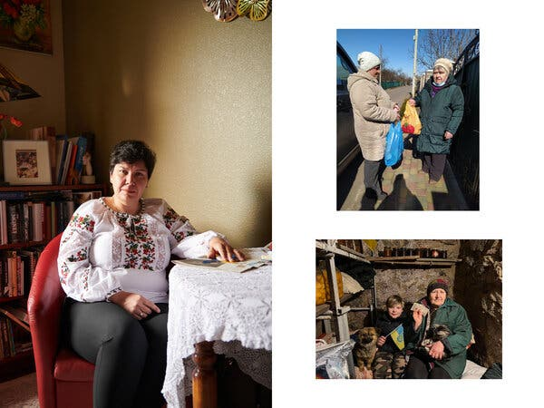



Image

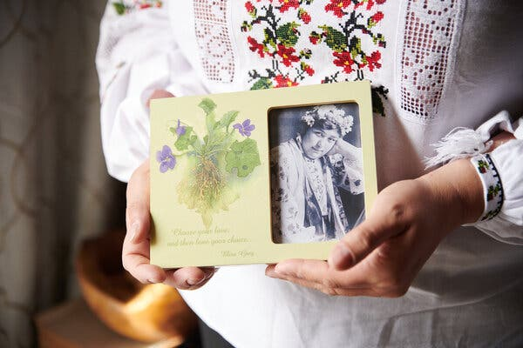

When Nataliya Pleshkova, pictured left, moved to Estes Park, Colo., she packed a black and white framed photograph of her grandmother, taken in 1937, that reminds her of home. This September, her mother, pictured top right, fled their war-torn country, leaving behind a community of friends and her beloved pets, pictured middle right.Credit...Top left and bottom: Theo Stroomer for The New York Times; Top right and middle right: via Nataliya Pleshkova



Though it is not well-known, that feeling has a name: cultural bereavement. Coined in [1991 by Dr. Maurice Eisenbruch](https://pubmed.ncbi.nlm.nih.gov/1957187/), a psychiatrist and professor at Monash University in Melbourne, Australia, while interviewing Cambodian refugees, it is more complex than culture shock. Dr. Eisenbruch felt as though he needed more precise vocabulary to capture the refugees’ emotions and mental health; their experiences did not fit neatly under anxiety or depression or post-traumatic stress disorder, he explained in a paper at the time. [Research](https://www.ncbi.nlm.nih.gov/pmc/articles/PMC1414713/) from 2005 expanded the concept beyond refugees to all migrants and also children of migrants.

## Coping With Grief and Loss

### **Living through the loss of a loved one is a universal experience. But the ways in which we experience and deal with the pain can largely differ.**

* **What Experts Say:**Psychotherapists say that [grief is not a problem to be solved](https://www.nytimes.com/2018/01/15/well/live/understanding-grief.html?action=click&pgtype=Article&state=default&module=styln-grief&variant=show&region=MAIN_CONTENT_1&block=storyline_top_links_recirc), but a process to be lived through, in whatever form it may take.
* **How to Help:**Experiencing a sudden loss can be particularly traumatic. [Here are some ways to offer your support to someone grieving.](https://www.nytimes.com/2022/01/07/well/live/sudden-death-loss.html?action=click&pgtype=Article&state=default&module=styln-grief&variant=show&region=MAIN_CONTENT_1&block=storyline_top_links_recirc)
* **A New Diagnosis:**Prolonged grief disorder, a new entry in the American Psychiatric Association’s diagnostic manual, [applies to those who continue to struggle long after a loss](https://www.nytimes.com/2022/03/18/health/prolonged-grief-disorder.html?action=click&pgtype=Article&state=default&module=styln-grief&variant=show&region=MAIN_CONTENT_1&block=storyline_top_links_recirc).
* **The Biology of Grief:**Grief isn’t only a psychological experience. It can affect the body too, but [much about the effects remains a mystery](https://www.nytimes.com/2021/04/22/well/what-happens-in-the-body-during-grief.html?action=click&pgtype=Article&state=default&module=styln-grief&variant=show&region=MAIN_CONTENT_1&block=storyline_top_links_recirc).

“The tragedy for migrants is that their identity as a migrant quite often trumps everything else,” said Dinesh Bhugra, a professor of mental health and cultural diversity at King’s College London and the lead author of the 2005 study. “You are not a doctor who just happens to be a migrant; you’re suddenly a migrant doctor.” That “reorganization of the self” can lead to “multiple layers of stress,” he added, and depression or high levels of anxiety.

Now, the term is slowly gaining recognition. [Researchers](https://www.tandfonline.com/doi/abs/10.1080/15401383.2019.1702131?journalCode=wcmh20) around the world are starting to explore the phenomenon further, applying Dr. Eisenbruch’s original framework to other groups of refugees and migrants. One small study of Ethiopian refugees in South Korea, [published in January](https://www.mdpi.com/2227-9032/10/2/201/htm), confirmed that cultural bereavement is characterized by complex mental distress. Nonprofit organizations that regularly work with [refugees](https://www.socialworkers.org/LinkClick.aspx?fileticket=X2QaNfEuJUk%3D&portalid=0) and new migrants are beginning to [open up conversations](https://twitter.com/Heritage_Nation/status/1538854938092118016?s=20&t=90IVVf1cAcWm0R8nJjaFbg) about the phenomenon.

But it is still rarely taught in the Western-trained mental health sphere or understood among clinicians and therapists. “While I was in grad school, I was taking a grief-counseling class, there wasn’t anything that covered cultural bereavement in what I was learning,” said Sahaj Kaur Kohli, who received a master’s degree in clinical mental health counseling and created [Brown Girl Therapy](https://www.instagram.com/browngirltherapy/?hl=en), a social media account that discusses the specific mental health struggles that people of color experience.

This summer she shared on social media that she was navigating cultural bereavement, and said in an interview that it quickly became one of her higher-performing posts, with dozens of people commiserating in the comments.

“I just assumed that there was always going to be a part of me that felt alone and isolated. I would feel ashamed because I should know more about my family or my history,” Ms. Kohli said. “But when I talked about it openly on Brown Girl Therapy, I realized, oh my gosh, we’re all kind of navigating this in some capacity.”

## **Why Cultural Bereavement Gets Overlooked**

What complicates matters is that cultural bereavement often manifests as amorphous depression or anxiety without an obvious cause, experts said. And the more an immigrant assimilates, the more intensely they might feel the grief of “losing familiar social structures, cultural values and self-identity,” as Dr. Eisenbruch described it.

“When refugees or immigrants come to America, we know we’ve lost our country, food, language, all those clear objects, but we quickly jump into assimilation,” said Shinhee Han, a psychotherapist at the counseling center of the New School in New York City and co-author of the book “Racial Melancholia, Racial Dissociation.” “We think ‘I must lose the accent’ or ‘I must not smell like my food,’ without stopping to think about the consequences of shedding those parts of an identity.”

ADVERTISEMENT

[Continue reading the main story](https://www.nytimes.com/2022/10/22/well/family/bereavement-culture-refugee-immigrant.html#after-story-ad-1)

The pandemic, which hindered family reunions, might have also intensified those feelings. “The losses that have been incurred over time or intergenerationally exploded during the pandemic because, all of a sudden, we couldn’t go see our families. I have patients who still have not been able to go to Hong Kong or other parts of the world to see their family members,” Dr. Han said. “So there is this kind of melancholia — an undercurrent of mourning.”

Image





Image

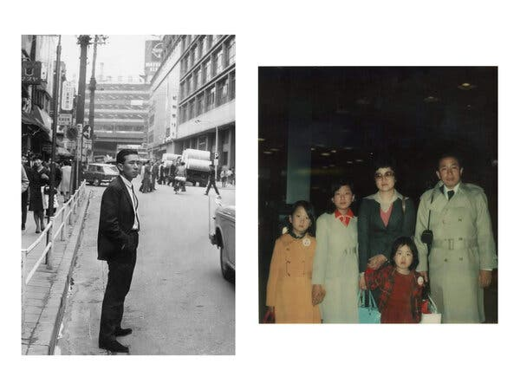



Image

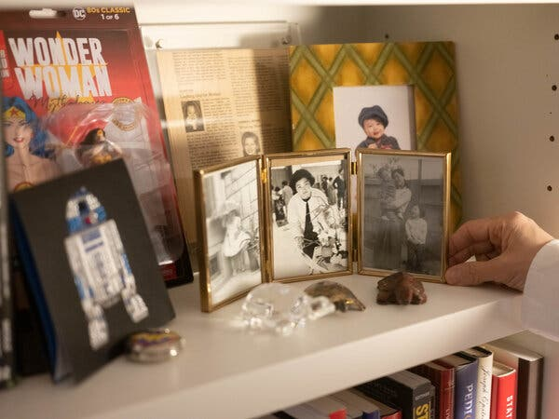

The author Min Jin Lee, seated at her home in New York, saw signs of cultural bereavement in the experiences of her parents after they moved from Seoul, South Korea. Her father, pictured middle left during a work trip to Tokyo in the 1960s, was a marketing executive back home. But when Ms. Lee’s family, pictured middle right at the airport in Seoul, moved in 1976, he bought and ran a newsstand in what is now Koreatown, where he received little respect from customers. “That humiliation or loss of status would have been felt very keenly,” Ms. Lee said. Framed pictures of her family and childhood back in Seoul help Ms. Lee feel connected to her roots.Credit...Top and Bottom: Christopher Lee for The New York Times, Middle left and middle right: via Min Jin Lee



Dr. Eisenbruch noted in his 1991 research paper that a big part of the sadness associated with cultural bereavement comes from the inability to complete significant rites and rituals, like birth ceremonies or burials, in culturally specific ways.

Paurvi Bhatt, 56, a health care executive in Minneapolis, Minn., said one of the hardest parts of losing her parents — who migrated from India in the 1960s — was recreating funerals for them the way that her family might have done at home. “We have to scatter the cremated ashes into the water,” she said. “That is very difficult to do here” because individuals have to get permits to dispose of anything into the water, hindering her ability to carry out that Hindu tradition.

ADVERTISEMENT

[Continue reading the main story](https://www.nytimes.com/2022/10/22/well/family/bereavement-culture-refugee-immigrant.html#after-story-ad-2)

The author Min Jin Lee, 53, who often touches on the feelings of loss and grief associated with migration in her work, including in her novel “Pachinko,” witnessed degrees of cultural bereavement in her own parents after they moved to New York from Seoul, South Korea, in 1976. Her father was a marketing executive back home. After moving, he bought a newsstand in what is now the Koreatown neighborhood of the city.

“I remember, as a little girl, watching people throw a dime at him or 15 cents to purchase the daily paper,” she said. “In Korea, when you hand an object to another person, you use both hands. That’s a sign of respect and he faced so many of these kinds of indignities.”

Ms. Lee found others expressing that same sentiment when she conducted interviews for her books. “It’s not a nation or a place and it’s not just that they miss the taste of food — it’s that all those things are essentially associated with a loss of an identity.”

Image

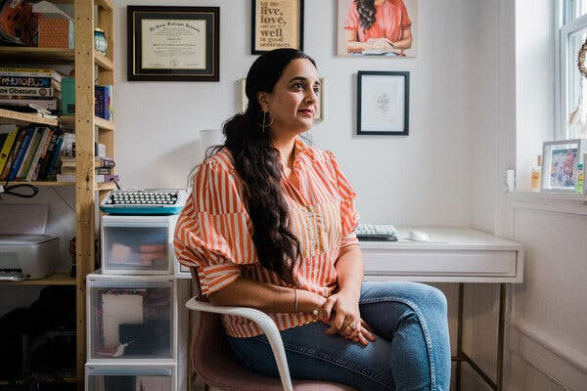



Image

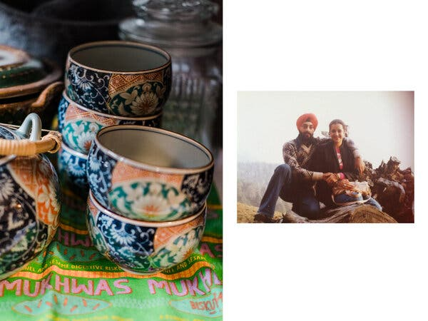



Image

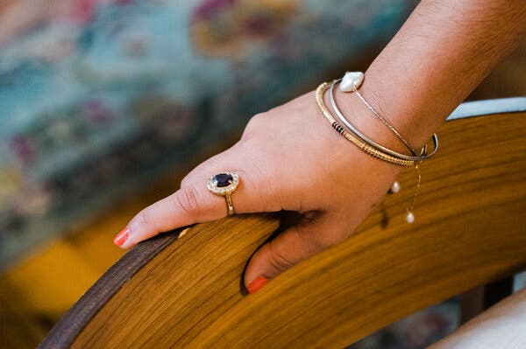

To reconnect with her ancestors, Sahaj Kaur Kohli, a mental health professional, wears a bangle and ring that belonged to her grandmother. She has picked up a passion for collecting East Asian ceramics, pictured middle left, from her mother, shown middle right in India with Ms. Kohli’s father, who grew up in Japan.Credit...Top, middle left, and right: Gabriela Bhaskar for The New York Times; Middle right: via Sahaj Kaur Kohli



Though Ms. Pleshkova moved to the U.S. for better professional opportunities, she could only find work as a camp counselor and a day care worker, despite her experience as an English literature professor in Ukraine. “I was upset when I found out that the payment is not adequate,” she said. “And I did feel like I could do better. I’m suddenly at the bottom of the food chain.”

She eventually decided to put aside her passion for teaching and now works in event planning for a steakhouse in her town.

## **‘My Feet are Hurting’**

The fact that people from different cultures tend to express sadness in different ways can further complicate how those individuals seek help, said Ms. Kohli. Oftentimes, given cultural stigmas around mental health, many people might not feel comfortable asking at all.

“When my dad is stressed out, he’ll never say he’s stressed; he’ll say, ‘My feet are hurting.’ Or my mom will say, ‘I have a headache.’ She won’t say ‘I’m overwhelmed,’” Ms. Kohli said. “And that will show up in the room with a clinician as well, and there’s no rule book for a Western-trained practitioner that says, ‘Here’s the criteria for this type of grief, here’s how to medicate it, treat it and so on.’”

Ms. Kohli suggests seeking out therapists who may have a deeper understanding of different cultural expressions of grief or anxiety and depression. During the pandemic, more and more of her Brown Girl Therapy followers were reaching out to Ms. Kohli asking for references to therapists who would understand their cultural background, so she made a spreadsheet of names that she linked to from her Instagram page.

Even using and understanding the term cultural bereavement can be “powerful,” she said.

“Naming it makes the grief more manageable. If you were to go to a clinician and say, ‘I think I’m struggling with cultural bereavement,’ I would hope a good clinician will do their research and will want to explore that with you to understand how it’s impacting you,” she said.

There are also ways to cope beyond therapy. While it can look different for everyone, dealing with cultural bereavement often involves variations of two things. The first is rediscovering or relearning one’s history, culture and self, said Dr. Han, and the second is finding and building your community.

She often recommends that her Asian American patients, for example, read books by Asian American authors or watch movies that represent their different cultures so that they can see their own experiences reflected back and feel less alone in their grief. It also helps resurrect the things — the food, the language, the smells — that were perhaps pushed to the side in an attempt to assimilate.

## Editors’ Picks

[[](https://www.nytimes.com/2022/10/23/arts/television/matthew-perry-friends-lovers-and-the-big-terrible-thing.html?action=click&algo=identity&block=editors_picks_recirc&fellback=false&imp_id=289060092&impression_id=24f02a50-52de-11ed-b0eb-ff7112d95aaa&index=0&pgtype=Article&pool=editors-picks-ls&region=ccolumn&req_id=261994554&surface=home-featured&variant=0_identity&action=click&module=editorContent&pgtype=Article&region=CompanionColumn&contentCollection=Trending)](https://www.nytimes.com/2022/10/23/arts/television/matthew-perry-friends-lovers-and-the-big-terrible-thing.html?action=click&algo=identity&block=editors_picks_recirc&fellback=false&imp_id=289060092&impression_id=24f02a50-52de-11ed-b0eb-ff7112d95aaa&index=0&pgtype=Article&pool=editors-picks-ls&region=ccolumn&req_id=261994554&surface=home-featured&variant=0_identity&action=click&module=editorContent&pgtype=Article&region=CompanionColumn&contentCollection=Trending)

### **[The One Where Matthew Perry Writes an Addiction Memoir](https://www.nytimes.com/2022/10/23/arts/television/matthew-perry-friends-lovers-and-the-big-terrible-thing.html?action=click&algo=identity&block=editors_picks_recirc&fellback=false&imp_id=289060092&impression_id=24f02a50-52de-11ed-b0eb-ff7112d95aaa&index=0&pgtype=Article&pool=editors-picks-ls&region=ccolumn&req_id=261994554&surface=home-featured&variant=0_identity&action=click&module=editorContent&pgtype=Article&region=CompanionColumn&contentCollection=Trending)**

[[](https://www.nytimes.com/article/cheap-fall-dinner-recipes.html?action=click&algo=identity&block=editors_picks_recirc&fellback=false&imp_id=839753569&impression_id=24f02a51-52de-11ed-b0eb-ff7112d95aaa&index=1&pgtype=Article&pool=editors-picks-ls&region=ccolumn&req_id=261994554&surface=home-featured&variant=0_identity&action=click&module=editorContent&pgtype=Article&region=CompanionColumn&contentCollection=Trending)](https://www.nytimes.com/article/cheap-fall-dinner-recipes.html?action=click&algo=identity&block=editors_picks_recirc&fellback=false&imp_id=839753569&impression_id=24f02a51-52de-11ed-b0eb-ff7112d95aaa&index=1&pgtype=Article&pool=editors-picks-ls&region=ccolumn&req_id=261994554&surface=home-featured&variant=0_identity&action=click&module=editorContent&pgtype=Article&region=CompanionColumn&contentCollection=Trending)

### **[19 Cozy and Cheap Fall Dinners for Sweater Weather](https://www.nytimes.com/article/cheap-fall-dinner-recipes.html?action=click&algo=identity&block=editors_picks_recirc&fellback=false&imp_id=839753569&impression_id=24f02a51-52de-11ed-b0eb-ff7112d95aaa&index=1&pgtype=Article&pool=editors-picks-ls&region=ccolumn&req_id=261994554&surface=home-featured&variant=0_identity&action=click&module=editorContent&pgtype=Article&region=CompanionColumn&contentCollection=Trending)**

[[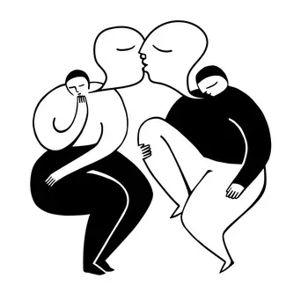](https://www.nytimes.com/2022/10/21/well/family/sex-therapy.html?action=click&algo=identity&block=editors_picks_recirc&fellback=false&imp_id=490192600&impression_id=24f02a52-52de-11ed-b0eb-ff7112d95aaa&index=2&pgtype=Article&pool=editors-picks-ls&region=ccolumn&req_id=261994554&surface=home-featured&variant=0_identity&action=click&module=editorContent&pgtype=Article&region=CompanionColumn&contentCollection=Trending)](https://www.nytimes.com/2022/10/21/well/family/sex-therapy.html?action=click&algo=identity&block=editors_picks_recirc&fellback=false&imp_id=490192600&impression_id=24f02a52-52de-11ed-b0eb-ff7112d95aaa&index=2&pgtype=Article&pool=editors-picks-ls&region=ccolumn&req_id=261994554&surface=home-featured&variant=0_identity&action=click&module=editorContent&pgtype=Article&region=CompanionColumn&contentCollection=Trending)

### **[Is It Time to See a Sex Therapist?](https://www.nytimes.com/2022/10/21/well/family/sex-therapy.html?action=click&algo=identity&block=editors_picks_recirc&fellback=false&imp_id=490192600&impression_id=24f02a52-52de-11ed-b0eb-ff7112d95aaa&index=2&pgtype=Article&pool=editors-picks-ls&region=ccolumn&req_id=261994554&surface=home-featured&variant=0_identity&action=click&module=editorContent&pgtype=Article&region=CompanionColumn&contentCollection=Trending)**

ADVERTISEMENT

[Continue reading the main story](https://www.nytimes.com/2022/10/22/well/family/bereavement-culture-refugee-immigrant.html#after-story-ad-3)

After Ms. Kohli’s last grandparent died in 2019, she realized that she had lost all physical connection to her ancestry. So she started relearning her mother tongue, Punjabi, and is hoping to learn some family recipes from her mother.

Seeking out community, Dr. Han said, can reduce feelings of isolation and help people recreate the kind of social network they might have had at home. This can involve befriending people at work or in your neighborhood who might have similar cultural backgrounds, and participating in or even organizing culturally specific annual celebrations, like the Lunar New Year.

When Dr. Bhugra moved from Punjab to Cork, Ireland, in the 1980s, no one spoke his language. One day, “somebody told me about a guy in Dublin who spoke Punjabi,” Dr. Bhugra said. He looked up this stranger’s phone number and “rang him, just to speak Punjabi. I know it sounds rather silly but you miss those things; you miss language, you miss art and so on.”

Ms. Bhatt said her parents were very deliberate in building community around them. “My mom and I would have a Diwali open house,” she said, referring to the annual Hindu new year festival of lights. “We’d open our doors, our neighbors were invited, anyone and everyone could come. That became a way for us all to feel a bit closer.”

Alisha Haridasani Gupta is a gender reporter covering politics, business, technology, health and culture through the gender lens. She writes the [In Her Words](https://www.nytimes.com/newsletters/in-her-words) newsletter. [@alisha__g](https://twitter.com/alisha__g)

*L. M. KLARENBEEK AND M. WEIDE*

*It could, for example, be argued that their participation*

*brings in a broader set of perspectives and experiences, thereby enhancing the epistemic*

*quality of decision-making in the polity (Anderson 2006).*

*(^cite this one in critique of assimilationism)*

*Or, that the selftransformative*

*qualities of participation positively affect the autonomy and thereby*

*freedom of immigrants (Warren 1992).*

*the paradox affects the democratic*

*position of resident foreigners most directly, since the right to participate is on the line.*

*Second, when immigrants do participate, they are not free to voice any interest or*

*perspective. Because participation is to function as a tool for integration, it is discursively*

*restricted to supporting the status quo. Participation aimed at change could be*

*interpreted as non-integration, which is feared, and could be used as an argument for*

*restrictions of political rights. To borrow Isin’s (2009) distinction: immigrants are to act*

*as ‘active citizens’, but not as ‘activist citizens’. They should follow ‘a script for already*

*existing citizens to follow already existing paths’ (383), and not disrupt the existing*

*order by breaching such norms (384).*

*(^again cite in critique of assimilationism)*

THE GREAT CHAIN OF ORIENTALISM: JEWISH IDENTITY, STIGMA MANAGEMENT, AND ETHNIC EXCLUSION IN ISRAEL

m. It is argued that prior to their immigration to Israel, Jews the world-over had been stigmatized as Oriental. Through a complex process, they accepted this stigma, and they arrived in Israel deeply invested in developing the new country as "western" and uncomfortable with anything identified as "eastern." It is the im- peratives of this westernization "identity project" that account for the initial impe- tus to exclude Middle Eastern Jews, as well as non-Jewish Arabs, from emerging Israeli society. Viewing history from this perspective, ethnic cleavages in the Jewish world appear to have a historical stability and consistency that is at odds with the current focus on contingency and historical in

structure emerged in which Ashkenazim (European, primarily East European1 Jews) were the dominant group and Mizrahim (Middle Eastern and North African Jews) were subordinate (Amit 2001; Nahon 1987). It has been argued that one of the ways Ashkenazim acquired their domination of Jewish Israeli society was to "orientalize" Mizrah

That is, Ashkenazim used the pre- viously-existing east/west dichotomy to ad- vance a binary construction of ethnicity in Israel in which the heterogeneity of the ar- riving cultures was simplified into two, ho- mogenous categories: Ashkenazim, who were fully "western," and Mizrahim, who were fully "eastern" (Shohat 1988, 1989). This bifurcation in the realm of representa- tion, it is argued, both shaped and justified an unequal distribution of resources (Bernstein and Swirski 198

d building on the works of Goffman (1963) and Said (1978), I argue that the past two centuries of Diaspora Jew- ish history in Europe and the Middle East can be conceptualized as a series of oriental

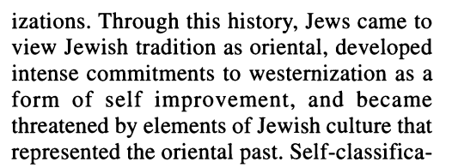

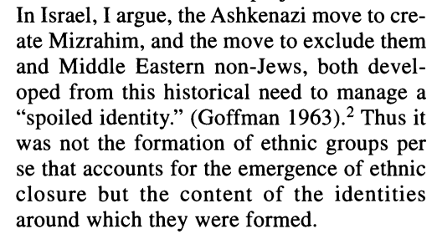

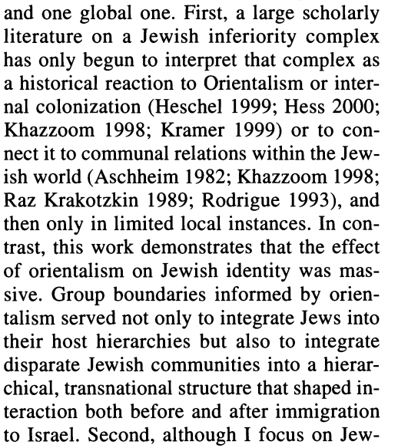

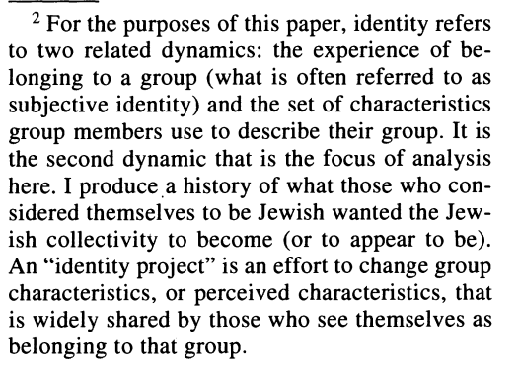

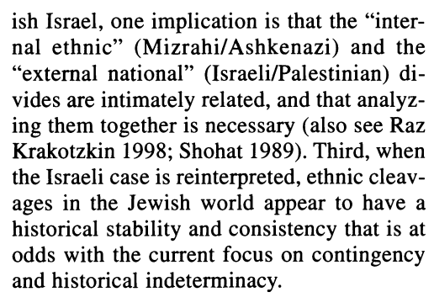

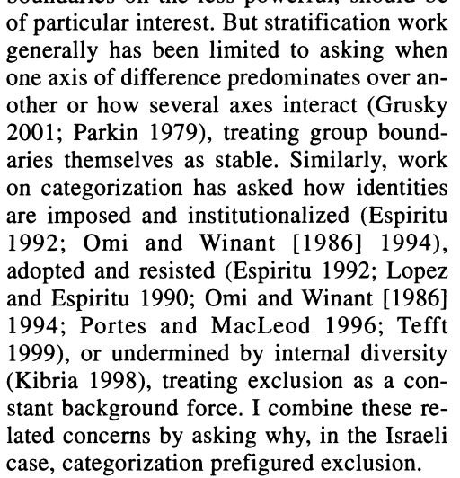

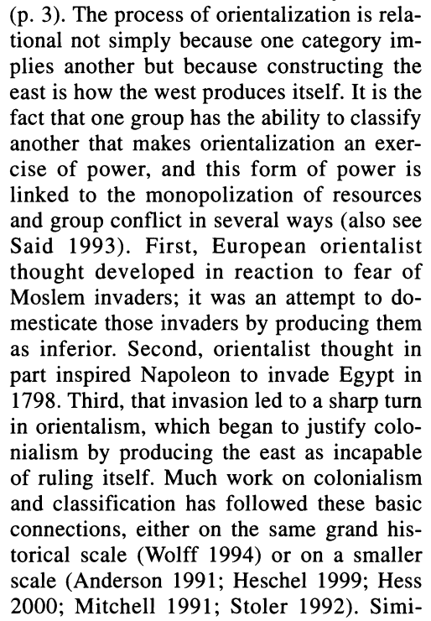

ion. This paper is very much in the post-colonial vein. However the focus of post-colonial scholarship has been on the relationship between the colonizer and the colonized, not on the relationship between different groups of stigmatized oth- ers (e.g., Heschel 1999; Hess 2000; Memmi 1965; Said 1978; Spivak 1988; Trinh 1989).6 As such, the kind of chain I elaborate here has not appeared be

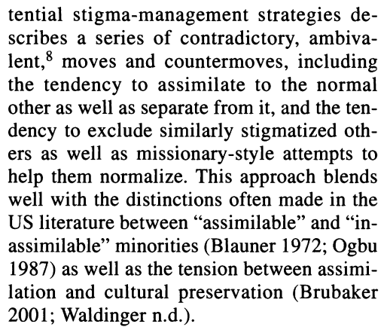

**(^but this has no discussion of how assimilation affects the society that is doing the assimilated)**

All constructions of the other are simulta- neously constructions of the self, but only sometimes does the need to define the self in a particular way cause moves to construct and exclude an other. Israel can serve as an example of such a "relationally-driven" sys- tem, as, it has been argued, can the black/ white line in the United States (Roediger 1991)

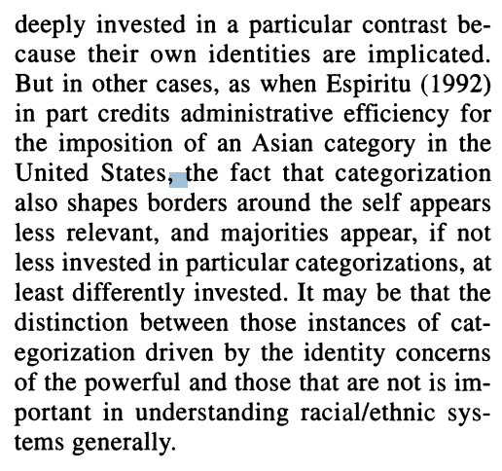

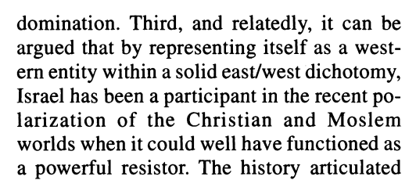

researchers began supplementing information on Miz- rahi disadvantage with that on Ashkenazi so- cial closure behavior in housing, politics, the educational system, and the labor market (e.g., Herzog 1985; Kraus and Hodge 1990; Levy 1997; Lewin-Epstein and Semyonov 2000; Segev 1986; Shafir 1989; Shalev 1992; Shavit 1990; Smooha 1978; Smooha and Kraus 1985; Swirski 1989; Yaish 19

These latest works made the assertion that Israel did not receive Mizrahim and Ash- kenazim but rather created them, producing two ethnic groups when in fact it started with many more. Nahon (1987), for example, found that among older immigrant men, edu- cational attainments varied widely among their 10 major countries of origin with no obvious clustering of Middle Eastern and European countries. Among younger Israeli- born men, however, educational attainments did in fact cluster into the two gropus

But particularly with language and behavior, in- ternal differences within each group may have been greater that those between the two groups. For example, even though all Middle Eastern im- migrants probably understood Arabic, and most Europeans Yiddish, the upper classes both geo- graphical regions tended to speak Western Euro- pean languages, while the lower classes spoke ei- ther Yiddish or Arabic

ces. The con- struction of Mizrahim as eastern, primitive, and uneducated was explicitly linked with the notion that they needed less: less pay, less immigrant or socialist worker benefits, less attention paid to the quality of their housin

Similarly, characterizations of Yemenites as nonintellectual, quantity workers (as op- posed to intellectual, quality workers) under- lie a proposal that only 1,000 francs need be spent on each Yemenite family's housing, as opposed to 2,000 for each Ashkenazi family (Shafir 1989). Also, Swirski (1989) argues that Ashkenazim built on their construction of Mizrahim as inexperienced to use them as a ready-made proletariat, on the backs of which the Ashkenazi-dominated Israeli in- dustries gained their strength and sophistica- tio

y. The Zionist discourse also held wide currency, and Zionist condescen- sion, even disgust, toward "weak" Holocaust survivors, "backward" Yiddish-speakers from East European ghettos, "non-ideologi- cal" refugees, and Diaspora Jews generally (Zerubavel 1995), in addition to a heartfelt commitment to ethnic equality, all provided alternate axes for social closure and miti- gated against the kind of ethnically based solidarity that would make preference for all Europeans an obvious response

r, because their concern was actually westernization/modernization, and not the forma- tion of ethnic inequality, there was room for Mizrahim to prove their westernness, and thus avoid exclusion; similarly there was room for Ashkenazim to inadvertently demonstrate insuf- ficient westernness (e.g., by speaking Yiddish) and thus become victims of exclusion.

he details that are central to my argu- ment. My "concern" is thus not with the rep- resentativeness of data that was collected in the past, but with how that data can be dif- ferently interprete

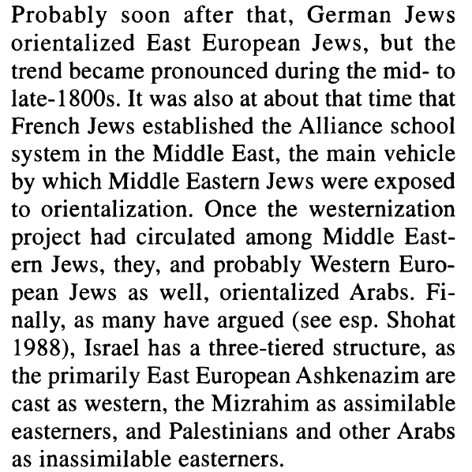

*language. Not only, argued the enlightened,*

*was it "the incarnation of linguistic*

*ugliness" (Miron 1973:45), it was also*

*too underdeveloped to support high-powered*

*thoughts (Miron 1973). Jewish economic*

*structure accounted for what everyone*

*agreed was their dishonesty and parasitic natures.*

*To solve the problem, Jews needed to*

*reduce their numbers in commerce, especially*

*peddling (Barzilay 1955; Mendes-*

*Flohr and Reinharz 1980). Christians attacked*

*Jews for their particularistic orientation,*

*their "state within a state." Finally,*

*Jewish education had to be completely reformed.*

*The heder, the primary educational*

*institution, was dismissed as crowded, unhygienic,*

*and chaotic. Children, it was said,*

*were taught by rote rather than by rational*

*thought. And the subjects of their education,*

*particularly the Talmud, were denounced as*

*everything from superstition to sedition*

*(Barzilay 1955; Heschel*

*three*

*observations: (1) Jews were considered Asiatic,*

*(2) the package of deficiencies said to*

*characterize them was already part of a discourse*

*of Western European superiority*

*(Fredrickson 1981), and (3) the discourse*

*that constructed Orientals as inferior already*

*existed (Said 1978). Thus Dohm, quoted*

*above, appeared to clearly connect the dislike*

*of Jews to their origins in Asia*

*addition, while*

*Dohm complained that Jews overbuilt, colonists*

*to the Americas asserted that Native*

*Americans did not build enough. Denouncing*

*Jews for their particularistic orientation*

*is also suspicious because Jews were initially*

*attractive to the Western European*

*powers precisely because of their lack of investment*

*in the internal European power*

*struggles (Barzilay 1955). Finally, with the*

*increasing importance of commerce to the*

*Western European economies, and indeed to*

*the Enlightenment itself, Christians should*

*have been delighted to have a skilled commercial*

*group in their m*

*From this perspective, straight streets, decorum,*

*and even a peddler-free occupational*

*distribution, have little to do with practical*

*questions of advancement or with economic*

*and social efficiency. They are, rather, characteristics*

*that are given value by a group*

*with power, often because perceived cultural*

*superiority can make economic or political*

*privilege appear deserved (Bourdieu 1984,*

*Bourdieu and Darbel 1991*

*other binarily opposed characteristics-*

*straight/not straight, quiet/not quiet,*

*rational/emotional and Christian/non-Christian-*

*as a discourse. Nearly every possible*

*social and personal characteristic becomes*

*associated with one side of the discourse's*

*dichotomy. It is because of this power-byassociation*

*that something as trivial as street*

*width can appear to indicate something as*

*complex as social development*

*These characteristicsreligiousness,*

*traditional clothing, narrow*

*streets, even employment in sales-were*

*later used to create other distinctions, not so*

*much because distinction was the goal but*

*because observing these features on other*

*Jews induced panic among those who believed*

*they had made some progress in*

*bringing them under control*

*history. Jews became vulnerable*

*to self hatred, as they began to see*

*themselves from the orientalizers' eyes.*

*Even further, they placed the legitimate*

*judges of Jewish acceptability outside the*

*Jewish world. Over time, the goal was less*

*to produce a Judaism that Jews liked than it*

*was to produce a Judaism that the Christians*

*could tolerate.*

The immediate presence of normals is likely

to reinforce this [sense of inadequacy], but

in fact self hate and self-derogation can also

occur when only he and a mirror are about.

(Goffman 1963:7)

One reaction to such a process, says

Goffman, is to attempt to rid the self of the

stigmas to gain the acceptance of "normal

(^so this is what Tavory was referring to as a process of deflecting stigma—but I should emphasize that I am not interested in this process; instead, I shall emphasize how I am emphasizing that in deflecting this stigma has the untiended consequence for validating the dominant host culture’s chauvinism and preventing them from learning and developing by learning from immigrants with different cultural and societal backgrounds.

*them, Jews accepted*

*and propagated the negative image developed*

*by others (Aschheim 1982; Boyarin*

*1997; Cuddihy 1974). They decried the narrow*

*Talmudic world of the Heder, Berr Isaac*

*Berr exhorted his fellow Jews "to divest ourselves*

*entirely of that narrow spirit, of Corporation*

*and Congregation" (1807, reprinted*

*in Mendes-Flohr and Reinharz 1980:108),*

*Eduard Gans wanted to destroy Jewish particularism,*

*"the obstinate, self-centered independence*

*of the Jews" (1882, reprinted in*

*Mendes-Flohr and Reinharz 1980:191),*

*Heinrich Graetz called Yiddish a "half bestial*

*language" (1895, quoted in Miron*

*1973:36). And they simply loathed peddlers*

*(Aschheim 1982)*

*only when western Jews*

*orientalized other Jewish communities in*

*the mid- to late-1800s that the characterization*

*of their own pasts as Oriental crystallized.*

*But the less-stigmatized not only exclude*

*the more-stigmatized, they also feel attached*

*to other members of the stigma*

*group. This is partly because normals are*

*insensitive to differences among the stigmatized*

*and partly because the less-stigmatized*

*experience empathy. "In brief, he can*

*neither embrace his group nor let it go"*

*(Goffman 1963:108). Goffman argues that*

*in an attempt to free themselves from this*

*ambivalence, normalizing members of the*

*stigmatized group may simultaneously push*

*other members to normalize, and also distance*

*themselves from them*

*westernization. Aschheim (1982)*

*argues that it was at this point that an east/*

*west distinction first began to shape Jewish*

*intercommunal relations, as German Jews*

*dubbed East Europeans "Ostjuden," literally*

*"Eastern Jews":*

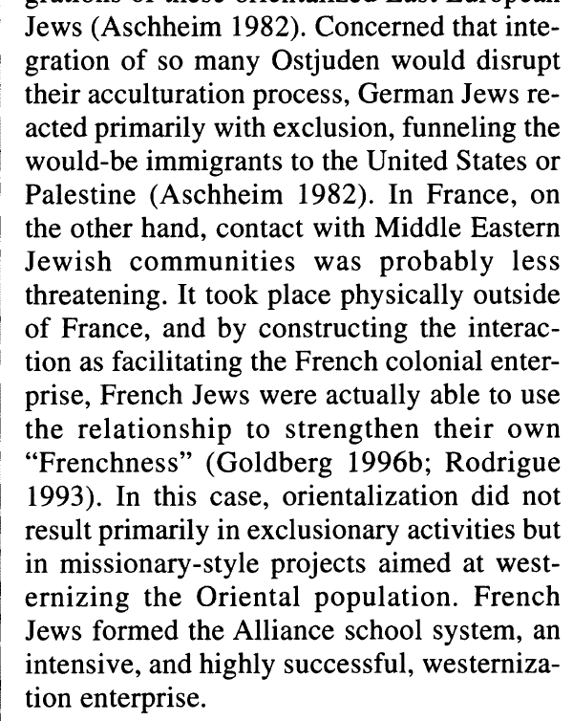

*This is important because few westernization*

*projects had full acculturation as their*

*goal; rather most, including Zionism, aimed*

*for a synthesis between "old" and "new."*

*But having also accepted the diametric opposition,*

*most groups experimenting with*

*synthesis wanted to be seen as fundamentally*

*western with oriental features, not as*

*fundamentally Oriental*

*upset. Eyal (1996, personal*

*communication) suggests that Jews*

*became more adventurous in their syntheses*

*when they were confident in their westernization.*

*Thus, later groups of German Jews*

*built synagogues with oriental architecture;*

*similarly early Zionists experimented with*

*Arab dress and other forms of*

*"Arabization." Second, for westernizing*

*Jews who wanted to connect to preservation of other populations*

*ness may have become important (for similar*

*dynamics in the colonial context, see*

*Bhabha 1994; Trinh 1989). Work on German*

*Jewish romanticization of the Osjuden*

*(Aschheim 1982; Brenner 1996) suggests*

*such a dynamic, as does the combination, in*

*Israel, of admiration for the purity and authenticity*

*of Yemenite Jewry with exclusion*

*from central areas of the country and*

*economy (Raz Krakotzkin 1998; Segev*

*1986).*

*acculturation. First,*

*movements with formally articulated philosophical*

*stances on how Jews should alter*

*religious observance (such as Germany's reform*

*or conservative movement) emerged in*

*Europe but not the Middle East. Westernizing*

*Middle Eastern Jews did become less*

*observant (Goldberg 1996a), but there is evidence*

*that they did not see religious change*

*as necessary (Goldberg 1996a; Stillman*

*1995; Zohar 1986, 1996) and may have even*

*played it down to preserve communal*

*unity.16 In Europe, in contrast, specific*

*changes in religious thought and practice became*

*highly salient, visible, and even requisite*

*symbols of adherence to westernization*

*projects. Haskalah thinkers placed the elimination*

*of older forms of thought and practice*

*high on the list of priorities and were*

*often virulent in their attacks*

*modernity. In Germany, the Haskalah project*

*involved both thought and practice, including*

*bringing the logic of justification for individual*

*religious belief in line with Christian*

*thought, stressing the voluntary nature*

*of belief and ritual observance, abandoning*

*or privatizing conspicuous religious behaviors*

*(particularly dress), and inventing new*

*traditions more in line with Christian practice*

*(Katz 1973). In Eastern Europe, two*

*shifts occurred: "The Haskalah became less*

*religiously-oriented and more overtly polemical*

*against the established Orthdoxy"*

*(Bayme 1981:179), and orthodoxy explicitly*

*redefined maintenance of tradition as resistance*

*to westernization (Katz 1986;*

*Kimmerling 1999). Finally, while East European*

*maskilim continued to favor transformation*

*over secularization (Bayme 1981;*

*Katz 1973), their Zionist inheritors were often*

*explicitly non- or even antireligious*

*(Shimoni 1995), as was the larger Jewish*

*population (Greenberg 1944*

*west. To manage conquered societies,*

*colonizers often used previously marginalized*

*ethnic groups as mediators between*

*themselves and the mainstream of the conquered*

*society. In return, the marginalized*

*groups were provided with social and economic*

*opportunities, and often themselves*

*became pro-western elit*

*Within this framework,*

*French Jews used the Alliance school*

*tem, established in the 1860s, to simultaneously*

*reinforce their French and Jewish*

*identities. First, French Jews would advance*

*the French cause by westernizing Arab Jews*

*and developing them as an inroad for cultural*

*colonialism. Second, they would help*

*fellow Jews by teaching them the languages*

*and skills that would enable them to take full*

*economic advantage of the European presence*

*in the Arab world. But there was a third*

*goal as well. By westernizing this "oriental"*

*component of world Jewry, French Jews*

*would be eliminating a potential source of*

*embarrassment (Goldberg 1996; Laskier*

*1983; Rodrigue*

*19 Scholars such as Shohat (1988), Shiblak*

*(1986), Alcalay (1993), and Shenhav (1999) argue*

*that the non-Arab identity was neither popular*

*nor indigenous among Jews in the Arab*

*world. They suggest instead that Ashkenazi Zionists*

*exacerbated and often even created divisions*

*between Middle Eastern Jews and their host*

*societies. That western Jews were themselves invested*

*in Mizrahi distance from Arabs is consistent*

*with these scholars' contention. Recent suggestions*

*that the Iraqi Jewish anti-Zionist (Esther*

*Meir, personal communication) and communist*

*(Kazzaz 1991, 2002) movements were larger and*

*more important than previously acknowledged*

*also suggests strong currents of Middle Eastern*

*Jewish identification with Arabs rather than the*

*west. Nevertheless, it is difficult to know how to*

*interpret anti-Zionist statements from Middle*

*Eastern Jewish leaders in a context in which pro-*

*Zionist statements could lead to imprisonment*

*and death.*

*Zionists were almost obsessed with creating*

*a culture that was new, unaffected by the*

*"medieval" religious culture most had only*

*recently left behind (Even-Zohar 1981;*

*Zerubavel 1995*

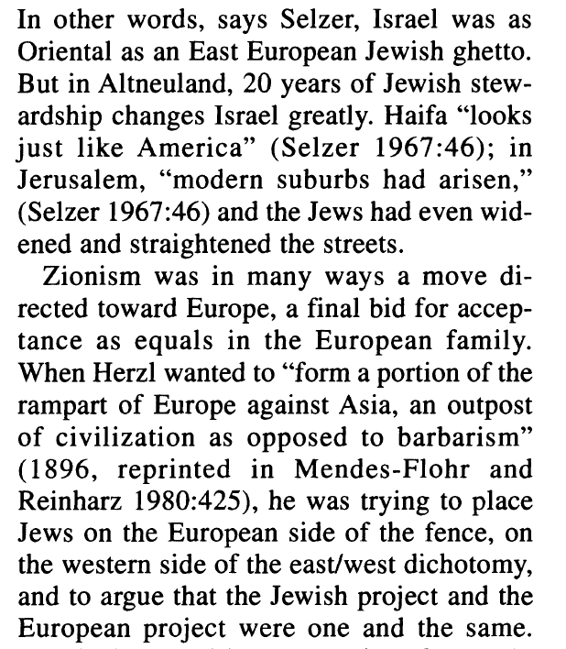

*21 Note, however, that Berkowitz's (1997) accounting*

*of "western" Jewry's attachment to Zionism*

*does not require reference to the westernization*

*project. Berkowitz argues, in part, that*

*western (Berkowitz does not unpack the concept)*

*Jews liked Zionism because it could alleviate the*

*poverty of the Ostjuden; he does not mention alleviation*

*of their easternness.*

*Zionism in fact struggled with the same*

*fundamental tension between stigmatized*

*authenticity and new western identities that*

*plagued most European Jewish identity*

*projects. It brought Jews to their ancient*

*roots in the east in order to westernize them;*

*it advocated a revival of Jewish life and celebration*

*of uniqueness, but saw Jewish tradition*

*as incompatible with modernity*

*(Zerubavel 199*

*that Mizrahim, being non-western and*

*thus not self-consciously philosophical,*

*were not intellectually Zionist. Rather, their*

*Zionism is understood to have emerged from*

*their deeply religious orientation, to have*

*been felt but not thought, inspired by mystical*

*and messianic tendencies (e.g.,*

*Eisenstadt 1967). This construction is, internally,*

*an extraordinarily powerful justification*

*for Ashkenazi dominance in Israeli politics;*

*the argument is that Ashkenazim, being*

*the "better" Zionists, were uniquely qualified*

*for stewardship of the*

*Orientalization in Israel also focused on*

*Middle Eastern educational practice prior to*

*immigration. It was portrayed as religious*

*rather than intellectual, with children being*

*taught by rote in large, uncontrolled classes,*

*by teachers "whose only method of teaching*

*is the whip" (Organization for Youth Immigration*

*in Morocco and Algeria, quoted in*

*Segev 1986:110*

*This left the state's elite torn between two*

*cherished identity projects. On the one hand,*

*they were deeply invested in westernization,*

*and the massive influx of Jews from the Levant,*

*as they saw it, could drag Jewish society*

*back to its not-at-all-distant Oriental*

*state. On the other hand, they were deeply*

*committed to the free immigration of*

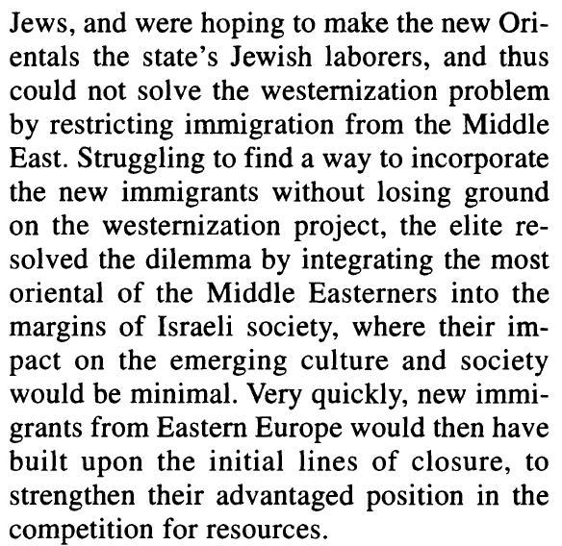

*1986). Second,*

*once a semiotic reference structure is found*

*to effectively establish distinctions, it is*

*likely to be used for a number of unrelated*

*purposes. In the Jewish case, I argue, stability*

*and fluidity are again both present. However*

*the always-unfinished westernization*

*project, and its accomplishment through the*

*definition of ethnic others, pushed ethnicity*

*in consistent directions across time, space,*

*and political formations. It is of more than*

*passing interest that this stability em*

*ways. The presence of stigma is always*

*frightening and always generates the*

*impulse to distance oneself; Goffman (1963)*

*himself notes that normals fear stigma by*

*proxy. But for those who were once stigmatized,*

*the discomfort is stronger and more*

*threatening. That Jews had established particularly*

*delicate projects-in which they*

*wanted not to eliminate the eastern but*

*rather retain it in neutralized or marginalized*

*form, and in which they moved the westernization*

*project to the geographical Middle*

*East-only intensified the dynamic further*

*arose. Dominating others, in other words,*

*was an integral part of, and a direct reaction*

*to, the experience of being dominated*

*(^but in contrast to this, I am looking at the impact of this on the dominating society)*

*24 Building on Said (1978), Roediger*

*(1991), and the Israeli case itself, I suggested*

*that, more generally, those instances*

*of categorization that are driven by the identity*

*concerns of the powerful are usefully*

*grouped together analytically because*

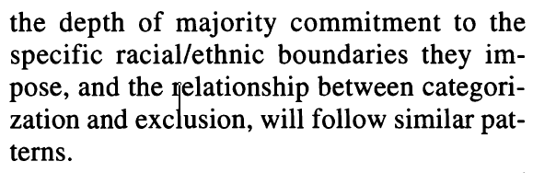

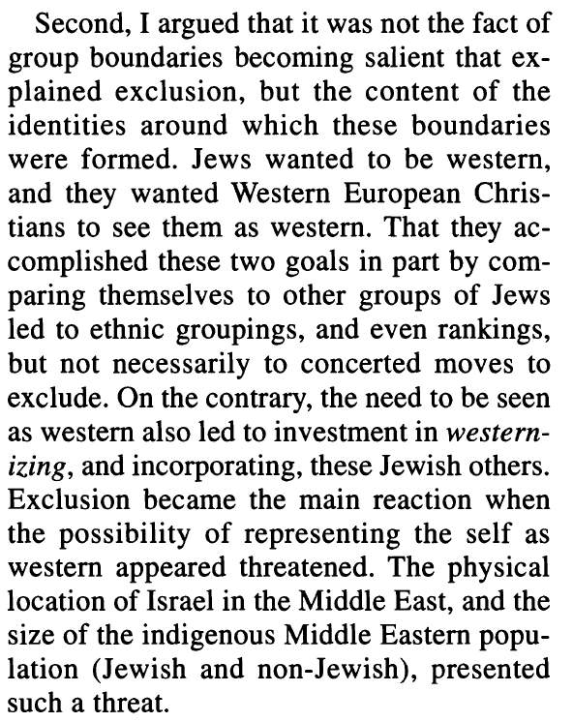

*(^but I am suggesting that lack of exclusion along with assimilation is harming htat which is doing the assimilating)*

*Finally, the specific argument I make*

*about social closure among Jews-that,*

*through the first years of statehood, exclusion*

*occurred when westernizing groups experienced*

*a serous threat to their own newly*

*minted statuses as western-can be further*

*examined with primary res*

History of Hmong Immigrants

2

[[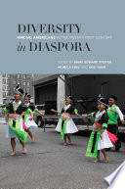](https://julac-cuhk.primo.exlibrisgroup.com/discovery/fulldisplay?docid=alma991040206068703407&context=L&vid=852JULAC_CUHK:CUHK&lang=en&search_scope=All&adaptor=Local%20Search%20Engine&tab=default_tab&query=any%2Ccontains%2CHmong%20Immigrant%20History&offset=0)](https://julac-cuhk.primo.exlibrisgroup.com/discovery/fulldisplay?docid=alma991040206068703407&context=L&vid=852JULAC_CUHK:CUHK&lang=en&search_scope=All&adaptor=Local%20Search%20Engine&tab=default_tab&query=any%2Ccontains%2CHmong%20Immigrant%20History&offset=0)

**BOOK**

### [Diversity in Diaspora : Hmong Americans in the Twenty-First Century](https://julac-cuhk.primo.exlibrisgroup.com/discovery/fulldisplay?docid=alma991040206068703407&context=L&vid=852JULAC_CUHK:CUHK&lang=en&search_scope=All&adaptor=Local%20Search%20Engine&tab=default_tab&query=any%2Ccontains%2CHmong%20Immigrant%20History&offset=0)

ed. by Mark Edward Pfeifer, Kou Yang, Monica Chiu.

Honolulu : University of Hawaii Press [2013]

Diversity in Diaspora : Hmong Americans in the Twenty-First CenturyOnline access

1 The American Experience of the Hmong A Historical Review Kou Yang

The majority of the post-1975 Hmong refugees from Laos were resettled in the United States. Others went to Australia, Argentina, Canada, France, French Guiana, and Germany. A few Hmong refugee families went to China, but they were later repatriated back to Laos. By the year 2010, it could be said that the Hmong had dispersed to all of the five continents, as there are some Hmong Thai and Hmong Americans working and residing in Africa

They were educationally, vocationally, technologically, and linguistically unprepared refugees, trying to adapt to life in the United States, the most economically and technologically developed country in the world. Moreover, the cultural and technological gap between the Hmong and their newly adopted country was vast, making it very difficult for them to take control of their destiny, leaving them to either sink or swim. As a result, they were preoccupied with accultura-

tion problems, needs, and issues as well as unemployment, poverty, and cultural and language barriers. They relied heavily on governmental assistance

(^cite this)

he flow of Hmong refugees to the United States had almost completely stopped by 2008 and that a preference for large families is not the norm among younger Hmong, who now form the majority of Hmong Americans.

1. Welfare participation. From the period of 1975 to 1991, the Hmong were among the poorest and least-known Asian American groups. The 1990 Census, for example, indicated that 65 percent of Hmong Americans were unemployed and more than 60 percent lived below the poverty line.4 The Hmong were basically at a stage of initial culture shock and depended heavily on public assistance

The welfare participation of the Hmong became an issue of concern to the Hmong community leadership and local, state, and federal governments

The Turning Point (1992–1999) This period is characterized by the Hmong’s transition from being refugees to becoming citizens of the United States

The older traditional leaders were for the most part former military and government officials in Laos. Their leadership represented the manner and attitudes of the pre-1975 Hmong leaders in Laos. One of their goals or topics of discussion was to return to Laos to overthrow the communist government of the Lao People’s Democratic Republic. The middle-aged, “middle-of-the-road” leaders were the bilingual/bicultural leaders who continued to show respect to their elders while maintaining positive working relationships with the younger Americanized leaders. Their priorities were to overcome the acculturation needs and issues of the Hmong American community, including economic and employment needs. The younger leaders were mostly college-educated Hmong Americans who had no language and cultural barriers. Their leadership focused on addressing Hmong American issues and needs as part of the public agenda of the large American community, and when they ran for office, their political platform was not a Hmong agenda but the needs and issues of the general American community that they wanted to represent.

\The Twin Cities—St. Paul and Minneapolis, Minnesota—with more than fifty thousand Hmong, surpassed Fresno as the largest urban concentration of Hmong in the United States (Yang 2001, 63). As a result of the Third Hmong Migration, the economic boom in Minnesota at the end of the 1990s, and their own motivation, the Hmong in the Midwest had almost reached the stage of self-sufficiency by the year 2000. It was reported that by the year 2000, Minnesota Hmong had increasingly joined the ranks of homeowners, with some of them buying homes in the price range of $300,000 to $500,000 (Gendler 2000).\\

The 2000 U.S. Census indicated that Hmong homeownership increased from little more than 10 percent in 1990 to about 40 percent in 2000 (Pfeifer 2002). Data from the 2006 American Community Survey indicates that the rate of Hmong homeownership increased to 54.1 percent, compared with 67.3 percent among the general U.S. population who owned their own homes (Pfeifer 2007, 3). E

(^note this as evidence of hteir assimilation)

The rate of poverty among Hmong Americans decreased from 34.8 percent in 2000 to 26.9 percent in 2009, and the rate of those who held occupations\in production, transportation, and materials removal decreased from 41.7 percent in 2000 to 29.7 percent in 2009. Consequently, the rate of those who held management or professional jobs increased from 17.1 percent in 2000 to 23 percent in 2009.

The first is that the Hmong came to the United States without educational or vocational preparation, and consequently they tended to initially acquire low-paying jobs. The second has to do with their residency in the United States. Unlike other Indochinese refugee groups, a large proportion of the Hmong population lives in the Midwest and central California, where the cost of living is lower and so are wages. Third, nearly 50 percent of foreignborn Hmong came to the United States after the 1990s; many of them have not yet resided in the country long enough to fully overcome acculturation issues

Since 2000, the businesses of Hmong Americans have become more diverse and now increasingly include real estate, insurance sales, financial services, and home health care. The Hmong in Minnesota, for example, own and operate about fifty home health care agencies (Yang 2008

the majority of the Hmong population is very young and more politically active than their immigrant parents. On the other extreme, language barriers, a lack of accessibility to information, and low literacy skills among the foreign-born Hmong will continue to be political barriers for years to come.

Moua reported on “an exchange of words where one of the defendants, Lo Cha Thao, compared the damage they were hoping to inflict to that of the terrorist acts of September-11.” This development appeared to contradict the 2003 announcement made by Vang Pao about a shifting policy toward a peaceful dialogue with the government of Laos. The dropping of all charges against Vang Pao in 2009, however, brought him back to the scene. On December 22, 2009, he publicly announced his decision to visit Laos in the upcoming year. Shortly after, the government of Laos responded that he could return to Laos but that the death sentence imposed by the Lao court in 1975 still stood (Ganjanakhundee 2009). It should be noted here that on September 4, 1975, Vang Pao and five other rightist military leaders of the Royal Lao Army were put on trial in Laos in absentia and sentenced to death. In August 2008, Radio Free Asia reported that the communist government of Laos had followed Vietnam in shifting its policy toward expatriates, favoring overseas residents or former citizens of Laos to return

to help rebuild the country. In the summer of 2009, the discussion of this shifting of policy was posted on the Web site of the Embassy of Laos to the United States, indicating the beginning of a debate on how to work with its expatriates, especially on matters related to their return and their purchase of property in Laos.

The passing of Vang Pao in early January 2011 is likely to speed up a shifting relationship between the government of Laos and expatriate Hmong and Lao.

1. Physical and mental health. A change of lifestyle and diet has contributed to many health problems, such as obesity, hypertension, and diabetes among Hmong Americans. Past traumatic refugee experiences, in addition to stresses associated with coping with a new life in the United States as well as family situations can contribute to mental health problems, especially in the form of post-traumatic stress disorder (PTSD). A study of Hispanic women and Hmong women in central California found that the Hmong in that area were seventeen times more likely than whites to develop a rare cancer that attacks the nose and sinus cavities (Anderson 2004). Hmong also face higher rates of cancer associated with chronic infections, and they are more likely than other groups to be diagnosed with late-stage cancer.23

• On September 21, 2004, Chai Soua Vang, a Hmong American hunter, shot to death six white persons in Wisconsin. This shooting and the trial and conviction of the shooter in 2005 contributed to an intense debate and discussion of the significance of race to what transpired. Although no one knew the exact circumstances that led to such a tragic event, it was reported that the shooting occurred after the shooter had been subjected to racial taunting. Thecase not only ended in the trial and conviction of the shooter; some white individuals also expressed their anger toward the Hmong in Wisconsin in general by reportedly driving around with bumper stickers stating “Save a Deer, Kill a Mung [sic].”

(^cite this)

the Hmong have always been a minority people, so they did not have to learn how to be a minority in the United States. In fact, being an ethnic minority in the United States is much easier than being an ethnic minority in other countries in Asia. On the negative side, as an ethnic minority for thousands of years, they did not have access to the education, economic resources, or experience with technology that would have better prepared them for life in the United States. As a result, most Hmong had to start their new lives in America at rock bottom.

3 An Analysis of Poverty in Hmong American Communities Yang Sao Xiong

1

[[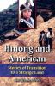](https://julac-cuhk.primo.exlibrisgroup.com/discovery/fulldisplay?docid=alma991022384889703407&context=L&vid=852JULAC_CUHK:CUHK&lang=en&search_scope=Books&adaptor=Local%20Search%20Engine&tab=default_tab&query=any%2Ccontains%2CHmong%20Immigrants%20History&offset=0)](https://julac-cuhk.primo.exlibrisgroup.com/discovery/fulldisplay?docid=alma991022384889703407&context=L&vid=852JULAC_CUHK:CUHK&lang=en&search_scope=Books&adaptor=Local%20Search%20Engine&tab=default_tab&query=any%2Ccontains%2CHmong%20Immigrants%20History&offset=0)

**BOOK**

### [Hmong and American : stories of transition to a strange land](https://julac-cuhk.primo.exlibrisgroup.com/discovery/fulldisplay?docid=alma991022384889703407&context=L&vid=852JULAC_CUHK:CUHK&lang=en&search_scope=Books&adaptor=Local%20Search%20Engine&tab=default_tab&query=any%2Ccontains%2CHmong%20Immigrants%20History&offset=0)

Sue Murphy Mote.

Mote, Sue Murphy, 1938-

Jefferson, N.C. : McFarland & Co. 2004.

Hmong and American : stories of transition to a strange landAvailable at University Library UL (E184.H55 M68 2004)

Kou Yang

161:

Hmong Americans are a double minority—a minority within the Asian American community and in American society—

Hmong intergration into US society has been remarkable, undergoing rapid and progressive changes within a short time.

A common measure of assimilatiois the degree to which an immigrant group mirrors the average American in income, occupation, education and rates of intermarriage.

Michael Barone finds the Irish have taken the longest to assimilate, nearly 120 years, while the Italians took 80 years.

Jews , although tye were destitute on arrival, took only 60 years.

In only 40 years, many Asian immigranst not only matched but surpassed the general population income and education. The Jews, Chinese, Japanese and Koreans assimilated fast because they were determined to esatblihs and work in their own businesses, even when facing severe strictions on where they could live and what they could own, and they were committed ot education.

But Hmong Americnas lag behind the general population and on pace ot match the slow assimilation of the Irish and Italians.

First Generation Hmongs considered the American welfare system a kind of military pension for hlping in the war. But welfare dependency is not a way to get ahead. Hmong fathers and mothers tried to acquire language and job skills to become self sufficient.

Every year more Hmong Americnas become professionals and earn advanced degrees.

Not until the 1990s did Jews match general population in intermarriage.

Hmong Americnas still mostly marry within their own ethnicity.

Due to influence of clans, even as they become increasingly at home with civic culture of Americans like Jews they retain unique ethnic identity.

Clans are depositories of Hmogn culture and its intergenerationa conduits

They adapted by developing subclans

The Hmong independent spirit and determination to govern one’s own life is typically American

Gary Yia Lee

88: Everywhere I went, I found abundant evidence of Hmogn Americnas taking initiatives to be self-sufficient, whether as farmers or assembly line workers.

Speaking different languages, sometimes parents and children follow different cultural values, widening gneraiotnal gap

Often women became providers.

Younger generations resisted asking for advaic e from elders due to American cultural influences. They felt entitled to their independence and rejected elders’ values that seemed irrelevant to modern life.

Pao Lor

154: Most Hmong stdnets begint o be aware of ethnic identity in late elementary or middle school.

Hmong Americans begin to form cliques

After they want to learn more about their own cultural heritage and history; they were proud to be Hmong. They wanted to ehance and advance their identity.

Some Hmong students due to assimilaton begint o disengage from other Hmong students and Hmong American community. They perceive Hmong as negative because of a) social media coverage of negative stories; b) current cultural practices and rituals that to them are hard to understand; and c) other Hmong ways of life that do not seem to fit into what they consider ot be their lifestyles (modernized, civilized and Americanized)—for them assimilation means isolation from Hmogn American community

Song Lee 139: Although parents want their young people to “obey or listen to parents, help around the house, show respect ot parents and elders, and stay hoem or do not go out younger Hmogn Americans find hit hard to fulfill those edxpectaiotns because they have been taught in school to be independent and assertive.

Elderly Hmong women note that younger people are more knwoeldable than before. If the youth do not agree with the leders, they will not do as elders say.{

Youth and Elders differ in what the word “respect” means

Young people want to develop their own values and follow their dreams yb pursuing educaitona nd professional carers.

Even if young Hmong Americans caould speak Hmong ,they often prefer to be direc tin expressing their views and opinions, creating tensiona dn misundersatndings. Many young Hmong cannot communicate with their grandparents because they cannot speak Hmong.

Hmong elders find their children do not speak to them “nicely”

“children soemtiems speak directly and don’t watch what they say, so they end up hurting our feelings. We, the elders, speak indirectly so it is difficult for htem to undersand what we mean”

Elders fear their children will foerget all of the ritual sthat connec thtem to their ancestors, disregard the importance of kwv tij (extended clan families) and neej tsa (relationships formed thorugh marriages) and abandon them in old age, a dereliction of duty that could disrupt continuities essesntial to the health of families.

8

[[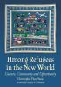](https://julac-cuhk.primo.exlibrisgroup.com/discovery/fulldisplay?docid=alma991035162979703407&context=L&vid=852JULAC_CUHK:CUHK&lang=en&search_scope=Books&adaptor=Local%20Search%20Engine&tab=default_tab&query=any%2Ccontains%2CHmong%20Immigrants%20History&offset=0)](https://julac-cuhk.primo.exlibrisgroup.com/discovery/fulldisplay?docid=alma991035162979703407&context=L&vid=852JULAC_CUHK:CUHK&lang=en&search_scope=Books&adaptor=Local%20Search%20Engine&tab=default_tab&query=any%2Ccontains%2CHmong%20Immigrants%20History&offset=0)

**BOOK**

### [Hmong refugees in the new world : culture, community and opportunity](https://julac-cuhk.primo.exlibrisgroup.com/discovery/fulldisplay?docid=alma991035162979703407&context=L&vid=852JULAC_CUHK:CUHK&lang=en&search_scope=Books&adaptor=Local%20Search%20Engine&tab=default_tab&query=any%2Ccontains%2CHmong%20Immigrants%20History&offset=0)

Christopher Thao Vang ; foreword by Gregory S. Goodman.

Vang, Christopher Thao

Jefferson, North Carolina : McFarland & Company, Inc., Publishers [2016]

Hmong refugees in the new world : culture, community and opportunityAvailable at University Library UL (DS509.5.H66 V35 2016)

Page 87:  
Prior to 1975, approximately 10 percent of Hmong population could read and write in the Mong language or another language like Lao, Thai, French or English

In Western nations, 100,000s of Hmong refugees have had to learn a new language at hteir new jobs

10 common stages of socialization proceses that Vang (2010) said most newcomers experience:

1. Arrival stage: honey period burt also experiencd shock and flashbacks, either pleased or happy with new place,
2. Family reunification stage: new arrivals happy to see parents, children or other family membesa fter separation;Hmong refugees almost never alone as one perspon or even one family.
3. Culture shock stage:: results in discomfort, personal guilt, embarrassment, shame, humiliataiotn and devastation (e.g. Halloween trick or treat as terrifying, leading to belief in ghosts);
4. Blaming stage: Hmong refugees blame the devestation they experienced in Laos on a) Chinese rulers and dictators, b) the French brutal colonial policy, the US Secret War in Laos and d) the bloodthirsty Laotian communists; and e) themselves for not helping one another as they fought hteir enemies or for their disunity and betrayal; parents blame to deal with clash of values, seeing children assimilate, inability to communicate in host nation’s language and health problems due to PTSD
5. Coping stage: unlike in Laos, both parents must often have ot owrok outside the home to provide financial support for the family, gender roles are different than they are traditionally; children emulate parents at home while imitating peers outside home; children lose their native langaue and older children balance two cultures;
6. Accommodation stage: Hmogn refugees learn to accommodate differences int wo cultures, and parents and children adapt to differnces betwemn them due to different levels of aceptanc eof new culture (e.g. Hmong parents change food menu at home to accommodate their native-born children who are used to food served at school and less inclined to eat traditional Hmong dishes at home, accommodate the law nad court system);—but Hmong refugees reject other aspects of US culture like a) refusing to send single daughtes away to attend collect or b) accept interracial marriages between certain races)
7. Mixture Stage: parents want children to preserve family’s values embodied in marriage customs, funeral services, religious rituals, cultural ceremonies and social structures like clan system, group cohesiveness, collectivism, and respect for elders; children want parnets to understand host country sooical phenomenona including curfews, expectations, of others on them, social temptations and adolescent courtship. Parents recognize children will fail academically if they fuflill traditional roles of completing household chores, family respnsibiltiiesa nd limited parent/child interaciotn.
8. Acceptance stage: Hmong begin to see education as key to success. Parents who stubbornly demand adhernec eto old ways see children lagging behind, so parents begint o show more interest in children’s education, social development and goals.
9. Rejection stage: Hmong refugees decide which of their traditions are unworkable in new environment (e.g. taditioanl method of detrmingin the value of daughters and sons, so they have more egalitarian attitudes toard daughters and sons; and Hmong children reject idea that females should get married yougna dn stay at home to rear children, and they become professionasl who work outside of home; they reject ntion of gay or lesbian lifestyle
10. Maintenance stage: cultural identity maintained in minor ways: (e.g. offering special classes to young childnre that explain Hmogn traditional rituals and customs; humong parents and children learn how to read nad writ ehte Hmong language as part of hteir Bible study; hold New Year’s celebrations each year ot expose the young gneraiotn to Hmong traditional values and customs)—needs persistent effot to keep up with social changes and brideg genraiton gap

34

[[](https://julac-cuhk.primo.exlibrisgroup.com/discovery/fulldisplay?docid=alma991020511839703407&context=L&vid=852JULAC_CUHK:CUHK&lang=en&search_scope=Books&adaptor=Local%20Search%20Engine&tab=default_tab&query=any%2Ccontains%2CHmong%20Immigrants%20History&offset=30)](https://julac-cuhk.primo.exlibrisgroup.com/discovery/fulldisplay?docid=alma991020511839703407&context=L&vid=852JULAC_CUHK:CUHK&lang=en&search_scope=Books&adaptor=Local%20Search%20Engine&tab=default_tab&query=any%2Ccontains%2CHmong%20Immigrants%20History&offset=30)

**BOOK**

### [I begin my life all over : the Hmong and the American immigrant experience](https://julac-cuhk.primo.exlibrisgroup.com/discovery/fulldisplay?docid=alma991020511839703407&context=L&vid=852JULAC_CUHK:CUHK&lang=en&search_scope=Books&adaptor=Local%20Search%20Engine&tab=default_tab&query=any%2Ccontains%2CHmong%20Immigrants%20History&offset=30)

Lillian Faderman with Ghia Xiong.

Faderman, Lillian

Boston : Beacon Press c1998.

I begin my life all over : the Hmong and the American immigrant experienceAvailable at University Library UL Chinese Overseas Collection (E184.H55 F33 1998)

45 Results

You have selected 0 recordsCHOOSE TOP 45 RESULTSDISMISS

**PAGE 5**

41

[[](https://julac-cuhk.primo.exlibrisgroup.com/discovery/fulldisplay?docid=alma991039977501103407&context=L&vid=852JULAC_CUHK:CUHK&lang=en&search_scope=Books&adaptor=Local%20Search%20Engine&tab=default_tab&query=any%2Ccontains%2CHmong%20Immigrants%20History&offset=40)](https://julac-cuhk.primo.exlibrisgroup.com/discovery/fulldisplay?docid=alma991039977501103407&context=L&vid=852JULAC_CUHK:CUHK&lang=en&search_scope=Books&adaptor=Local%20Search%20Engine&tab=default_tab&query=any%2Ccontains%2CHmong%20Immigrants%20History&offset=40)

**BOOK**

### [Southeast Asian migration : people on the move in search of work, refuge, and belonging](https://julac-cuhk.primo.exlibrisgroup.com/discovery/fulldisplay?docid=alma991039977501103407&context=L&vid=852JULAC_CUHK:CUHK&lang=en&search_scope=Books&adaptor=Local%20Search%20Engine&tab=default_tab&query=any%2Ccontains%2CHmong%20Immigrants%20History&offset=40)

edited by Khatharya Um and Sofia Gaspar.

Brighton : Sussex Academic Press 2016.

Southeast Asian migration : people on the move in search of work, refuge, and belongingOnline access

42

Even though many Hmong refugees worked tirelessly to rebuild their lives, lack of language skills and recognized work experiences prevented some adult refugees with no formal education from ever actualizing their full potential in the new societies. A significant number of Hmong refugees in the US became dependent on public programs for survival (Chung and Bemak 1996).6 Elderly Hmong unable to work experience stress and remain isolated in their homes and ethnic community (Detzner 2004: 35). Their sense of place is complicated by the length of the resettlement process that spanned more than three decades. This protracted timeframe contributed, in part, to the reluctance of the Hmong in refugee camps in Thailand to resettle in third countries.7 Some children either grew up, or were born in refugee camps, and thus, knew no other way of life. Others experienced multiple displacements by initially emigrating to Europe and South America as refugees and later migrating from those countries to the US.

(^cite how they had a rough time immigrating)

Physically, they are Asians, but as children of Hmong refugees, they lack the resources to enable them to thrive at the same rate as other Asian Americans. The situation is further exacerbated by the fact that most Hmong refugees live in impoverished neighborhoods throughout the country, and some of their group’s cultural practices that were revered in Hmong villages in Asia no longer make sense in American society. This forces many Hmong refugees in the US to disassociate themselves from Hmong culture and its traditions.

(^cite this as evidence of how they are much more negatively selected than other Asian Americans)

Sociologists Rubén Rumbaut and Kenji Ima (1988) found that early on during their settlement in the US, Hmong refugee children performed well academically despite the disadvantages they experienced.

“Mothers’ roles impact how well youths do in school. Mothers’ psychological well-being is associated with children’s education achievement” (Rumbaut and Ima 1988: 38–9). Family support, thus, served as a protective factor for refugee children

y, Supple and Small (2006) suggest that Hmong American youths who feel they receive less support because of their parents’ lack of formal education may not consult with

them about important decisions. For example, since many Hmong American parents do not possess higher education experiences, their children do not visit colleges and universities with them.

To be sure, few Hmong refugees arrived with formal education and their children often had limited exposure to formal education prior to settling in the US. In 1969 approximately 10,000, or three percent, of Hmong people in Laos attended village schools (Yang 1993: 98).

(^maybe cite this)

While parental support is shown to motivate college students, some find themselves torn between Hmong collectivist worldviews and the emphasis on individualism in American society. Hmong society teaches its members to put family and community before the self, which contradicts the messages in American society that promote the individual. As Serge Lee’s research on Hmong college students reveals, “nowadays, young Hmong are more than ever expected by their parents, elders, and leaders

not only to be extremely intelligent and emotionally strong but to also be model representatives for their parents and the Hmong community as a whole” (Lee 2007: 4). The increased expectations are a symptom of the community’s desire to improve their social position in American society, which they believe may be obtained through educational achievement.

Refugee parents who lack English language skills are regarded as foreign and unassimilable. In a nation where whiteness has historically carried privileges unavailable to nonwhites, it is no surprise that children growing up would want “so much to be white and speak English.”

(^cite this)

the suicides of eight Hmong teens resulted from their cultural beliefs as new immigrants who did not seek professional intervention services. The proposed solution was for the Hmong to assimilate by utilizing these services (Xiong and Jesilow 2007), but suggesting that their “immigrant status” and “cultural beliefs” prevent them from doing so. It was assumed that culturally specific professional services were available to these individuals, but that Hmong culture, like that of many Southeast Asian communities, frowns upon speaking about personal or domestic problems, and stigmatizes mental health issues. The report also neglected the fact that homosexuality had not historically been an acknowledged part of Hmong lives. The ways in which cultural acceptance of homosexuality has transformed in American society were foreign to Hmong elders.

[[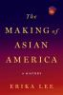](https://julac-cuhk.primo.exlibrisgroup.com/discovery/fulldisplay?docid=alma991034880949703407&context=L&vid=852JULAC_CUHK:CUHK&lang=en&search_scope=Books&adaptor=Local%20Search%20Engine&tab=default_tab&query=any%2Ccontains%2CHmong%20Immigrants%20History&offset=40)](https://julac-cuhk.primo.exlibrisgroup.com/discovery/fulldisplay?docid=alma991034880949703407&context=L&vid=852JULAC_CUHK:CUHK&lang=en&search_scope=Books&adaptor=Local%20Search%20Engine&tab=default_tab&query=any%2Ccontains%2CHmong%20Immigrants%20History&offset=40)

**BOOK**

### [The making of Asian America : a history](https://julac-cuhk.primo.exlibrisgroup.com/discovery/fulldisplay?docid=alma991034880949703407&context=L&vid=852JULAC_CUHK:CUHK&lang=en&search_scope=Books&adaptor=Local%20Search%20Engine&tab=default_tab&query=any%2Ccontains%2CHmong%20Immigrants%20History&offset=40)

Erika Lee.

Lee, Erika

First Simon & Schuster hardcover edition. New York : Simon & Schuster 2015.

The making of Asian America : a historyAvailable at University Library UL (E184.A75 L43 2015)

287: Minnesota is home to the secone largest population of Hmong Americans in the country after California

“Mark E. Pfeifer et al. “Hmong population and demographic Trends in the 2010 Census and 2010 ACS” 2012

Flight of Hmong occurs on very short notice and under conditions of duress; their resettlement in another country can take months or year; they arrive with physical and psychological woudns of war and grief; and they often have to rebuild their communities from scratch

318: In 1961, CIA agnet James William (Bil) Lair contacted Vang Pao, a military officer in Royal Lao Army, to recruit Hmong soldiers to the US military effort. US would arm and train special Hmong guerrilla units to attack North Vietnamese communits coming through Laos. In exchange, the Hmong would receive military and humantiarain aid. Many Hmong believe Vang Pao’s explanation that the US also promised a long-sought Hmong homeland or sanctuary in exchange for hteir services. Hmong soldiers, based out of the military base at Long Cheng and supplied by CIA airline Air America, Hmong soldiers carried out espionage, sabotage and propaganda missions. Because the US paid the Hmong a fraction of what it paid its own military personnel, this was war on the cheap. Vang Pao initialy recruited 9000 soldiers in 1961.

By the late 1960s, US increased reliance on the Hmong to involve the entire Hmong population. 25% of enlisted Hmong were killed. By 1970, more Hmong soldiers were boys only 12 or 13 years old.

An estimated 50,000 civilians also killed or wounded, even though the entire Hmong population before the war was only 300,000

322: After fall of Saigon, CIA airlifted Vang Pao and his officers out of harm’s wy, but few planes were sent to do this did not evaucuate all who wanted to leave.

Although 10,000 Hmong crowded onto the airbase at Long Cheng, only around 2500 were evacuated by the US in May 1975

328: US prioritized resettelemnt of Vietnamese, Hmong and Lao, less willing to accept Cambodians

333: The Hmong contemplated laon gand hard before deciding to leave family members behind in the camp with no assurances they would ever see each other again.

Mao Heu Thao explained her greatest fear was to be separated form her parnets, aunts and uncles and brother and sisters forever.

334: Hmong fled with few resources and have faced considerable obstacles.

In many cases, they have been set decieedly outside the model minority Asian American success narrative.

Few Hmong had lived in cities befor ethe war orh ad acquired enough formal educaiotn to learn how to read or write.

Once proudly self-sufficient, many Hmong now felt helpeless because hey could not communictate with people around htem.

Fidning familiar foods, navigating through busy city stresets and surviving the bitterly cold weather in the northeastenra nd midwestern US were all new challenges.

Like other Southeast Asian refugees Hmong were often placed in poor, urban neighborhoods and were mixed in with other ilow income families in public housing complexes.

As more Hmong arrived in Twin Cities, word spread that particular neighogrhoods were places where Hmogn could live togerha nd assist each other.

Many Hmong faced uphill battles with little Englihs, non agricutlrual skills or work experience enad inadequate job placement and training assistance. Hmong refuges had persisnetly high rates of unemployment, poverty, and dependency on federal and state assistance in early years of resettlement.

US Office of Refugee Resettlement, Simon M. Fass and Diana D. Bui, The Hmong Resettlement Study, Final Report, vol. 1 (Washington, DC, Office of Refugee Resettlemnet, 1985), 67; Appendix 3-4 (

In 1982, only 20 percnet of Hmong adults were employed in Twin Ciites area, and 85% of households were received some form of public assistance. Even those with jobs often had difficulty supporting their families on the low wages they earned.

^use his age to infer that probably when his parents were raising him this was the situation)

The 1990 US Census found that 65 percent of Hmong Americnas were unemployed and more htan 60 percent lived below the poverty line

-- US Office of Refugee Resettlement, Simon M. Fass and Diana D. Bui, The Hmong Resettlement Study, Final Report, vol. 1 (Washington, DC, Office of Refugee Resettlemnet, 1985), 104

Kou Yang, “Americna Experience eof the Hmong” in Diveirsety in Diapsora: Hmong Americnas in 21st century, ed. Mark Edward Pfeifer (Honolulu: U of Hawaii Press, 2013), 8

Like many patriarchal cultures, authority and respect tin Hmong families were granted to men, especially older men.

After resettlement however, some Hmong men, found their ability o support their families, and with it, their authority and sense of selves—changed and diminished.

Hmong women were finding it easier to find work outside the home and to learn Englihs as compared to Hmong men.

With more economic power, they were demanding equality in their homes and communities

“Is a Hmong men a man when he can’t control his wife?” he asked an interviewer in 1998 . Here in the US Hmong women are really changing, I am confused. I don’t know what to do. Women are supposed ot serve hteir husband, but now they are arguing that sharing the duty is better. This makes many Hmong men feel stressful—to argue eveyr day about equality around the house.”  
--Faderman and Xiong, I begin my Life all Over, 156; Vang, Hong American 55-56; Kou Yang: “Hmong Men’s Adaptaiton to Life in the US”

Bilingual children also began to wield more power iwhtin families due to their English language capbilitie and their skills as family translators

Lilian Faderman and Ghia Xiong: “It’s hard to present yourself as a wise man if your sons aor daughters hav eot each you how to cross the street or dial the phone”  
Many Hmong refugees felt they turned into helpless children in their own homes.

(Faderman and Xiong 164)

Ka Pao Xiong: “Our children are assimilating into American society, so they no lnger listen to us.” –Sucheng Chan, Hmong Means Free (1994), p 85

Researchers identified high dropout rates amng women who married and had children while still in high school (US Hmogn Resettlement Study 175, 208; Bic Ngo, 2002, p. 163-6

Poverty, feelings of powelresssness and alientation-> gang activity

Although their father was a policeman in Laos, brothers saw him as helpless refugee.

Parnets had to work nighshift in factory so older sibligns took care of younger siblings.

Hmong potrayed as primitive and backwards people who lacked the abilities ot survive in modern world and assimilate into the US. “Laos Nomads find US Life Confusing—Minneapolis Star.

Press reports blamed “vastly different customs” between Hmong and Americans that made it hard for Hmogn to “cope with modern American ideas” (Saint Paul’s Dispatch 1980, October 20

Researchers and jurnalists added to idea that “cultural differences’ between Hmong and AMericnas were great, perhaps insurmountable *Ngo, Contesting Culture 163-8

The Spirit Catch es You and You Fall Down by Anne Fadiman bestsetlling book that told story of clash between Americna doctors who wanted to treat Lee with durgs and procedures and parents who believe that her condtion was a result of her interacitonw ith Hmong spirit world.

(Monica Chiu, 2004: p. 5 “Medical, Racist and Colonial Constructions”

Americans complained that newcomers recerived more rfianncial asistanc ,e priority for housinga dn other benefits.

Hmong families in St. Paul had Molotov cocktails thrown into their units or left in their mailboxes. Gunshots fired into window sof refugee homes, insuring residents.

Two white attackers widelding clubs beat two Hmong brothers walking home.

As early as April 1975, a Harris poll found that 54 percetn of Americans surveyed believed htat SE Asians should be excluded, while 36 percent bleived they should be admitted.

342: To minimize the growing public backlash against refugees, other aspects of the bill focused on geographic dispersal, economic self-sufficiency and assimilation (Hing, Makinga dn Remaking Asian American 127-28; Reimers, Still the Golden Door 197; Normal L Zucker and Noami Flink Zucker (Desperate Corsisngs (Armonk NY 1996: 6-7; Kevin R Johnson, Indiana Law Jouranl 73, no 4 (1998):1134; Harvey Gee “Refugee Burden” 2000: 579

342: Such Resettlement policies backfired and in many ways and actually slowed and thrawarted refugee integration.

Many host communities also lacked culturally and lingsutuically appropriate social services

Resettlement and dispersal disrupted strong ties and roles of Hmogn Patriarchal clan system which were core meanins of origanizigna nd responding to community needs.

Faced with problems, many Hmogn rejected US policies and resettled a second time among family members and other Hmong to survive

Minnesota was a magnet for Hmong refugees because it had many social service providers and history of refugee rsettlement and many orgnaizaiton of Hmogn community

344: 64% of Hmogn sruvieed in 1982 community study said they moved ot Twin Cities to be with family.

345: Big family memetings used to instill certain values in younger generation in order ot spur them on toward socioeconomic success.

In 1977, the Associaiton of Hmong in Minnesota was formed ot assist Hmong refugees in finding jobs and getting access to programs and services, and advocated for needs of Hmong refugees and a ted as uclturla borkers

Hmong Americna partnership, formed in 1990 to provide culturally appropriate social services like classes in Englisha dn technology, academic and career mentorship for at risk teenagers, parental support and job placement.

Association for Advancement of Hmong Women in Minnesota addressed specific issues and needs of women (Vang Hmong America, 72-73_

Mee Moua became first Hmong Americna electedot state legislature.

Elderly Hmong men often wear impressive imilitary uniforms and medals at public events.

US congressional support for the Hmong veterans Naturalization Act of 2000, which helped over 45,000 people become citizens (Vang, Hmong America 126

In response to the cutting of welfare benefits in 1990s, advocates mboilzed to have Minnesota and 13 other states develop food assistance program who would not be covered by federal govenrment’s program

(Vang 126)

Vang was arrested by US authorities in Claifonria for allegedly purchasing illegal weapons and for plotting to overthrow the Lao government in 2007—charges that were later dropped—the orgnaizaiotn suffered another damaging blow (Vang, “Political Transmigrants” 1-46)

Hmong Americnas pressured president Bill Clinton’s adminsitraiton to keep Thai refugee camps open or ease US immigration rules. (Grigoleit, “Coming Home?”

348:

Percentage of Hmogn Americnas with jobs increased from 24 percnet in 1990 to 56 percent in 2010 (compared ot a 60 percent employment rate for general population in 1990 and 65 percent employment rate in 2010)

Decline in overall poverty in Hmong population from 64 percent in 1990 to 38 percdnte in 200 to 25 percnet in 2010.

Number of Hmong Americnas increased from 3 percnet in 1990 to overall 11 percent in 2009.

More hold management and professional job than in previous years(Chia Youyee Vang 2012: 1-20; Yang Sao Xiong “Hmong Americans” (2012): 1-18; Yang “American Expeirence” 23-24; Kou Yang “Forging New Paths” in Her and Loulise Buley Meissner, 2012: 168

Homeownership increased from 40 percent in 1990 to 54 percent in 2006

In 2010, per capita income was $26279 for general US population, for Hmgon maeircnas 11766. Heavily concentrated in declining manufacturing job sector.

They have lowest bachelor’s degree attainment across racial and ethnic groups.

Only 14.5 % of Hmong Americans 25 years and older hold bachelors degrees compared to 31.4% non Hispanic whites, 18 percent non Hispanic blacks, 50.2% non Hispanic Asians, and 13.1 percent Hispanics.

Hmong women lag further behind.

Few Hmogn Americna households have nay reitrmeent income, and as population ages, financial support for elers is challenge.

Hmong remain one of the poorest groups in US.

Hmong Poverty rate is twice as high as that of the general US population.

(Vang :Makign Ends Meet”; Hmong National Development<, “The Styate of the Hmong” 2010 US Census report, 2013 (Washignton DC 2013)

350: Hmong have simultaneously been portrayed as rescued, yet unassimilated, refugees, “natural” soldiers who were effective in moutnains of Laos, but dangerous on American city strengths, anti communist friends of freedom urign cold war who became terroirsts during War on Terror.

Hmong activists fored “Communtiyu Action Against Racism” a multiraical coalition of whites, Latinos and Asian and African Americnas that staged protests and publicized the issues.

Organized ecnomic boyfcott of radio station.

351:

Common for Hmong American boys to take greater homemaking responsibitileis, including traidoitanlly feminine duties as cooking, cleaning and cre of younger siblings, because parents are busy working multiple jobs (Bic Ngo and Pa Nhia Lor, “Great Expectaiotns” in Hmogn and American , 156; Cha, “Women in Hmong Diaspora, 172

3

[[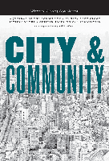](https://julac-cuhk.primo.exlibrisgroup.com/discovery/fulldisplay?docid=cdi_webofscience_primary_000339952500003&context=PC&vid=852JULAC_CUHK:CUHK&lang=en&search_scope=All&adaptor=Primo%20Central&tab=default_tab&query=any%2Ccontains%2CHmong%20Immigrants%20in%20Minneapolis%20History&offset=0)](https://julac-cuhk.primo.exlibrisgroup.com/discovery/fulldisplay?docid=cdi_webofscience_primary_000339952500003&context=PC&vid=852JULAC_CUHK:CUHK&lang=en&search_scope=All&adaptor=Primo%20Central&tab=default_tab&query=any%2Ccontains%2CHmong%20Immigrants%20in%20Minneapolis%20History&offset=0)

**ARTICLE**

### [The Urban Ethnic Community and Collective Action: Politics, Protest, and Civic Engagement by Hmong Americans in Minneapolis-St. Paul](https://julac-cuhk.primo.exlibrisgroup.com/discovery/fulldisplay?docid=cdi_webofscience_primary_000339952500003&context=PC&vid=852JULAC_CUHK:CUHK&lang=en&search_scope=All&adaptor=Primo%20Central&tab=default_tab&query=any%2Ccontains%2CHmong%20Immigrants%20in%20Minneapolis%20History&offset=0)

Hein, Jeremy

City & community, 2014, Vol.13 (2), p.119-139

**PEER REVIEWED**

The Urban Ethnic Community and Collective Action: Politics, Protest, and Civic Engagement by Hmong Americans in Minneapolis-St. PaulFull text available

[Available at BrowZine](https://browzine.com/libraries/946/journals/11343/issues/7299545?showArticleInContext=doi:10.1111%2Fcico.12063&utm_source=api_147)

he Hmong are the only Asian-American group who have a high level of concentration in a comparatively small midwestern metropolitan area.

Insights from Dee in Cairns about Indingeous people

I ws terrified of the gun culture in the US.

Some people have 60 guns in their hand.

Assimilation can go both ways.

I relate this to cultural chauvinism, the absurdity of some problems in US society, just mind blowing, yet we are not stopping to think, what can we learn from other people.

To have the ability , how would I feel, If I was in the same situation, wearing some sort of shoes, how would you feel if I can into your house and take over.

My sister is 50 years old, around bloody covid and refugees, the world does not revolve over you, we are overpopulated already, the whole idea of individualism is ridiculous,

You are all the same, you are not different, we thik we are something special. Human beings we are a pack of dogs, we don’t do well socially isolated from each other.

The whole idea of us being individual cannot be squared with us being human.

Thinking about me me me, is unsustainable, when we get to 10, we going to be bitching.

In a small village population arrangement, that individualism would not be as rampant, .You would have to be on the outside, small parochial town, if you wear a bright shirt you would be labeled gay, so if you are even in smaller social circle.

In a larger population you can get away with more individualism but that does not make indivdulaism any less destructive

When you get more and more people you need more regulation to control the population.

You need less individuality and need ot be more collective. How can you govern a society if we are all doing our own thing?

You have all these different factions wanting their needs or values met first. If you have that you got chaos. No wonder Russians think democracy is chaos. Or the Chinese even more!

I am very uncomfortable with any sort of essentialism.

A lot of Westernized people who live in urban communities, they have a very biased understanding of indigenous people, because the only time they observe them in these urban settings and those people take on the worst, that problematizes the idea of their being a pure indigenous culture, but also they are not paying attention to this very bias.

Either oral history or tribal records, still sustaining itself within the urban context

They maybe would not have their ceremony or forgot their language.

They have hteir little community and support each other, them and us.

They have that little collectivism, they are surrounded by other culture.

They live in small communities than in a house with two kids.

I feel the way I was writing about the indigenous people it is as if they just live away from cities.

I have to acknowledge they changed because of settler colonialism.

We spend 350 million a year on their health but look at them, they are still sick.

But where does that money go? It goes into white people’s pockets.

It does not go to the health care. You might start with 350 million dollars but it does not get to them.

Then you start playing the victim, because they live in poverty, so then we just blame them, because they are all so poor. They forget per capita, there is more drunk white Australians than drunk black Australians, who are more visible than the white ones.

I have seem much better behaved black drunk Asutralians than drunk white Australinas. Who are vicious.

I have never once felt threatened by black drunk Australians.

They have no qualms about their personal relationships or being so drunk they can barely stand up, but there is no more domestic violence than, in fact there is more domestic violence committed by white men but they just do it more cleverly, make sure there are no bruises on the face and obvious places. Aboriginal men do not think about hiding anything.

Abooriginal people tend to more accurately report how much alcohol they drink than white people.

They are more open about how much they can chew whereas we white Austrlaians beat around the bush or we don’t disclose how much we drink.

They don’t care about how much they drink.

They are so forthright.

They are all laboured, you can’t trust the men, they don’t work hard enough.

We have far more white people, generation after generation, on the dole than aborigional people.

Migrant people work the hardest, their kids go to school.

Harder to preserve your indigenous culture if you are surrounded in a city.

You protect your culture by sticking to your own people.

I look around and think Australia is so racially segregated. They would rather be around each other.

Out in the Eplanade, you have indigenous sitting on the bench, having picnic with each other. It would be weird but also almost hostile fro a bunch of white Australians to watlk up and try to chit chat?  
No no no

It is just not done that often and it is because white Australians don’t know anything about them, they have a very negative stereotype and racist view of them, based on gossip, nothing tuahgt int their schools, should be mandatory curriculum, pure ignorance.

Any books they teach in the classes.

Only you go to indigenous studies will you read at university the writings of idnigneous people.

In high school nothing?  
No, nothing. Most of their language disappeared.

In each state, the government will have cultural information about indigenous people

In Queensland, any government department, they do the land acknowledgment.

This is just rhetoric.

About cultural orientation, and they get indigenous people to present it.

Push back on that is that white Australians say, well it was not my fault, I did n’t kill them, and you say bloody hell, they feel like they are being blamed, not what it is about, you idiots. They get so caught up in feeling guilty, they say they just want us to feel like we are responsible.

But it is not about blaming them for anything, it is just about validating their own experience.

Unless it is validated people just think it is a story.

It is the same with rape victims.

Indigenous studies: like African Americans have their own history, all the things that are footnotes in standard US history books are the big story for them.

They are small stories but they are important about the symbolism

Indigenous people have their own important stories;.

They have their precolonial history their oral history and their beliefs and creation myths.

They have a strong ssense of contemporary history.

They probably do not have that to the same degree and they want to have a place in the contemporary society, they want to have their own indigenous constitution.

Diffiucult to get a decision from them, because they are a communal decision making so I can’t go to you, can I walk over there. I have to walk several other men and get a consensus , so no one has a right to speak for someone else, so it takes ages to get a decision made.

When indigenous person stands up, Nell Pierson, he is a lawyer, he is not really well respected by other indigenous people, he needs to come to us and we talk about it and we. He can’t decide this is what idngneioius people thin.k.

He does not get it. There is always a communal decision, not one person can be asked a question and you get an answer, you have to put it ot the group, that is what we want to do and they give you a decision about that.

That makes things take a long time, we always want things done yesterday.

There is no civil rights in Australia so hard to have anything like the civil rights movmenet.

We have anti discrimination laws but they are not called rights, similar to Canada.

That is why I found it seriously when my sister during the covid pandemic said that you don’t have a right to spread diseases to other people willingly and knowingly. They are picking that up from the Americans.

And my sister comes from a science background.

Maoris have their treaties and that gave them a lot of rights.

Melanisns are much smaller and darker than Polynesians, but still very tribal.

Maoris can be super chilled out people and then suddenly they become very beetlecjuice eyes and scary.

Vanuatuans are very leaner and slimmer, but they can have some very mean look.

You can get in touch with the yachtees or the sailors.

You get paid, you will be working as a crew person, you have ot let them know. You can do that all through Indonesia. They don’t do it in the summer because they get caught in the cyclones.

So easy to fly out of HK to anywhere, you just zip up to Europe and to South Pacifics or to Asia.

Vanuatu was split: influenced by French and the English. Wadfallow is the capital of Vanuatu, city was split in half, you had two hospitals and schools.

Each island has its own language.

They speak Bislama, a bit like Creole, a mixture of languages that comes from outside influence but use the local language.

You could almost read what it means, since it has some English, so literal, hysterical, people would think I was mad because I was laughing.

Western society is so out of whack, we don’t’ know how to be still, how to be calm.

Take some time out, I don’t have time. Of course you don’t have time, it is all about priority, do you want to do this or that?you have a choice. Don’t want to deal with your stress, shut up about it.

Everyone is so busy doing something, makes you seem like you are important.

What are you going to say on your deathbed?  
Oh I wish I did this, I wish I did that.

Too bloody late now.

I get really anxious, at this conference, I am at a conference, my university paid for this. I should get their money’s worth, I am going to stick to it with the end because at the end u a bunch of eureka light bulbs went off, paid off, the last 2-3 hours.

A lot of it was htat I would much rather just be doing my rsearch, I got so much in the mdoe of working, I love what I do.

People need to be constantly surrounded by others or constantly on their media so they felel like they are worth someone, I have 500 friends on FB, no they are not, friends are people that change your life, who are there to support you in the bad times.

Friends are those you will tell your secrets to.

Young people do not know or understand body languages any more because they do not interact as much in person.

This is an artificial medium and the Energy that transpires in the presence of each other

I am teaching on zoom and it is so hard to communicate.

Where you can’t be in the presence of y our breath or fully present because very soon you have another meeting, it breaks that connection.

Removes you from people you want to work.

Also depends on the angle from which you are viewing someone’s body with the camera.

Your shoulders are not over your hips, but it may be the angle, gives you a distorted perception of what the body shape, I can’t wait to get into person.

Technology is great for a lot of things, but in terms of real communication, there is a breakage with technology, , we are not connected as humans together in the same space.

Another reason why I prefer to live in a population dense metropolitan place, a city, more ecological in many ways.

In HK, they forced me to teach on zoom, but I am still more free to meet people and interact with them, but I feel sorry for graduate students who went home to North Dakota to teach remotely, for me that is not as interesting.

I feel that lack of connection between people in the city.

I find strange that it is weird when people think civil inattention is cool.

Australian National Library,

Menadue Box 16, Immigration 1980-1983

“Towards a Multicultural Australia” by John L Menadue, at Conference of Ex-Students of Sancta Sophia College, Univeirsty of Sydney, 8 August 1981

“In Australia as well as other countries, it became obvfious that a policy of assimilation was no longer adequate as it created more problems than it solved.

Under the mask of uniformity and cohesion grew many social problems: discrimination; isolation of immigrnats; difficulties of communication between sections of the community; lack of access to services; migrant enclaves.”

(^these are all examples of how assimilation has been harmful to immigrnats, rather than migrant-receiving society)

Page 6

Multilingualism in a multicultural society will help remove the barriers which have too often been erected between cultural groups, because of ignorance and suspicion, and will go a long way towards determining the quality of Australia’s future society.

**[Social Immune Mechanisms: Luhmann and Potentialization Technologies](https://journals.sagepub.com/doi/full/10.1177/0263276419868768)**

**Niels Åkerstrøm Andersen**, **Paul Stenner[](https://orcid.org/0000-0003-4505-6422)**

First Published September 5, 2019; pp. 79–103

[Abstract](https://journals.sagepub.com/doi/abs/10.1177/0263276419868768)

Hide Preview

Contemporary discourses of management are full of encouragements to ‘expect the unexpected’ and to celebrate ‘the future of the future’. Many new public managerial technologies of change – such as steering labs, future games, and managerial performance arts – promise the co-creative ‘potentialization’ of employees, citizens and organizations. This paper approaches such potentialization technologies as immune mechanisms which serve to protect the social system from itself. From a perspective inspired by autopoietic systems theory, potentialization technologies provide autoimmunity by problematizing institutional structures and providing ‘anti-structural’ space-times to facilitate transformation. There is a price to pay for this immune function, however, since these immune mechanisms cannot discriminate between productive and unproductive structures. By dissolving the certainty of the expectations that underlie the connectivity of diverse organizational operations, they risk harming the welfare systems that host them.

**[Peter Sloterdijk and the ‘Security Architecture of Existence’: Immunity, Autochthony, and Ontological Nativism](https://journals.sagepub.com/doi/full/10.1177/0263276419839119)**

**Thomas Sutherland[](https://orcid.org/0000-0003-1538-7044)**

First Published May 6, 2019; pp. 193–214

[Abstract](https://journals.sagepub.com/doi/abs/10.1177/0263276419839119)

Hide Preview

Centred on *Foams*, the third volume of his *Spheres* trilogy (2011, 2014, 2016), this article questions the privilege granted by Peter Sloterdijk to motifs of inclusion and exclusion, contending that, whilst his prioritization of dwelling as a central aspect of human existence (drawing in part upon the work of Martin Heidegger) provides a promising counterpoint to the dislocative and isolative effects of post-industrial capitalism, it is compromised by its dependence upon an anti-cosmopolitan outlook that views cultural distantiation as a natural and preferable state of human affairs, and valorizes a purported ontological security attained through defensive postures with respect to perceived foreigners or externalities. Sloterdijk’s conceptualization of culture as a kind of immune system, it is argued, although posited as a rebuke to models of essentialism and ethno-nationalism, provides ontological support to the xenophobic critiques of immigration that are today finding increasing currency.

### [Living Multiples: How Large-scale Scientific Data-mining Pursues Identity and Differences](https://journals.sagepub.com/doi/full/10.1177/0263276413476558)

**Adrian Mackenzie**, **Ruth McNally**

First Published May 15, 2013; pp. 72–91

[Abstract](https://journals.sagepub.com/doi/abs/10.1177/0263276413476558)

Hide Preview

This article responds to two problems confronting social and human sciences: how to relate to digital data, inasmuch as it challenges established social science methods; and how to relate to life sciences, insofar as they produce knowledge that impinges on our own ways of knowing. In a case study of proteomics, we explore how digital devices grapple with large-scale multiples – of molecules, databases, machines and people. We analyse one particular visual device, a cluster-heatmap, produced by scientists by mining data from a large number of experiments on human blood plasma proteins. These proteins make up a myriad multiple whose identity shifts in many ways. Rather than displaying data about proteins, the heatmap constructs a view of the differences and similarities between experiments. We find this attempt to construct a view on many things at once instructive in thinking about multiples more generally. Instead of flattening molecular ‘life itself’, this visual device superimposes layers of digital devices and techniques from a wide variety of disciplines. This layering suggests a different way of relating to the life sciences more generally: rather than *what* they know, *how* they know might be of use to social and human sciences when attending to multiplicities.

Bottom of Form

(^fascinating, and may be a critique of my critique of assimilationism paper)

The stigma attached

to these immigrants has led many nationals to question whether undocumented

immigrants have even the ‘right to have rights’ in these countries

(Arendt, 1973). It is argued that even the most basic right granted to the

most innocent immigrant provides an anchor for the whole population to

spread like a viral contagion.

Facing these powerful discursive barriers, one would expect undocumented

immigrants to avoid the public sphere and eke out an existence in

the shadows of receiving countries. They would occupy a similar position

as the slave during the Roman Republic, cast out of the world of truly

free and truly ‘human’ beings and sealed into the nether world of the

private arena (Arendt, 1958: 50).

However, contrary to expectations,

recent studies have shown that undocumented immigrants have done the

opposite in countries as diverse as the United States, France, Germany,

Great Britain, and the Netherlands (Anderson, 2010; Barron et al., 2011;

CisseÅL , 1999; Iskander, 2007; Laubenthal, 2007; Nicholls, 2011; SimeÅLant,

1998; Voss and Bloemraad, 2011).

The mobilization in the

United States (primarily during the 2000s) has called for the legalization

of undocumented youths attending universities. In France (primarily

during the 1990s), the mobilization was largely spearheaded byundocumented parents of French-born nationals (the sans papiers).1

In spite of the important differences

between these examples, we can identify a remarkably similar process

in transforming undocumented immigrants from stigmatized outcasts

into legitimate political subjects.

(^cite this in talking about transformations in subjectivity)

Demonstrating national identification has therefore

become the means by which this ‘other’ reveals its humanity to the

native. Once natives recognize the immigrant other as human, they are

more likely to recognize that the group has been wronged because it has

been denied certain ‘inalienable’ and ‘human’ rights. This does not necessarily

mean that rights will automatically be granted to the claimants but

it makes this issue a legitimate subject of public debate.

Although this

discursive strategy provides a route to inclusion and recognition for outcasts,

pursuing the strategy comes at a cost because it reinforces the

notion that basic rights should only be granted to those who conform

to national codes, cultures, and morals. As a consequence, those immigrants

lacking the attributes needed to demonstrate their conformity with

national norms find themselves excluded from basic rights in these

countries.

this article maintains that these movements often play the opposite

role by disciplining transnational immigrants to nationalize their claims

for basic human rights

the national strategy

assumes greater prominence under conditions of greater hostility and the

degrees of hostility change with time and place.

Like the ‘dangerous’ working class of the 19th century, immigrants

have been viewed as lacking the core attributes needed to be recognized

as possible rights-bearing members of national communities (Chavez,

2008; Ngai, 2004; Raissiguier, 2010; Rancie` re, 1992; Wahnich, 1997).

Jacques Rancie`re (2007: 561) maintains that outcasts employ a

strategy of ‘dis-identification’ to turn them into new and powerful subjects

in the public sphere: ‘A process of dis-identification is what creates a

political subject. A political subject is a being that arrives as supplement

to the social distribution, since it cannot be identified as a part of the

police order.’

Making a political subject in this instance is intricately bound to the

process of dis-identification, whereby the outcast publicly asserts his or

her non-place and indeterminacy in the existing order of things. ‘By

changing the relations between names, identities and places, it created

a space of indeterminate possibilities for unknown competencies’

(Rancie` re, 2007: 561). Staking out a site of indeterminacy or what he

calls an ‘un-space’, the outcast becomes ‘dissensus’:

There is dissensus when there is something wrong in the picture,

when something is not at the right place. There is dissensus when we

don’t know how to designate what we see, when a name no longer

suits the thing or the character that it names, etc. (p. 559)

participants

of massive immigrant rights demonstrations in California in 1994

proudly waved flags from different parts of the world (see Chavez, 2008).

Their dis-identification with any particular nation-state was used by antiimmigrant

forces to reinforce their argument that immigrants were irreducibly

foreign and bent on ‘reconquering’ America. Rather than opening up

the public sphere to this emergent political subject, the strategy of disidentification

sealed the door shut. This was followed by the introduction

of new measures to reinforce border controls and the further rollback of

rights in the 1990s.

immigrant rights activists in the United States have learned

from the failure of the dis-identification strategy of the 1990s and now

employ a strategy of national identification. They have constructed a

discourse and performances to demonstrate that they are not foreign

and irreducibly different from nationals. They no longer have attachments

to their native countries and cultures, and their tastes, values,

aspirations, and commitments align with those of nationals. ‘Maybe

our parents feel like immigrants, but we feel like Americans because

we have been raised here on American values’ (Carlos Saavedra

in Preston, 2009).

In the French example, undocumented

immigrants stressed their identification with the nation through

the names of undocumented associations (Right to Live in a French

Family; Foreign Parents of French Children).2

Having demonstrated their ‘humanity’ by identifying

with national values and norms, continuing to deny immigrants

‘inalienable’ rights becomes increasingly viewed as a wrong inflicted on

this population. Moreover, by focusing on the attributes that transform

some immigrants into good ones, it becomes more difficult to justify the

denial of rights claims on the basis that they represent a threat to the

country. As the threatening other evaporates into representations of conformity

and similarity, the moral grounds for denying rights evaporates

(i.e. protect the national community).

gaining inclusion in hostile citizenship regimes

requires that immigrants reproduce the national discourses and ideas

that make such regimes exclusionary.

The relative poverty

of recent immigrants (in terms of cultural capital) requires them to

develop working relations with well-established organizations in possession

of these scarce resources (i.e. professional immigrant rights associations,

labor unions, religious organizations, etc.) (Cordero-GuzmaÅLn

et al., 2008; Milkman, 2006; Nicholls, 2011; PeÅLchu, 2004; Voss and

Bloemraad, 2011).

During the 1990s in France, leading rights associations3

formed a coalition called the Groupe de 10 to assume this representational

role. This handful of associations made up primarily of French,

middle-class, and highly educated native citizens met regularly between

1994–1997 to formulate strategies for representing undocumented immigrants

and their struggle for legal rights.

In the

mid-2000s, prominent rights associations such as the National

Immigration Law Center, Center for Community Change, and Center

for Human Immigrant Rights of Los Angeles, among others, formed a

coalition to support a measure that would grant undocumented students

the right to stay in the country. The members of the ‘United We Dream

Coalition’ made use of weekly conference calls to discuss the political and

discursive strategies of the campaign

This has

required leading rights associations to build an infrastructure to control

and discipline how thousands of activists across a country talk and represent

immigrants and their struggle in the public sphere. The infrastructure

enables the leading associations to produce controlled discourses,

diffuse these discourses downwards to local activists across a national

network, train activists in different sites to deploy these discourses in a

disciplined and controlled fashion, and police the lines between acceptable

and unacceptable discourses (Mann, 1986; Ong, 1999). Through this process,

undocumented activists internalize the dominant discourse of the

movement and become a real political subject. The activist becomes capable

not only of repeating talking points in the public sphere but of feeling

and believing those talking points as well.

Personal tangents and peculiarities tempt most

new undocumented activists to veer ‘off-message’ or to personalize their

stories too much. This requires intensive and emotional training. The

emotionally intensive character of these training programmes helps

new activists to internalize the generic discourse and infuse it with personal

meaning. Training has therefore allowed undocumented activists to

learn and feel the movement discourses. Feeling the discourse enhances

direct-action anarchists

have largely been viewed as a thorn in the side of immigrant

activists in the United States. Rather than reinforce the message that

protesters are law-abiding and hardworking residents in search of a

better life, they associate immigrant protesters with radicals who want

to end capitalism and the ‘American way of life’.

In the French example, the leadership

of the movement has actively shunned Muslim clergy while simultaneously

cultivating ties with a range of Protestant and Catholic

organizations. Inviting the participation of Muslim clergy would highlight

the stigmatized religion of undocumented immigrants and accentuate

their irreducible otherness. By contrast, gaining the support of

Catholic clergy has been an important way of bolstering the moral

authority of these immigrants and establishing their cultural continuity

with the values of the French public. Thus, the construction of a legitimate

political subject requires active efforts to police the boundary

between acceptable and unacceptable discourses, performances, and

utterances – harnessing what are deemed to be good discourses and

silencing those considered negative and damaging to the immigrant’s

public image.

In this

instance, it is not the state that compels new immigrants to conform to

national codes and categories through the technologies of coercive citizenship

but the leadership of the movement that ensures such conformity.

The struggle is about gaining

recognition for themselves as legitimate political subjects capable of

making rights claims on their own behalf (Arendt, 1958). Equality

means gaining recognition (from the public, politicians, immigrant

rights associations) that they have the right to express their own voice

in the public sphere. The struggle for equality is as much about gaining

legal rights as it is about demanding recognition as political equals in a

community of citizens.

This drive for recognition compels some undocumented activists to

criticize not only the government for its exclusionary policies, but also

the immigrant rights associations for maintaining their monopoly over

the means of representation. It is argued that this monopoly blocks the

ability of undocumented activists to represent their own voices in the

public sphere and restricts them from gaining recognition as equal,

rights-bearing political subjects

more politicized undocumented activists come to believe that

the struggle is indeed about gaining legal-juridical rights but it is also about

gaining recognition as equals within the political community (i.e. ‘right to

have rights’). Because speaking, arguing, and performing in the public arena

is a precondition for gaining recognition for themselves as equals, the practice

of representing immigrants is not simply a means to an end but an end in

its own right. Undocumented immigrants can only achieve true recognition

for themselves as equal political subjects when they speak for themselves in

the public sphere. The continued prominence of leading associations is

therefore passionately criticized because it blocks them from speaking for

themselves and becoming truly equal beings in the country.

(^this relates to double consciousness and can be cited)  
making

a subject a ‘legitimate’ claimant of rights contributes to legitimating the

exclusionary principles at the heart of national citizenship regimes. Their

inclusion depends on their abilities to demonstrate that they possess the

distinctive normative and cultural attributes needed to be considered

equals within these regimes. They stress that their rights must be recognized

because they have strong ties to the country, hold the same values

as nationals, and are well integrated in national cultures and traditions.

Rather than argue that all people are equal irrespective of their attributes,

the argument is ultimately that nationally-specific attributes are

indeed the keys to equality.

Their ‘impossible’ status is not sealed by the stigmatizing discourse

of native citizens but by other rights activists who make claims

to equality on the basis of attributes that others simply lack.

the ability for

these types of outcasts to reposition themselves in the public sphere

depends on their abilities to demonstrate how easily they can fit into

the moral and cultural worlds of national citizenship. The case of

undocumented immigrants shows that even the greatest outcasts operating

in the most hostile of environments can achieve legitimacy and have

their rights recognized. However, mounting a campaign to show that ‘we’

are just like ‘you’ is dependent on the attributes that qualify people as

‘fully human’, thereby making it more difficult for those lacking these

competencies to gain recognition for themselves and their cause.

**[Huey Newton’s Lessons for the Academic Left](https://journals.sagepub.com/doi/full/10.1177/02632764211039278)**

**Jim Vernon[](https://orcid.org/0000-0001-7840-3297)**

First Published September 27, 2021; pp. 267–287

[Abstract](https://journals.sagepub.com/doi/abs/10.1177/02632764211039278)

Hide Preview

The Black Panther Party was founded to bridge the radical theorizing that swept college campuses in the mid-1960s and the lumpen proletariat abandoned by the so-called ‘Great Society’. However, shortly thereafter, Newton began to harshly criticize the academic Left in general for their drive to find ‘a set of actions and a set of principles that are easy to identify and are absolute.’ This article reconstructs Newton’s critique of progressive movements grounded primarily in academic debates, as well as his conception of vanguard political theory. Newton’s grasp of revolution as a gradual, open, and above all dialectical process, not only provides a corrective to many dominant academic accounts of the nature of progressive change but, more importantly, it also grounds an emancipatory philosophy that can direct collective struggle, precisely because it remains grounded in the imperfect and internally conflicted lives of those whose freedom is to be won through it.

(^maybe cite in critique of assimilationism)

**[Peter Sloterdijk and the ‘Security Architecture of Existence’: Immunity, Autochthony, and Ontological Nativism](https://journals.sagepub.com/doi/full/10.1177/0263276419839119)**

**Thomas Sutherland[](https://orcid.org/0000-0003-1538-7044)**

First Published May 6, 2019; pp. 193–214

[Abstract](https://journals.sagepub.com/doi/abs/10.1177/0263276419839119)

Hide Preview

Centred on *Foams*, the third volume of his *Spheres* trilogy (2011, 2014, 2016), this article questions the privilege granted by Peter Sloterdijk to motifs of inclusion and exclusion, contending that, whilst his prioritization of dwelling as a central aspect of human existence (drawing in part upon the work of Martin Heidegger) provides a promising counterpoint to the dislocative and isolative effects of post-industrial capitalism, it is compromised by its dependence upon an anti-cosmopolitan outlook that views cultural distantiation as a natural and preferable state of human affairs, and valorizes a purported ontological security attained through defensive postures with respect to perceived foreigners or externalities. Sloterdijk’s conceptualization of culture as a kind of immune system, it is argued, although posited as a rebuke to models of essentialism and ethno-nationalism, provides ontological support to the xenophobic critiques of immigration that are today finding increasing currency.

(^cite in critique of assimilationism)

From Chen Zhen’s interview:

<https://china-underground.com/2016/03/23/transexperiences-conversation-chen-zhen-zhu-xian/>

C. Z.: This time it is a very appropriate metaphor. It is well known that viruses are very tiny, but extremely harmful to human bodies. Wherever they go, nobody dares to ignore them. Some viruses are capable of not being easily defeated and cannot be killed by any medicine. Most of them «live and die by themselves.» Once viruses invade the human body, they will cause the active response of the human immune system: the viruses from outside will engage in battles against the antibodies from inside. The aggressive viruses will destroy the immune system. You see, all of this seems to be describing an artist’s posture towards the so-called main stream culture or the central culture, and his contributions to «multicultural exchanges.» We could say that cultural exchange is the process and symptoms of virus infection. The qualities of the viruses are exactly the ones we should possess today!

Lu Et al. Why

American organizations could

benefit from EA cultures’ group-focused, protection-oriented

leadership style (31, 58). By appreciating diverse leadership

styles, American organizations can better leverage EA leadership

talent—especially since EAs appear no less interested in leadership

roles than SAs or whites.

From: In Search of Our Frontier:

17:

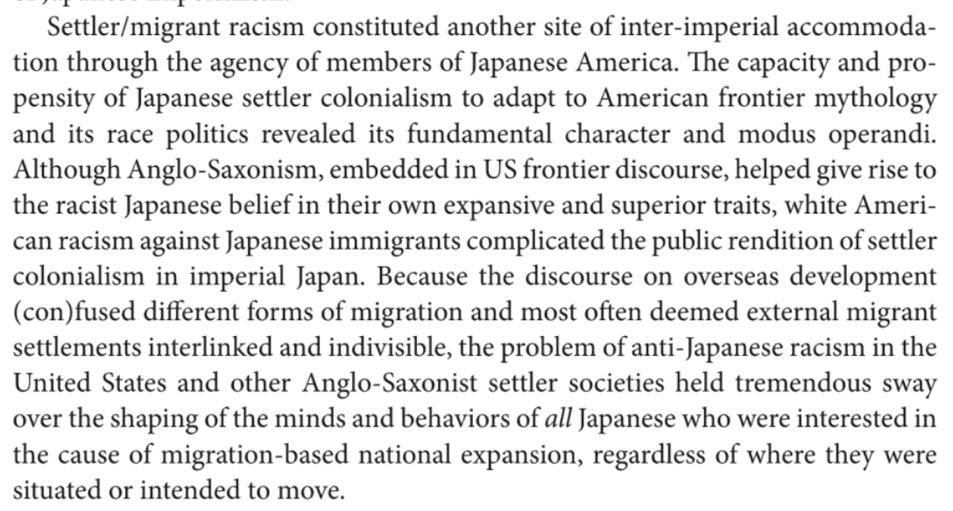

(^cite inter-imperial accommodation in “Does Assimilation Hurt Us More than Them”?)

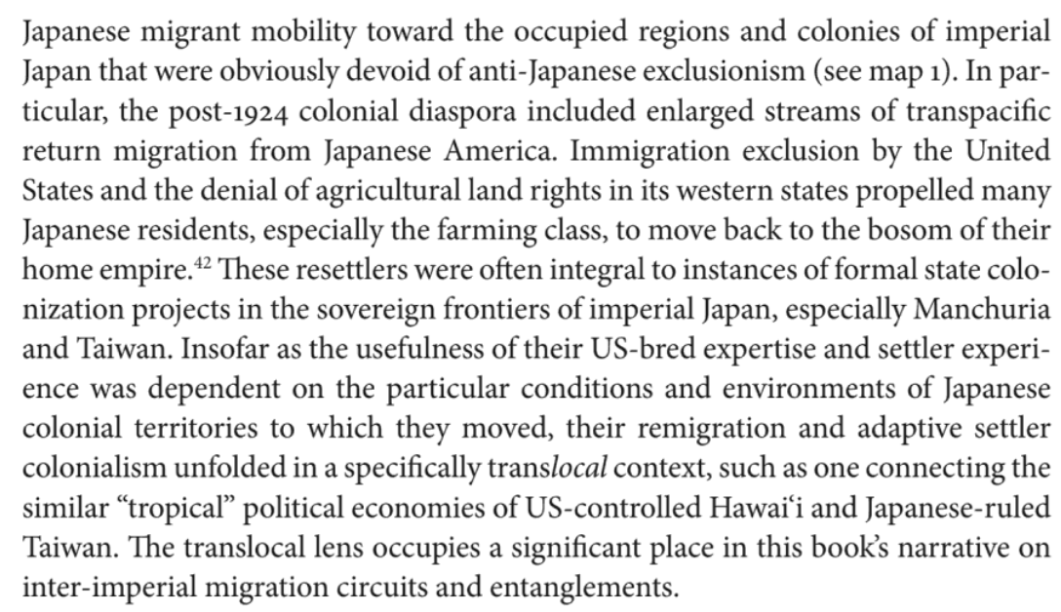

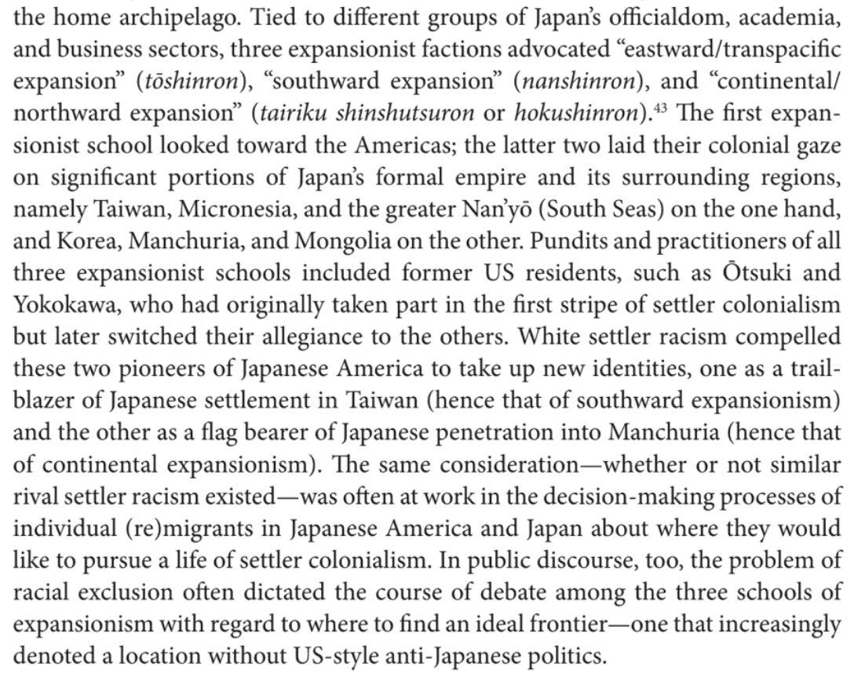

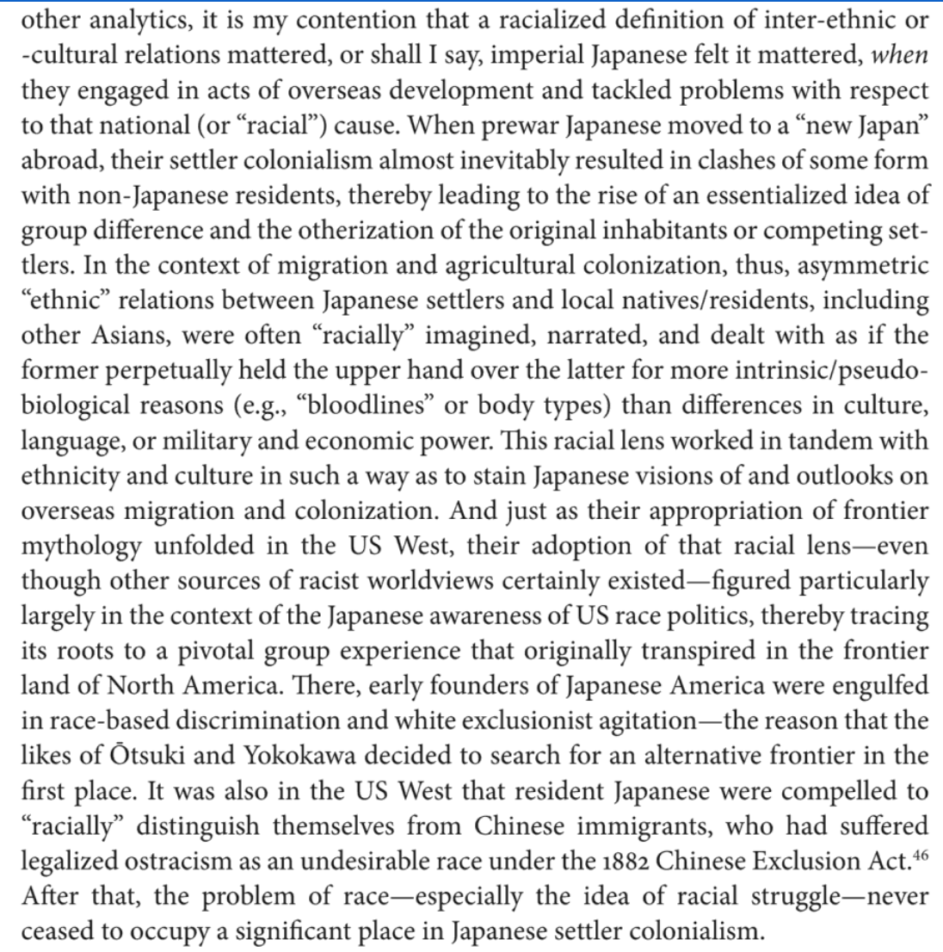

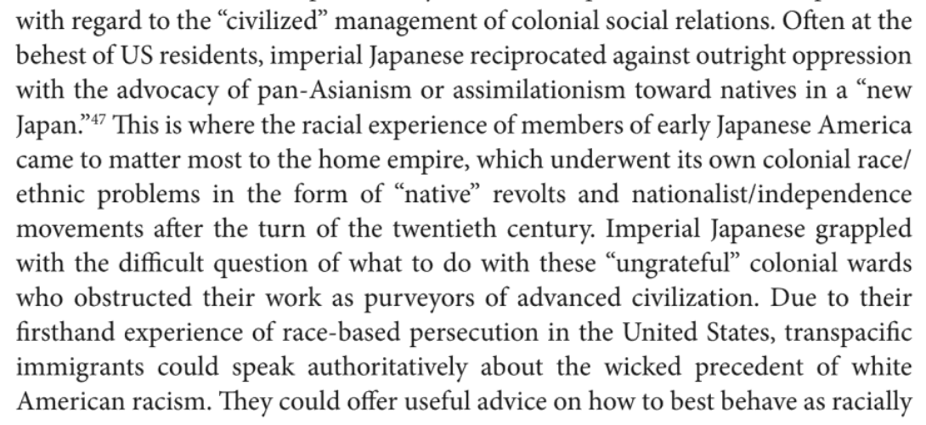

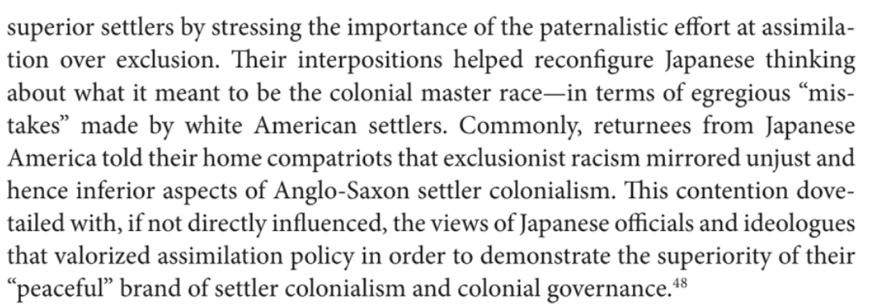

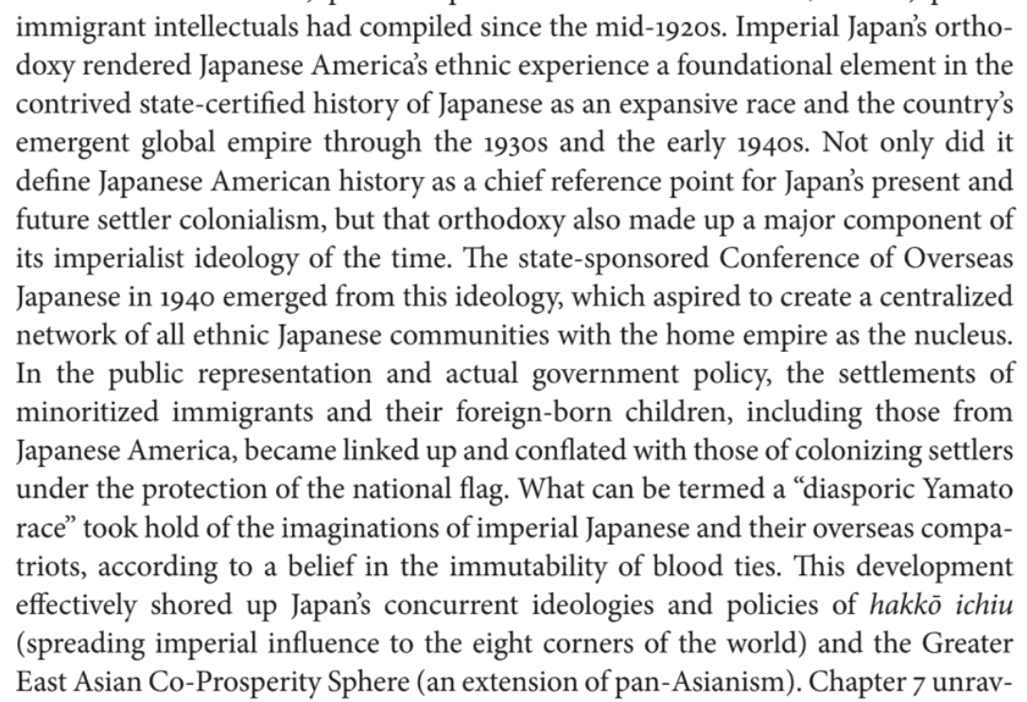

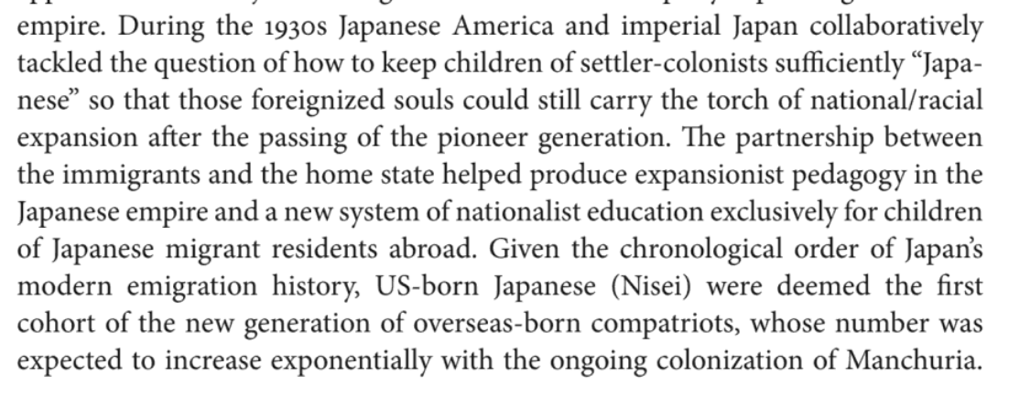

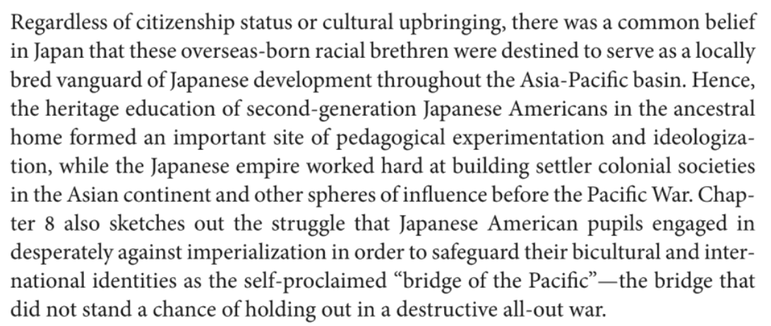

Twitter reports:

<https://twitter.com/LouRaguse/status/1493620481005600775>

**[Lou Raguse](https://twitter.com/LouRaguse)**

[@LouRaguse](https://twitter.com/LouRaguse)

·

[Feb 15](https://twitter.com/LouRaguse/status/1493608028851036170)

As court begins, Thomas Lane now says he *will* testify. That means all three defendants will testify in their federal trial.

1

12

24

[[](https://twitter.com/LouRaguse)](https://twitter.com/LouRaguse)

**[Lou Raguse](https://twitter.com/LouRaguse)**

[@LouRaguse](https://twitter.com/LouRaguse)

·

[Feb 15](https://twitter.com/LouRaguse/status/1493608686824087560)

Judge Magnuson says one juror has had a death in the family. But that juror will remain on. A second juror has a commitment on Feb 25. Magnuson says it's possible the jury will be in deliberation at that time. They are not dealing with this juror now.

1

2

3

[[](https://twitter.com/LouRaguse)](https://twitter.com/LouRaguse)

**[Lou Raguse](https://twitter.com/LouRaguse)**

[@LouRaguse](https://twitter.com/LouRaguse)

·

[Feb 15](https://twitter.com/LouRaguse/status/1493612468119248903)

The first witness, called by Tou Thao's attorney Robert Paule, is FBI Special Agent Blake Hostetter. He was the "Case agent" meaning the lead investigator in this case, which makes it curious that the defense is calling him instead of the prosecution.

1

1

3

[[](https://twitter.com/LouRaguse)](https://twitter.com/LouRaguse)

**[Lou Raguse](https://twitter.com/LouRaguse)**

[@LouRaguse](https://twitter.com/LouRaguse)

·

[Feb 15](https://twitter.com/LouRaguse/status/1493613168756731910)

Paule begins pointing out the public interest that grew in this case immediately because of the protests and riots. Sounds like they will go into the BCA/FBI interview of Thao that took place on June 2, 2020. The jury did not watch this interview so first they are hearing.

1

2

3

[[](https://twitter.com/LouRaguse)](https://twitter.com/LouRaguse)

**[Lou Raguse](https://twitter.com/LouRaguse)**

[@LouRaguse](https://twitter.com/LouRaguse)

·

[Feb 15](https://twitter.com/LouRaguse/status/1493614586293063681)

Hostetter has been in the courtroom for this entire trial -- at the side of the prosecution table. Paule is currently asking about Donald Williams, who has not testified in this trial.

1

1

4

[[](https://twitter.com/LouRaguse)](https://twitter.com/LouRaguse)

**[Lou Raguse](https://twitter.com/LouRaguse)**

[@LouRaguse](https://twitter.com/LouRaguse)

·

[Feb 15](https://twitter.com/LouRaguse/status/1493614927428345857)

Scrutinizing statements Williams can be heard saying on the video, such as "i trained with you at the academy." Paule wanting to show Williams didn't train at a police academy and the officers did not train at the Jiu Jitsu academy if that is what Williams was referring to.

1

1

1

[[](https://twitter.com/LouRaguse)](https://twitter.com/LouRaguse)

**[Lou Raguse](https://twitter.com/LouRaguse)**

[@LouRaguse](https://twitter.com/LouRaguse)

·

[Feb 15](https://twitter.com/LouRaguse/status/1493615598512791555)

Paule is going into decisions the FBI/BCA made in recording interviews. Tough to completely see where it is going. Special Agent Hostetter does not give the impression he is helping the defense. He continues to make Paule rephrase questions.

2

1

[[](https://twitter.com/LouRaguse)](https://twitter.com/LouRaguse)

**[Lou Raguse](https://twitter.com/LouRaguse)**

[@LouRaguse](https://twitter.com/LouRaguse)

·

[Feb 15](https://twitter.com/LouRaguse/status/1493615958216392706)

Paule is revealing a special agent named Jonathan Holden recorded an interview with someone without prior permission from a supervisor -- which flies in the face of FBI policy. Holden filed the "request" after the fact -- after the interview was recorded.

1

1

1

[[](https://twitter.com/LouRaguse)](https://twitter.com/LouRaguse)

**[Lou Raguse](https://twitter.com/LouRaguse)**

[@LouRaguse](https://twitter.com/LouRaguse)

·

[Feb 16](https://twitter.com/LouRaguse/status/1493617044809523203)

Paule finishes with Special Agent Hostetter after this issue was raised about the other agent, Holden, recording an interview without permission. No info given about which interview this concerns.

1

1

1

[[](https://twitter.com/LouRaguse)](https://twitter.com/LouRaguse)

**[Lou Raguse](https://twitter.com/LouRaguse)**

[@LouRaguse](https://twitter.com/LouRaguse)

·

[Feb 16](https://twitter.com/LouRaguse/status/1493617132432764929)

BREAKING: Tou Thao is now taking the witness stand in his own defense.

[@kare11](https://twitter.com/kare11)

1

4

9

[[](https://twitter.com/LouRaguse)](https://twitter.com/LouRaguse)

**[Lou Raguse](https://twitter.com/LouRaguse)**

[@LouRaguse](https://twitter.com/LouRaguse)

·

[Feb 16](https://twitter.com/LouRaguse/status/1493617374582423554)

Tou testifies that he lives with his wife, two brothers mom and three children. He was born in St. Paul and spent most of his childhood in North Minneapolis

1

1

3

[[](https://twitter.com/LouRaguse)](https://twitter.com/LouRaguse)

**[Lou Raguse](https://twitter.com/LouRaguse)**

[@LouRaguse](https://twitter.com/LouRaguse)

·

[Feb 16](https://twitter.com/LouRaguse/status/1493617697317396482)

The neighborhoods he grew up in were diverse -- Hmong (which Thao identifies as.. his parents were refugees from Laos) -- as well as black, Asian, Hispanic and some white.

1

1

1

[[](https://twitter.com/LouRaguse)](https://twitter.com/LouRaguse)

**[Lou Raguse](https://twitter.com/LouRaguse)**

[@LouRaguse](https://twitter.com/LouRaguse)

·

[Feb 16](https://twitter.com/LouRaguse/status/1493618185907675140)

Thao's father was a "medical assembler" i think he said, and his mom stayed at home. He had 6 siblings --2 sisters and 4 brothers. They were poor. Ate once a day. Two times if there was school. They would rotate 4 outfits between them. His father was strict.

1

1

1

[[](https://twitter.com/LouRaguse)](https://twitter.com/LouRaguse)

**[Lou Raguse](https://twitter.com/LouRaguse)**

[@LouRaguse](https://twitter.com/LouRaguse)

·

[Feb 16](https://twitter.com/LouRaguse/status/1493618504322490372)

Thao says they were pretty restricted to play in the backyard because Hmong kids were bullied a lot back then. In 5th grade they moved to Fridley. His cousins were joining gangs in Minneapolis - and parents didn't want Thao and brothers to get into that.

1

1

1

[[](https://twitter.com/LouRaguse)](https://twitter.com/LouRaguse)

**[Lou Raguse](https://twitter.com/LouRaguse)**

[@LouRaguse](https://twitter.com/LouRaguse)

·

[Feb 16](https://twitter.com/LouRaguse/status/1493618658119143434)

At his new school, Thao was the only minority. "It was tough.. I didn't really relate to them. Coming from Minneapolis to suburban area."

1

1

2

[[](https://twitter.com/LouRaguse)](https://twitter.com/LouRaguse)

**[Lou Raguse](https://twitter.com/LouRaguse)**

[@LouRaguse](https://twitter.com/LouRaguse)

·

[Feb 16](https://twitter.com/LouRaguse/status/1493618887115653126)

Thao worked at McDonalds through high school, 15-20 hours per week. That money went to support the family. His siblings did the same thing.

1

1

2

[[](https://twitter.com/LouRaguse)](https://twitter.com/LouRaguse)

**[Lou Raguse](https://twitter.com/LouRaguse)**

[@LouRaguse](https://twitter.com/LouRaguse)

·

[Feb 16](https://twitter.com/LouRaguse/status/1493619477937897472)

Thao went to post-secondary at Anoka-Ramsey but "failed out." Then he says he started working at Cub Foods grocery store. At that point he started considering becoming a police officer, which he had thought about as a kid, wanting to work in North Minneapolis.

[[](https://twitter.com/LouRaguse)](https://twitter.com/LouRaguse)

**[Lou Raguse](https://twitter.com/LouRaguse)**

[@LouRaguse](https://twitter.com/LouRaguse)

·

[Feb 16](https://twitter.com/LouRaguse/status/1493678632421629953)

Thao says he was confused when he heard EMS needed help with CPR at 36th and Park after ambulance left... that's when he realized Floyd was in critical condition. "Did you have any idea up to that point of the seriousness of the medical condition of Mr. Floyd?" "I had no idea"

1

2

7

[[](https://twitter.com/LouRaguse)](https://twitter.com/LouRaguse)

**[Lou Raguse](https://twitter.com/LouRaguse)**

[@LouRaguse](https://twitter.com/LouRaguse)

·

[Feb 16](https://twitter.com/LouRaguse/status/1493679091320508417)

Paule is playing a Thao's body camera video where you hear bystanders saying "he hasn't moved one time" You can hear Thao say on the radio that EMS is needed at 38th and Chicago.

1

1

4

[[](https://twitter.com/LouRaguse)](https://twitter.com/LouRaguse)

**[Lou Raguse](https://twitter.com/LouRaguse)**

[@LouRaguse](https://twitter.com/LouRaguse)

·

[Feb 16](https://twitter.com/LouRaguse/status/1493680371417948175)

Thao testifies that he was on the scene in the capacity of a "support unit" because the two officers (Lane and Kueng) had the most information. Paule closes his examination with: "At any point did you touch Mr. Floyd?" Thao: "I did not."

1

2

4

[[](https://twitter.com/LouRaguse)](https://twitter.com/LouRaguse)

**[Lou Raguse](https://twitter.com/LouRaguse)**

[@LouRaguse](https://twitter.com/LouRaguse)

·

[Feb 16](https://twitter.com/LouRaguse/status/1493681081295511565)

Now prosecutor LeeAnn Bell is beginning cross-examination. Going through Thao's certifications and training first.

1

1

3

[[](https://twitter.com/LouRaguse)](https://twitter.com/LouRaguse)

**[Lou Raguse](https://twitter.com/LouRaguse)**

[@LouRaguse](https://twitter.com/LouRaguse)

·

[Feb 16](https://twitter.com/LouRaguse/status/1493682631766126594)

Bell gets Thao to agree that delaying CPR diminishes the chance of survival, as he learned in his training. ... She also get him to agree that delaying administering Narcan can be deadly if thinking someone is ODing.

1

2

4

[[](https://twitter.com/LouRaguse)](https://twitter.com/LouRaguse)

**[Lou Raguse](https://twitter.com/LouRaguse)**

[@LouRaguse](https://twitter.com/LouRaguse)

·

[Feb 16](https://twitter.com/LouRaguse/status/1493683789305987072)

Bell: You can't use force under theoretical point that they might do something later like jump up? Thao: Sure. Bell: If they stop fight you have to stop using force? Thao: I would agree.

1

1

1

[[](https://twitter.com/LouRaguse)](https://twitter.com/LouRaguse)

**[Lou Raguse](https://twitter.com/LouRaguse)**

[@LouRaguse](https://twitter.com/LouRaguse)

·

[Feb 16](https://twitter.com/LouRaguse/status/1493684071595233288)

Bell: Force that was reasonable at one point might not be reasonable later? Thao: Potentially yes Bell: Because the situation might change? Thao: Correct.

1

1

2

[[](https://twitter.com/LouRaguse)](https://twitter.com/LouRaguse)

**[Lou Raguse](https://twitter.com/LouRaguse)**

[@LouRaguse](https://twitter.com/LouRaguse)

·

[Feb 16](https://twitter.com/LouRaguse/status/1493684560441360386)

Bell using Thao against his co-defendants with this question: Would you agree using force on someone who has no pulse is unnecessary? Thao: Sure.

1

2

3

[[](https://twitter.com/LouRaguse)](https://twitter.com/LouRaguse)

**[Lou Raguse](https://twitter.com/LouRaguse)**

[@LouRaguse](https://twitter.com/LouRaguse)

·

[Feb 16](https://twitter.com/LouRaguse/status/1493684705652314112)

Bell also gets Thao to agree that officers who see a fellow officer committing a crime have a duty to intervene.

1

1

2

[[](https://twitter.com/LouRaguse)](https://twitter.com/LouRaguse)

**[Lou Raguse](https://twitter.com/LouRaguse)**

[@LouRaguse](https://twitter.com/LouRaguse)

·

[Feb 16](https://twitter.com/LouRaguse/status/1493686351983628289)

Bell hasn't gotten into any specific questions regarding the interaction with George Floyd yet. But she is hitting on a number of quick-hit Qs that Thao can't realistically disagree with -- and the jury could apply those answers to the Floyd case without stretching imagination.

1

1

1

[[](https://twitter.com/LouRaguse)](https://twitter.com/LouRaguse)

**[Lou Raguse](https://twitter.com/LouRaguse)**

[@LouRaguse](https://twitter.com/LouRaguse)

·

[Feb 16](https://twitter.com/LouRaguse/status/1493686770902446088)

She asked a number of questions regarding the discipline officers need to have to reduce and stop force when a subject reduces and stops resisting. Nothing Thao can disagree with... and easy to see the jury imagining George Floyd.

1

1

2

[[](https://twitter.com/LouRaguse)](https://twitter.com/LouRaguse)

**[Lou Raguse](https://twitter.com/LouRaguse)**

[@LouRaguse](https://twitter.com/LouRaguse)

·

[Feb 16](https://twitter.com/LouRaguse/status/1493687137585319938)

Paule effectively used the paramilitary aspects of MPD training in direct and Bell is working now to try to diminish that.

1

2

2

[[](https://twitter.com/LouRaguse)](https://twitter.com/LouRaguse)

**[Lou Raguse](https://twitter.com/LouRaguse)**

[@LouRaguse](https://twitter.com/LouRaguse)

·

[Feb 16](https://twitter.com/LouRaguse/status/1493687652171886595)

Bell is getting Thao to agree to positive aspects of the paramilitary training, calling superiors Sir and Ma'am "to show respect"... training in formations "to learn discipline."

1

1

2

[[](https://twitter.com/LouRaguse)](https://twitter.com/LouRaguse)

**[Lou Raguse](https://twitter.com/LouRaguse)**

[@LouRaguse](https://twitter.com/LouRaguse)

·

[Feb 16](https://twitter.com/LouRaguse/status/1493688711036420096)

Thao agrees the neck is an area an officer might want to avoid once suspect is under control.

1

1

3

[[](https://twitter.com/LouRaguse)](https://twitter.com/LouRaguse)

**[Lou Raguse](https://twitter.com/LouRaguse)**

[@LouRaguse](https://twitter.com/LouRaguse)

·

[Feb 16](https://twitter.com/LouRaguse/status/1493689146350751751)

Thao agrees what Chauvin did was not a "neck restraint" as defined by MPD policy and training.

1

1

1

[[](https://twitter.com/LouRaguse)](https://twitter.com/LouRaguse)

**[Lou Raguse](https://twitter.com/LouRaguse)**

[@LouRaguse](https://twitter.com/LouRaguse)

·

[Feb 16](https://twitter.com/LouRaguse/status/1493693017500401665)

Now Bell is going into the events of May 25. lots of objections... concerning testimony not being applicable to Kueng or Lane. Judge sustained. This has to be confusing to a juror.

https://www.police1.com/legal/articles/ex-officer-tou-thao-takes-stand-in-civil-rights-case-for-floyd-death-prhBhfQsn8OnW5jr/

Under questioning by his defense attorney Robert Paule, Thao testified that he decided to pursue his childhood interest in becoming a police officer after flunking out of Anoka-Ramsey Community College in his first semester and a stint working at Cub Foods. Thao choked up as he recounted how he first encountered Minneapolis police when he was 7 or 8 and his father beat him and his younger brother with an extension cord to break up the boys' fight.

When their mother intervened, Thao said, their father beat her with the cord and then retrieved a gun and threatened to kill them. The family fled to an aunt's house where they called 911.

Thao said he accompanied police back to the family home where he used a key to open the door so police could arrest his father. Thao is the third oldest of seven children.

His father's time away from the home was "the two most peaceful days of my childhood," he said in a strained voice

Assistant U.S. Attorney LeeAnn Bell objected to Thao's testimony a few times, but was overruled by U.S. District Judge Paul Magnuson, who said Thao could testify about his life and background.

Thao testified that he was born in St. Paul but spent much of his childhood in north Minneapolis before his family moved to Fridley when he was 10. He is married and has daughters ages 5 and 2 and a 1-month-old son.

Paule showed jurors several photos from Thao's academy training that showed multiple recruits using their knees on different parts of actors' backs to pin them stomach-down on the ground while handcuffing them. One photo from a 2009 training showed Thao with another recruit positioned over an actor prone with their hands behind their back. Thao explained that he and his classmate used their knees to restrain the actor.

"Just to be clear, is this something that was typically taught at the academy when you were there?" Paule asked.

"Yes," Thao said.

Paule asked Thao if academy trainers ever corrected recruits for using their knees to pin actors.

No, Thao said.

In a different picture, Thao said a recruit appeared to have his knee on the neck of an actor who was stomach-down on the ground.

In an effort to show that other lines were not crossed in training, Paule asked Thao about demonstrations that recruits witnessed but did not replicate.

Thao told the court that recruits observed trainers wrapping their legs around actors' necks to restrain them, but that recruits were prohibited from performing the technique.

Just before noon Thao began testifying about the night of Floyd's arrest and killing. Kueng and Lane arrived at the scene first. Thao and Chauvin arrived as backup.

Thao said he and Chauvin wanted to provide Kueng and Lane with security "just in case things got out of hand because it sounded like they were in a struggle" with Floyd and he was worried it could get out of hand.

"From my experience Cup Foods is hostile to police," Thao said. "It's a well-known Bloods gang hangout."

<https://www.dreshare.com/tou-thao/>

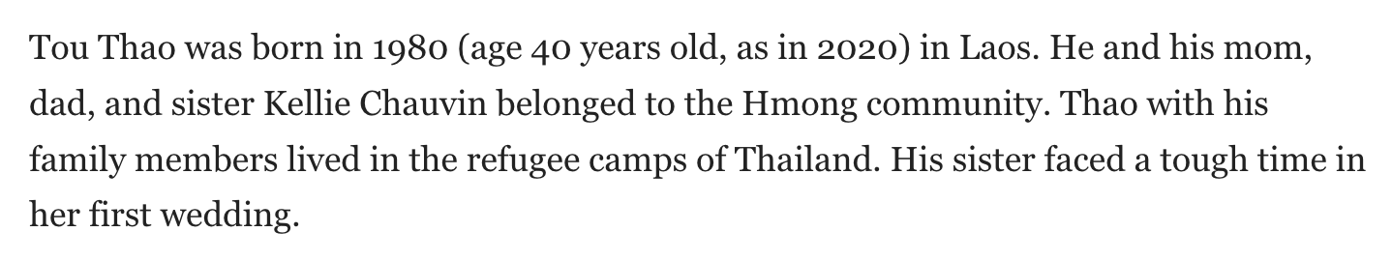

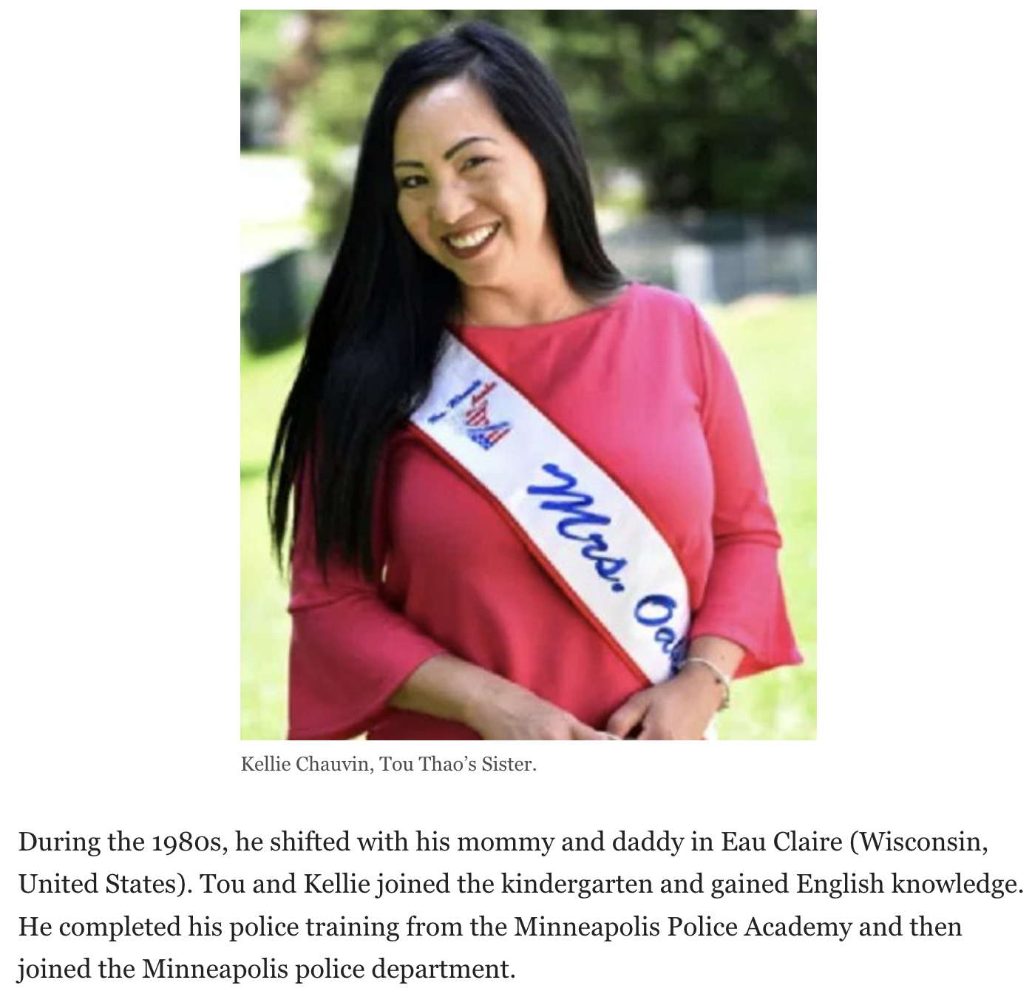

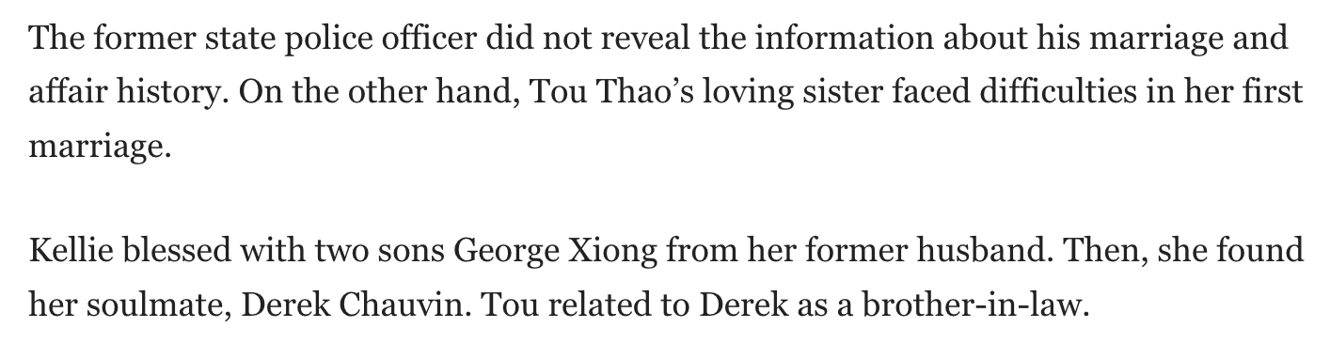

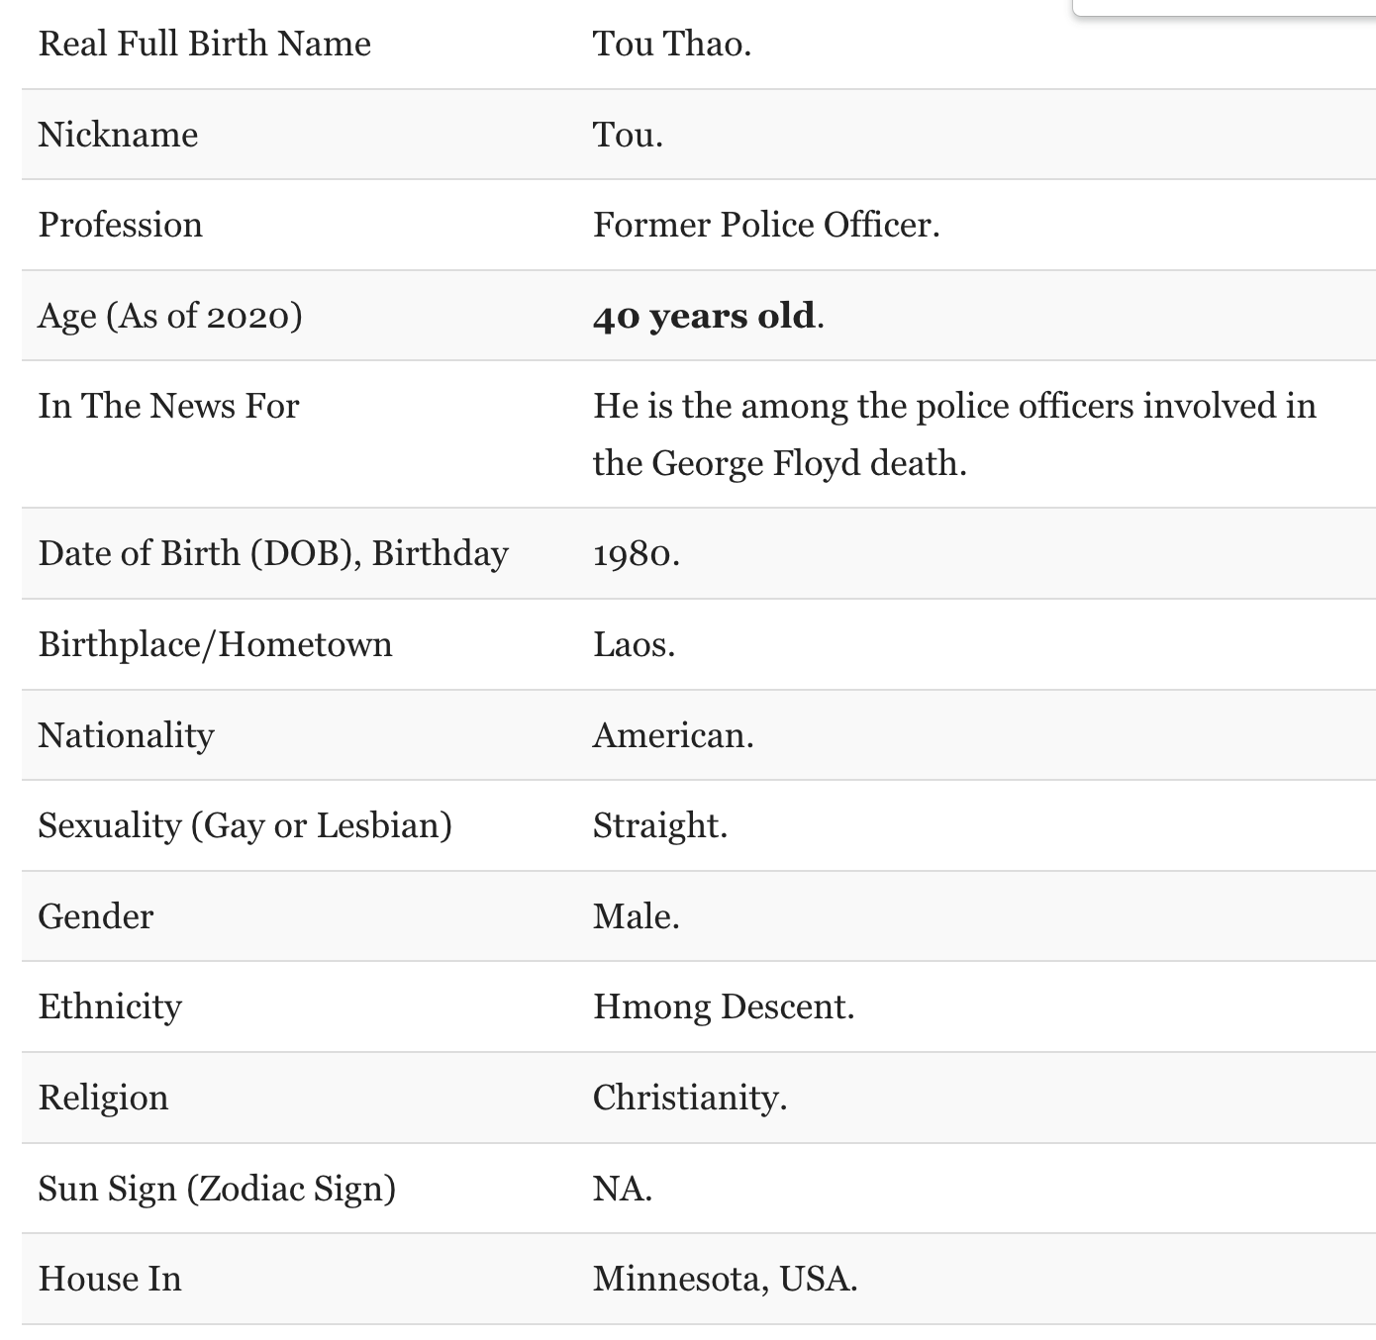

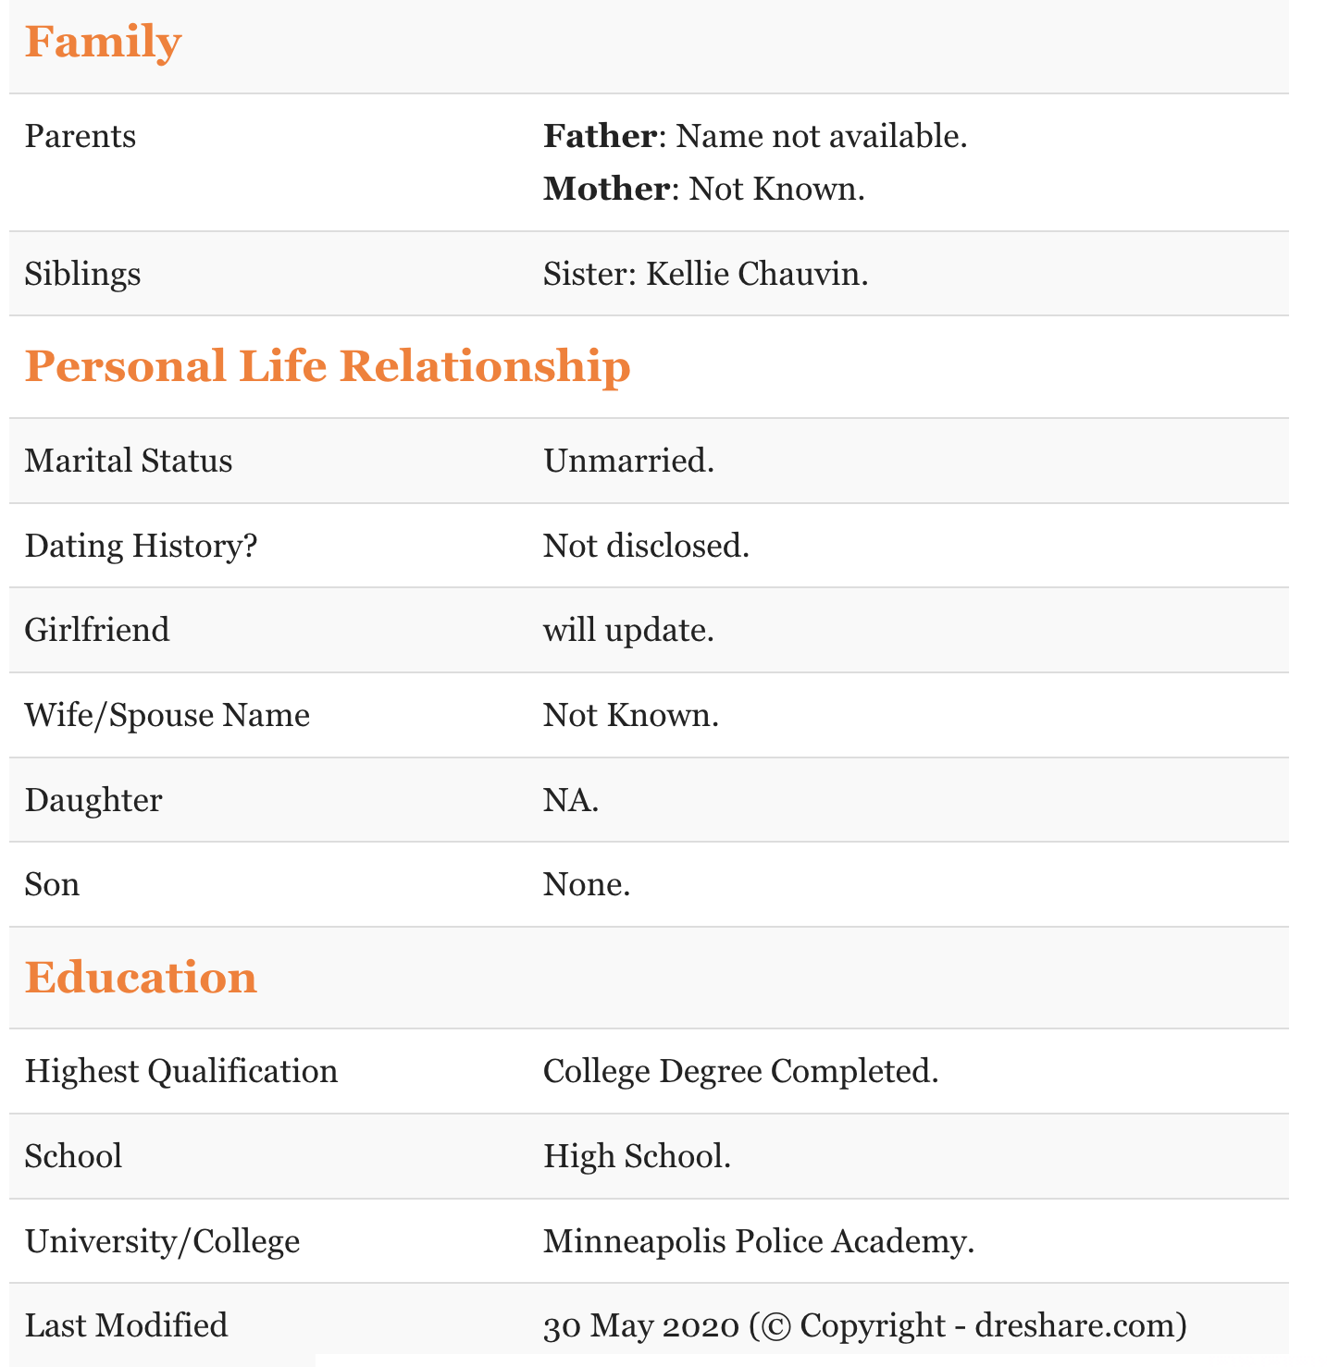

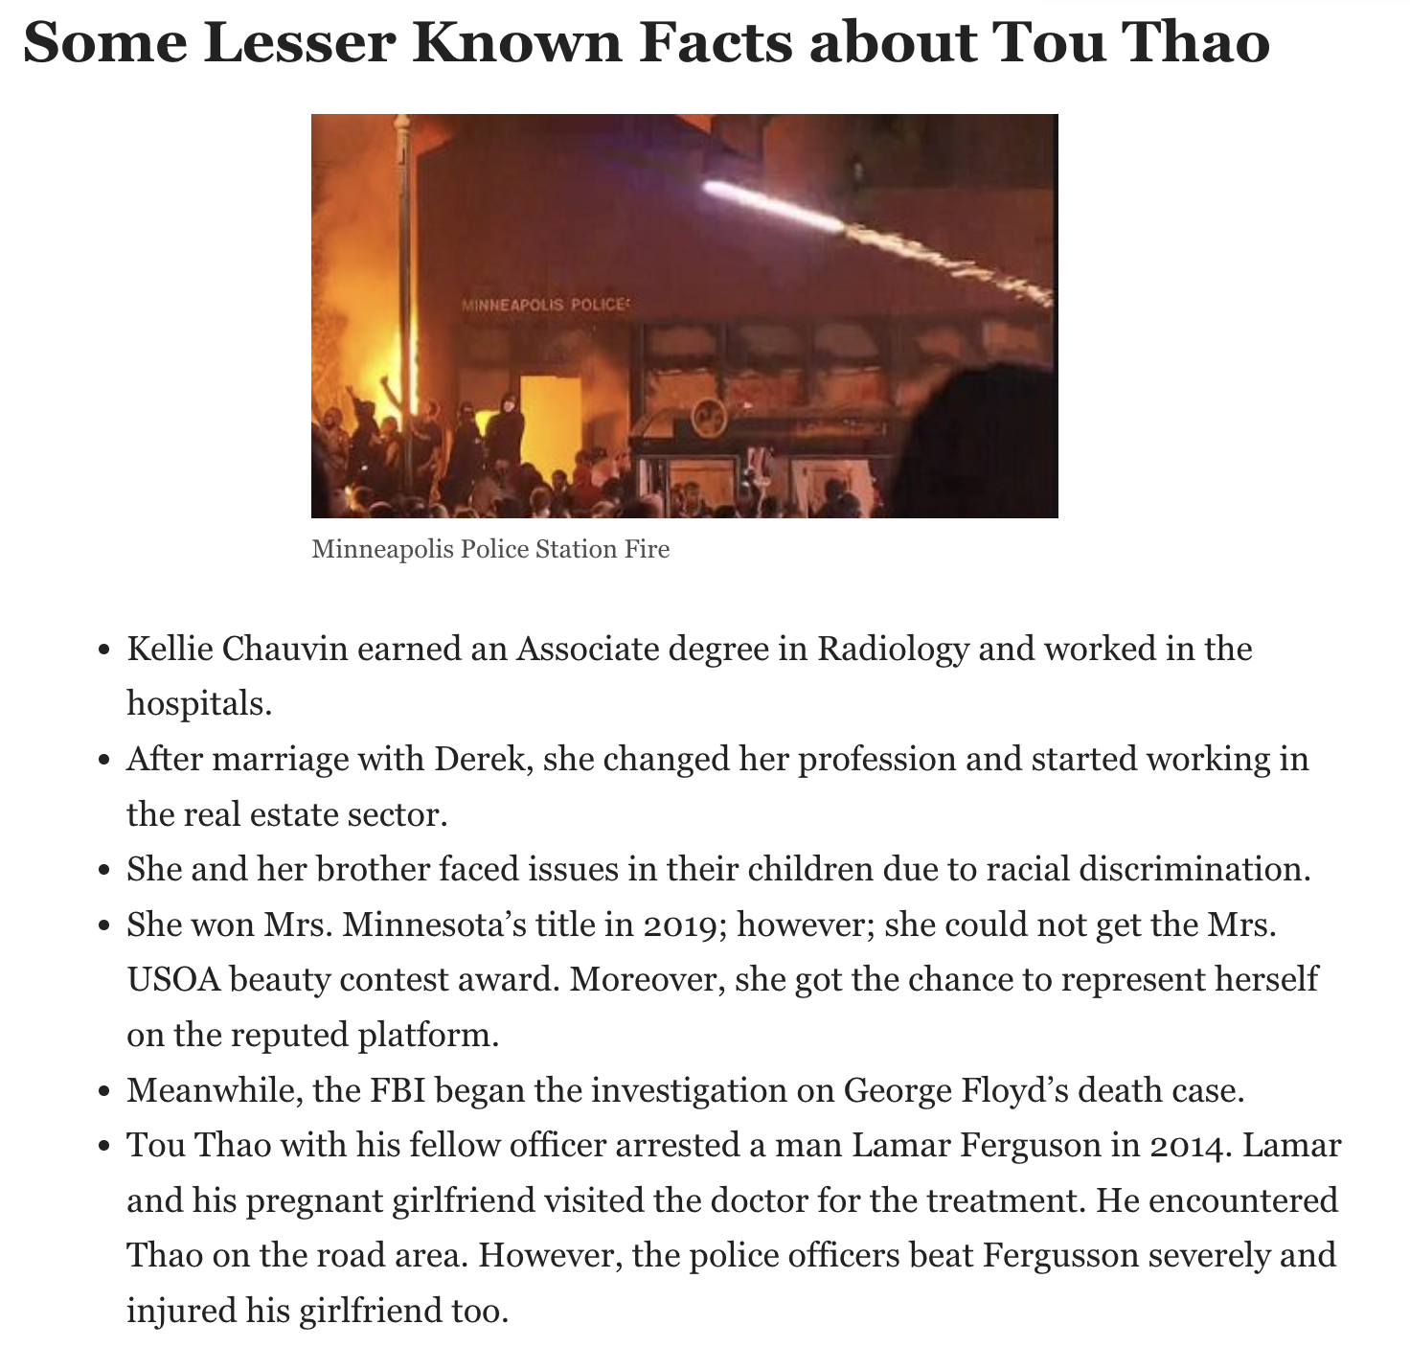

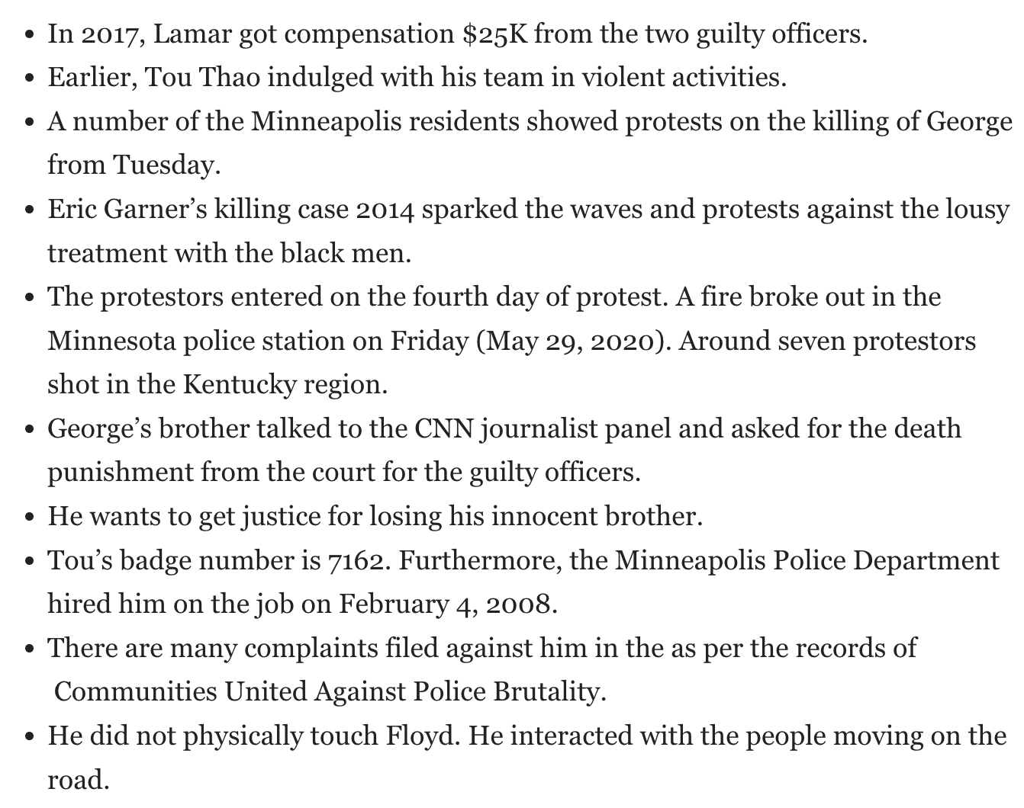

# 3 Former Officers Are Convicted of Violating George Floyd’s Civil Rights

Video

**00:00**

**1:05**

**1:05Jury Convicts Officers of Violating George Floyd’s Civil Rights**

Three former Minneapolis police officers were found guilty of federal crimes for failing to intervene as another officer killed George Floyd by pressing his knee on Mr. Floyd’s neck for more than nine minutes.CreditCredit...Tim Gruber for The New York Times

**By**[**Tim Arango**](https://www.nytimes.com/by/tim-arango)**,**[**Nicholas Bogel-Burroughs**](https://www.nytimes.com/by/nicholas-bogel-burroughs)**and Jay Senter**

* Published Feb. 24, 2022Updated Feb. 25, 2022, 12:27 a.m. ET

ST. PAUL, Minn. — Three former Minneapolis police officers were found guilty on Thursday of federal crimes for failing to intervene as another officer killed George Floyd by pressing his knee on his neck for more than nine minutes.

The case was an extraordinarily rare example of the Justice Department prosecuting officers for their inaction while another officer used excessive force. The verdicts signal to police departments across America that juries may become more willing to convict not just officers who kill people on the job, but also those who watch them do it.

A federal jury determined that the officers — Tou Thao, 36; J. Alexander Kueng, 28; and Thomas Lane, 38 — had willfully violated Mr. Floyd’s constitutional rights by not providing medical care when he lost a pulse and that two of them were also guilty of not intervening to stop a fellow officer, Derek Chauvin, from planting his knee on Mr. Floyd’s neck.

Mr. Kueng and Mr. Lane both helped Mr. Chauvin restrain Mr. Floyd while he was handcuffed facedown on the pavement. Mr. Thao stood nearby, keeping bystanders away. Mr. Chauvin was [convicted of murder](https://www.nytimes.com/2021/04/20/us/george-floyd-chauvin-verdict.html) last year and [sentenced to 22 and a half years](https://www.nytimes.com/2021/06/25/us/derek-chauvin-22-and-a-half-years-george-floyd.html)in prison.

ADVERTISEMENT

[Continue reading the main story](https://www.nytimes.com/2022/02/24/us/guilty-verdict-george-floyds-rights.html#after-story-ad-1)

The verdicts represented a significant victory for the Justice Department, which under the Biden administration has pledged to be more aggressive in prosecuting civil rights violations. It came days after federal prosecutors [secured hate crimes convictions](https://www.nytimes.com/2022/02/22/us/gregory-mcmichael-travis-mcmichael-william-bryan.html)against three white men in Georgia for [the murder of Ahmaud Arbery](https://www.nytimes.com/2021/11/24/us/ahmaud-arbery-murder-verdict.html), a Black man whom they chased and killed.

Judge Paul A. Magnuson said he would allow the three men to remain free on bond until their sentencing hearing, which has not yet been scheduled. Mr. Lane and his lawyer shook their heads as the judge read the guilty verdicts; the other two defendants had no visible reaction. All three men and their lawyers were escorted from the courtroom by a U.S. marshal.

Judge Magnuson has wide latitude to impose a penalty and could sentence the officers to any amount of prison time, including life. They still face state charges of aiding and abetting murder, with a trial scheduled for this year. Federal prosecutors had charged Mr. Chauvin along with the other three officers, but he reached a plea agreement with the Justice Department in December under which [prosecutors said they would seek a 25-year prison sentence](https://www.nytimes.com/2021/12/15/us/derek-chauvin-civil-rights-guilty-plea.html).

Mr. Floyd’s relatives hailed Thursday’s verdict.

“I’m starting to feel like I can breathe again,” said Philonise Floyd, a brother of George Floyd’s.

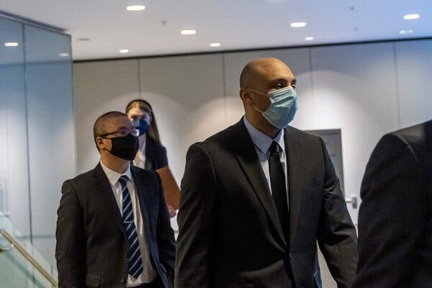

Image

The former Minneapolis police officers Tou Thao, left, and Alexander Kueng last month. Mr. Thao, Mr. Kueng and Thomas Lane were convicted of federal crimes.Credit...Kerem Yucel/Agence France-Presse — Getty Images

He and Brandon Williams, George Floyd’s nephew, said in the courthouse after the verdict that they hoped Judge Magnuson would sentence all three officers to the maximum possible prison term.

ADVERTISEMENT

[Continue reading the main story](https://www.nytimes.com/2022/02/24/us/guilty-verdict-george-floyds-rights.html#after-story-ad-2)

Legal experts and racial justice activists had been closely watching the case, saying it could have more ramifications for policing than even Mr. Chauvin’s murder convictions. At the heart of this case was a more widespread problem, experts say, than a single officer’s act of violence: the tendency of officers to stand by when they witness a fellow officer committing a crime.

The jurors’ decision, which came after about 13 hours of deliberations following a monthlong trial, suggested that they agreed with the prosecution’s arguments that the officers knew in the moment that Mr. Floyd was in severe medical distress and that Mr. Chauvin was breaking the law. The verdict was also a rejection of the argument cited in each of the three defense cases: that the officers trusted Mr. Chauvin, the senior officer on the scene, and therefore were not aware that what he was doing was illegal.

This case is believed to be the first time the federal government has charged police officers for failing to intervene against a more senior officer who was using excessive force, according to Christy E. Lopez, a professor at Georgetown University Law Center. She has worked with police departments on training officers about their constitutional duties to step in when they see colleagues breaking the law.

She said the guilty verdicts could significantly change law enforcement culture, compelling agencies to make sure that officers are properly trained and are upholding their duties.

“It forces you to move beyond the bad apple narrative,” Ms. Lopez said. She added, “Now you’re like, ‘Oh, everyone on the scene played a role in this.’ It shifts the entire narrative from misconduct being about just acts of commission to misconduct also being about acts of omission.”

Attorney General Merrick B. Garland said the verdict showed that the officers had violated the Constitution by not intervening.

ADVERTISEMENT

[Continue reading the main story](https://www.nytimes.com/2022/02/24/us/guilty-verdict-george-floyds-rights.html#after-story-ad-3)

“The Justice Department will continue to seek accountability for law enforcement officers whose actions, or failure to act, violate their constitutional duty to protect the civil rights of our citizens,” Mr. Garland said in a statement. “George Floyd should be alive today.”

During the trial, the defense lawyers tried to absolve the three officers, with Robert Paule, who represents Mr. Thao, telling the jury during his closing statement that “Just because something has a tragic ending does not mean it’s a crime.”

As Mr. Floyd was being killed, Mr. Thao, a veteran officer who was Mr. Chauvin’s partner, was keeping a crowd of bystanders at bay. Mr. Lane and Mr. Kueng, both rookies, were helping Mr. Chauvin detain Mr. Floyd after a convenience store clerk said he had used a fake $20 bill to buy cigarettes.

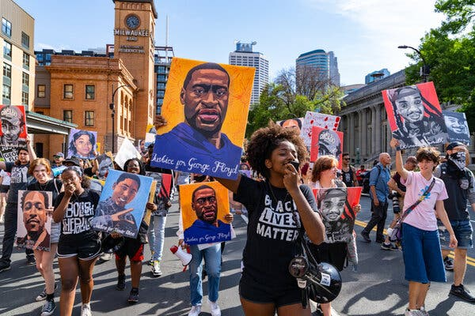

Image



Activists marched in Minneapolis last year after Derek Chauvin was sentenced for a murder conviction.Credit...Aaron Nesheim for The New York Times

All three officers, who along with Mr. Chauvin were fired a day after the killing, were charged with one count of failing to provide medical aid. Mr. Kueng and Mr. Thao were also charged with failing to intervene and stop Mr. Chauvin’s use of force; Mr. Lane, who twice asked Mr. Chauvin if they should roll Mr. Floyd on his side so he could more easily breathe, did not face that charge.

The 12 jurors who decided the case were drawn from across Minnesota because the trial was over federal crimes, and all 12 appeared to be white. That was in contrast to the more racially diverse juries, drawn from the Minneapolis area, that convicted Mr. Chauvin and [Kimberly Potter](https://www.nytimes.com/2021/12/23/us/manslaughter-kim-potter-verdict.html), the white officer in a Minneapolis suburb who shot and killed a Black man after mistakenly drawing her gun instead of her Taser during a traffic stop.

During this trial, prosecutors called to the witness stand doctors, police officers, bystanders and the paramedic who arrived on the scene and said he believed that Mr. Floyd was already dead. Prosecutors relied on the mountains of video evidence — from bystanders, from the officers’ body-worn cameras, from city surveillance cameras — that provided an excruciating second-by-second record of the killing.

ADVERTISEMENT

[Continue reading the main story](https://www.nytimes.com/2022/02/24/us/guilty-verdict-george-floyds-rights.html#after-story-ad-4)

One of the most important witnesses was Inspector Katie Blackwell, a Minneapolis police official who formerly was in charge of training. She testified for three days about the training that recruits receive on properly using force and on their constitutional duty to intervene when they see other officers using excessive force.

But the defense lawyers attacked Inspector Blackwell, arguing that the department failed in training officers to recognize when they have a duty to intervene, saying the discussion was perfunctory and “little more than a word on a PowerPoint.”

## Understand the Civil Rights Trial Over George Floyd's Death

Card 1 of 6

**Police culture on trial.**The federal civil rights trial that [found three former officers guilty](https://www.nytimes.com/live/2022/02/24/us/george-floyd-trial-verdict?action=click&pgtype=Article&state=default&module=styln-floyd-trial&variant=show&region=MAIN_CONTENT_3&block=storyline_levelup_swipe_recirc#guilty-verdict-george-floyds-rights) for their role in the [killing of George Floyd](https://www.nytimes.com/2020/05/31/us/george-floyd-investigation.html?action=click&pgtype=Article&state=default&module=styln-floyd-trial&variant=show&region=MAIN_CONTENT_3&block=storyline_levelup_swipe_recirc) centered on a crucial issue in American policing: the duty of officers to intervene against fellow officers when they witness misconduct.

**A new focus.**Ever since the murder of Mr. Floyd on May 25, 2020, the overwhelming focus has been on the officer who killed him, [Derek Chauvin](https://www.nytimes.com/2022/01/24/us/derek-chauvin-george-floyd-testify.html?action=click&pgtype=Article&state=default&module=styln-floyd-trial&variant=show&region=MAIN_CONTENT_3&block=storyline_levelup_swipe_recirc). While Mr. Chauvin was [convicted of murder](https://www.nytimes.com/2021/04/20/us/george-floyd-chauvin-verdict.html?action=click&pgtype=Article&state=default&module=styln-floyd-trial&variant=show&region=MAIN_CONTENT_3&block=storyline_levelup_swipe_recirc) in a state trial in April 2021, he wasn’t the only officer at the scene.

**The defendants.**[Three officers](https://www.nytimes.com/live/2022/01/24/us/police-officers-trial-george-floyd/who-are-officers-trial-george-floyd?action=click&pgtype=Article&state=default&module=styln-floyd-trial&variant=show&region=MAIN_CONTENT_3&block=storyline_levelup_swipe_recirc) were accused of willfully failing to intervene against Mr. Chauvin and help Mr. Floyd. Tou Thao, a veteran officer who was Mr. Chauvin’s partner, held back a group of bystanders. J. Alexander Kueng and Thomas Lane, both rookies, helped pin down Mr. Floyd.

**The charges.**The case centered around whether the defendants [deprived Mr. Floyd of his civil rights](https://www.nytimes.com/live/2022/01/24/us/police-officers-trial-george-floyd/heres-how-to-understand-the-federal-charges-in-the-trial-over-george-floyds-death?action=click&pgtype=Article&state=default&module=styln-floyd-trial&variant=show&region=MAIN_CONTENT_3&block=storyline_levelup_swipe_recirc). All three officers were charged with failing to provide medical aid to Mr. Floyd, while Mr. Kueng and Mr. Thao also faced a count of failing to intervene against Mr. Chauvin’s use of force.

**The verdict.**Prosecutors argued that the officers knew in the moment that Mr. Floyd was in severe medical distress and that Mr. Chauvin was breaking the law. On Feb. 24, 2022, [a jury found the former officers guilty](https://www.nytimes.com/live/2022/02/24/us/george-floyd-trial-verdict/guilty-verdict-george-floyds-rights?action=click&pgtype=Article&state=default&module=styln-floyd-trial&variant=show&region=MAIN_CONTENT_3&block=storyline_levelup_swipe_recirc). The three men still face a separate trial on state charges.

**The ramifications.**The verdict could have a [greater effect on policing than even Mr. Chauvin’s conviction](https://www.nytimes.com/2022/01/24/us/police-officers-culture-george-floyd.html?action=click&pgtype=Article&state=default&module=styln-floyd-trial&variant=show&region=MAIN_CONTENT_3&block=storyline_levelup_swipe_recirc), experts and activists say, because the case is about a far more common aspect of police culture: the tendency of officers to stand by when they witness a fellow officer committing a crime.

While cross-examining her, Thomas Plunkett, the lawyer for Mr. Kueng, played the audio of a fiery speech Al Pacino gave while playing a football coach in the movie “Any Given Sunday,” a clip that was played for recruits at the police academy. Mr. Plunkett said his point was that the department promoted a “cops versus the world” mentality.

The defense also tried to focus the jury’s attention on the hierarchical and paramilitary aspects of police culture — how recruits are taught to obey superiors and carry out orders without question.

Unlike Mr. Chauvin, who did not testify at his trial, each of the three officers took the stand in his own defense. They all said that they believed that Mr. Chauvin, as the senior officer, was in charge and knew what he was doing, and that they did not recognize that Mr. Floyd was in the throes of a medical emergency.

“I think I would trust a 19-year veteran to figure it out,” Mr. Thao said. Mr. Kueng, who had Mr. Chauvin as one of his field training officers, said, “He was my senior officer, and I trusted his advice.”

To simplify things for the jury, the prosecutors often used the phrase “in your custody, in your care” to describe the duty that officers have to protect a detained suspect. In Mr. Chauvin’s trial last year, prosecutors similarly condensed their case for the jurors to the slogan “believe your eyes,” arguing it was as simple as what they had seen in the harrowing bystander video.

ADVERTISEMENT

[Continue reading the main story](https://www.nytimes.com/2022/02/24/us/guilty-verdict-george-floyds-rights.html#after-story-ad-5)

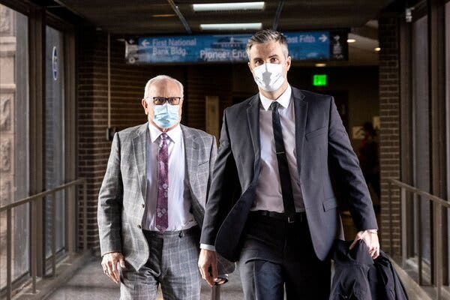

Image



Mr. Lane, right, wasn’t charged with failing to stop Mr. Chauvin’s use of force. Mr. Lane asked if they should roll Mr. Floyd on his side so he could more easily breathe.Credit...Kerem Yucel/Agence France-Presse — Getty Images

That video emerged from a group of ordinary citizens, young and old, who by circumstance found themselves witnessing a murder outside a convenience store in South Minneapolis almost two years ago.

Among them was Darnella Frazier, a teenager who was buying snacks with her young cousin and took out her cellphone to film the officers struggling on the ground with Mr. Floyd. Her video was the one that went viral, ricocheting around the world and drawing millions to the streets to protest police brutality and racial injustice.

George Perry Floyd, 46, was a Black security guard and onetime rapper who had lost his job in the coronavirus pandemic. Mr. Chauvin and Mr. Lane are white, [Mr. Thao is Asian American](https://www.nytimes.com/2020/06/01/us/hmong-americans-minneapolis-george-floyd.html) and [Mr. Kueng is Black](https://www.nytimes.com/2020/06/27/us/minneapolis-police-officer-kueng.html).

Throughout the trial, defense lawyers argued that members of the crowd, who over and over told the officers that they were killing Mr. Floyd and that he was struggling to breathe, were distracting to the officers, and possibly threatening.

But prosecutors tried to portray the actions of the onlookers as a powerful counterpoint to what the officers were doing — arguing that if a small crowd of average citizens could see clearly that Mr. Floyd was facing a dire medical emergency, then three well-trained police officers surely should have.

“You just need plain old common sense,” Manda Sertich, a prosecutor, told the jury in her closing argument. “And you just need plain old human decency.”

ADVERTISEMENT

[Continue reading the main story](https://www.nytimes.com/2022/02/24/us/guilty-verdict-george-floyds-rights.html#after-story-ad-6)

The trial and its outcome were yet another milestone in nearly two years of upheaval and trauma for the Twin Cities area, with a seemingly endless number of overlapping crises centered on the combustible issues of police brutality and racial injustice.

Ms. Potter’s fatal shooting of Daunte Wright, a 20-year-old man driving to get his car washed, took place as Mr. Chauvin was on trial last April. During this month’s trial, a Minneapolis officer [fatally shot and killed Amir Locke](https://www.nytimes.com/2022/02/03/us/amir-locke-minneapolis-police-shooting.html), a Black man, as the police carried out a no-knock raid. The killing plunged the city further into turmoil, with more protests and calls for the mayor to resign.

During the four weeks of the trial, family members of Mr. Floyd and his girlfriend, Courteney Ross, who testified at Mr. Chauvin’s trial, were frequently seen in the court’s gallery.

The trial of Mr. Kueng, Mr. Lane and Mr. Thao on state charges of aiding and abetting murder is scheduled for June. During their federal trial this week, state prosecutors who secured Mr. Chauvin’s conviction and are in charge of the state case against the other three officers, were spotted in the audience, taking notes.

# Former Minneapolis officers found guilty of violating George Floyd’s civil rights

**Listen to article**

13 min

**Error! Filename not specified.**

FILE - This image from video shows Minneapolis Police Officers Thomas Lane, left and J. Alexander Kueng, right, escorting George Floyd, center, to a police vehicle outside Cup Foods in Minneapolis, on May 25, 2020. (AP)

By [Holly Bailey](https://www.washingtonpost.com/people/holly-bailey/)

Today at 5:13 p.m. EST|Updated February 25, 2022 at 8:04 p.m. EST

ST. PAUL, Minn. — Three former Minneapolis police officers who were at the scene with Derek Chauvin as he pressed his knee into George Floyd’s neck were convicted Thursday of violating Floyd’s civil rights in a case that is likely to increase scrutiny over how officers are trained to intervene with rogue colleagues.

[Prosecutors](https://www.washingtonpost.com/nation/2022/02/22/george-floyd-federal-trial-closing/?itid=lk_inline_manual_4)had argued that former officers J. Alexander Kueng, Thomas K. Lane and Tou Thao knew Floyd was in medical danger beneath Chauvin’s knee but put their “discomfort in questioning a colleague” above their sworn duty to save a life.

After a month-long trial that cast a harsh light on police training and practices in Minneapolis, a jury found Kueng, Lane and Thao guilty of violating Floyd’s civil rights by failing to provide him medical aid. Kueng and Thao were also found guilty of failing to intervene with Chauvin. The jury found that the actions of all three men caused Floyd’s death.

U.S. District Judge Paul A. Magnuson, who presided over the case, did not order the officers to be taken into custody, citing a separate trial scheduled for June on state charges of aiding and abetting murder and manslaughter in Floyd’s death. Magnuson said he would announce sentencing in the civil rights case at a later date.

The courtroom was silent as Magnuson read the verdicts for each former officer. A limited number of friends and family of the former officers had sat in the socially distanced courtroom during the proceedings, but on Wednesday, just one woman sat behind the defense tables. Thao and Kueng showed no visible reaction as they were found guilty. Lane shook his head and appeared to toss something on the table in reaction to the decision, causing a noise that echoed across the courtroom.

At least one of the female jurors appeared to be crying as the verdicts were read.

In a statement, civil rights attorney Ben Crump and other members of the legal team representing the Floyd family called the decision “another important chapter in our journey for justice” for Floyd.

“These officers tried to devise any excuse that could let them wash the blood from their hands, but following these verdicts, George’s blood will forever stain them,” Crump said. “Today’s guilty verdicts should serve as the guiding example of why police departments across America should expand and prioritize instruction on an officer’s duty to intervene and recognize when a fellow officer is using excessive force.”

Floyd’s brother, Philonise, spoke to reporters afterward, his eyes wet with tears. “I feel like I can breathe again,” he said. But he added: "This is just accountability. It can never mean justice because I can never get George back.”

The former officers, each of whom took the stand in his own defense, [said they were deferring to Chauvin](https://www.washingtonpost.com/nation/2022/02/22/george-floyd-federal-trial/?itid=lk_inline_manual_19), the senior officer at the scene, unsure whether he was using unreasonable force and saying they relied on his experience to guide what they said was a chaotic scene. They also pointed a finger at the Minneapolis Police Department, claiming inadequate and confusing training and questioning why Chauvin was allowed to train young officers such as Kueng.

But acting U.S. attorney Charles Kovats called the jury’s decision “a reminder that all sworn law enforcement, regardless of rank or seniority … have a duty to intervene.”

“It’s a fundamental duty of policing … a duty followed every day by police officers in communities around the United States, often under very difficult circumstances,” Kovats said at a news conference after the verdicts. “Officers Thao, Kueng and Lane on that day failed to fulfill this duty, and as a result, George Floyd senselessly died. That is why they were charged. That is why they were convicted.”

[*Injustice in life and oppression in death: How systemic racism shaped George Floyd’s life and hobbled his ambition*](https://www.washingtonpost.com/graphics/2020/national/george-floyd-america/systemic-racism/?itid=lk_interstitial_manual_22)

The jury of eight women and four men — who appeared to be mostly White — deliberated for 13 hours beginning Wednesday. Unlike in Chauvin’s state murder trial last year, the federal jury included people from across the state of Minnesota, not just Hennepin County, where Floyd was killed — which had prompted some observers to question whether jurors might be more sympathetic toward the former officers.

The jury’s decision came after about [six hours of closing arguments](https://www.washingtonpost.com/nation/2022/02/22/george-floyd-federal-trial-closing/?itid=lk_inline_manual_26)Tuesday in which prosecutors and defense attorneys presented their dueling views of a case that was far more complex than the trial mounted last year against Chauvin, who was convicted of state charges of murder and manslaughter and sentenced to 22½ years in prison.

Kueng, Lane and Thao were charged with what prosecutors say they didn’t do at the scene of Floyd’s fatal arrest — including getting Chauvin off the man, putting Floyd into a side recovery position to help him breathe and performing CPR when Floyd lost a pulse.

“These defendants knew what was happening, and contrary to their training, contrary to common sense, contrary to basic human decency, they did nothing to stop Derek Chauvin, did nothing to help George Floyd. You know it because you’ve seen it,” prosecutor Manda Sertich told jurors during closing arguments, pointing to the numerous videos of the fatal May 2020 arrest that had been introduced into evidence.

**Error! Filename not specified.**

From left, former Minneapolis police officers J. Alexander Kueng, Thomas Lane and Tou Thao. (Hennepin County Sheriff's Office)

But defense attorneys [argued that the videos didn’t offer a complete picture](https://www.washingtonpost.com/nation/2022/02/22/george-floyd-federal-trial/?itid=lk_inline_manual_9&itid=lk_inline_manual_30) of what happened at the scene, including what the officers were seeing and experiencing in the moment, such as their perceptions of Floyd’s condition. [They blamed poor training](https://www.washingtonpost.com/nation/2022/02/22/george-floyd-federal-trial/?itid=lk_inline_manual_9&itid=lk_inline_manual_30) and shifted responsibility for the man’s death to Chauvin, saying their clients had trusted and deferred to him.

Thomas Plunkett, an attorney for Kueng who spent much of his defense case [attacking policies and practices](https://www.washingtonpost.com/nation/2022/02/22/george-floyd-federal-trial/?itid=lk_inline_manual_17&itid=lk_inline_manual_33) of the Minneapolis Police Department, pressed the jury to consider the “inadequate training” his client had received, including on the duty to intervene. He also pointed to Kueng’s “lack of experience” and his “perceived subordinate role to Chauvin.” Kueng had “confidence” that he was doing the right thing as they held Floyd on the ground, Plunkett said.

“I am not saying he wasn’t trained,” Plunkett told the jury. “I am saying the training was inadequate to see and understand what was happening there.”

Kueng and Lane had been full-time officers for less than a week when they encountered Floyd as they responded to a 911 call about a counterfeit $20 bill that had been passed at Cup Foods, a local market. [Body-camera video](https://www.washingtonpost.com/graphics/2020/national/floyd-bodycam-video/?hpid=hp_hp-banner-low_floydvideo-650a%3Ahomepage%2Fstory-ans&itid=hp_hp-banner-low_floydvideo-650a%3Ahomepage%2Fstory-ans&itid=lk_interstitial_manual_8&itid=lk_inline_manual_47&itid=lk_inline_manual_35) from the scene showed Lane pull a gun on Floyd within 15 seconds of encountering the man in a parked car, without announcing who he was or what he was investigating.

Chauvin arrived on the scene a few minutes later with Thao as Lane and Kueng struggled to place Floyd, who was handcuffed, inside a squad car. Body-camera video shows Floyd complaining of claustrophobia and ultimately being placed facedown on a city street, with Chauvin pressing his knees into Floyd’s neck and upper back, Kueng at Floyd’s back and Lane holding the man’s legs. Thao stood a few feet away, pushing back bystanders who increasingly pressed the officers to get off Floyd as he began to lose consciousness.

Video shows Floyd complained at least 25 times of not being able to breathe — cries the officers dismissed even as the man went limp. During the trial, Thao and Kueng told the jurors they disregarded Floyd’s complaints about breathing because people often claimed “I can’t breathe” to avoid being arrested.

Lane recalled for the jury how he[twice asked Chauvin](https://www.washingtonpost.com/nation/2022/02/21/defense-rests-after-testimony-former-minneapolis-officer-who-tried-get-derek-chauvin-reposition-floyd/?itid=lk_inline_manual_40)whether they should reposition Floyd — requests that his lawyer says prove that he tried to intervene with a senior officer but was rebuffed. Prosecutors repeatedly argued that Lane [did not follow those requests](https://www.washingtonpost.com/nation/2022/02/21/defense-rests-after-testimony-former-minneapolis-officer-who-tried-get-derek-chauvin-reposition-floyd/?itid=lk_inline_manual_24&itid=lk_inline_manual_40) with action that would have saved Floyd’s life — including actually asking Chauvin to get off Floyd or physically removing him so they could get Floyd onto his side to improve his breathing or perform CPR.

But Lane’s attorney, Earl Gray, in a fiery closing argument, repeatedly suggested it was unrealistic to think that two young officers like Lane and Kueng could have done anything to stop Chauvin. He pointed to body-camera video that he said showed Chauvin step in front of his client to gain control of Floyd as they struggled to place the man inside a squad car.

Gray suggested Chauvin, 46, was trying to put the rookies in their place, to “show these guys” that he was “the boss.” “He was going to be the leader of the pack with these two kids,” Gray said of Kueng, 28, and Lane, 38. “He was going to take charge.”

**Error! Filename not specified.**

In a courtroom sketch, from left, former Minneapolis police officer Tou Thao, attorney Robert Paule, attorney Natalie Paule, attorney Tom Plunkett, former Minneapolis police officer J. Alexander Kueng, former MPD Officer Thomas Lane and attorney Earl Gray appear for opening statements for the ex-officers' trial in the killing of George Floyd in federal court in St. Paul, Minn., on Jan. 24, 2022. (Cedric Hohnstadt/AP)

In his testimony, Kueng [recalled](https://www.washingtonpost.com/nation/2022/02/16/j-alexander-kueng-george-floyd/?itid=lk_inline_manual_46) twice telling Chauvin that he couldn’t detect Floyd’s pulse and said he assumed Chauvin would check the pulse on Floyd’s neck — which he had been trained to know was more reliable — but the senior officer didn’t check and kept his position. He said he didn’t know whether Chauvin was violating policy by kneeling on Floyd’s neck because he’d never been trained on the maneuver.

But prosecutors tried to cast doubt on Kueng’s claims that he wasn’t sure the scene was safe enough to reposition Floyd or render medical aid — pointing to the fact that [video](https://www.washingtonpost.com/video/national/officer-thaos-body-camera-footage-from-george-floyds-arrest/2020/08/13/6899c11a-1e1b-4841-88a1-da26d43ab69c_video.html?itid=lk_inline_manual_49) showed he had laughed at Chauvin telling Floyd that it takes “a heck of a lot oxygen to keep talking” as the man repeatedly told the officers he couldn’t breathe.

Kueng said it was a “brief moment of levity” and insisted he detected no “serious medical condition” with Floyd even as he acknowledged he later couldn’t find the man’s pulse.

Thao, who held back bystanders as they urged the officers to check Floyd’s pulse and “get off” the man, acknowledged under prosecution questioning that [he heard the concerns voiced by the onlookers](https://www.washingtonpost.com/nation/2022/01/28/officers-charged-george-floyds-killing-had-been-taught-intervene-police-trainer-testifies/?itid=lk_inline_manual_30&itid=lk_inline_manual_51)about Floyd’s health but said he did not say anything to Chauvin or the other officers.

“I think I would trust a 19-year veteran to figure it out,” Thao said, referring to Chauvin, who was his partner that day.

Thao [repeatedly told the jury](https://www.washingtonpost.com/nation/2022/02/15/george-floyd-trial-tou-thao/?itid=lk_inline_manual_53) that he never physically touched Floyd and played a “different role” at the scene. He said he relied on the officers who were restraining Floyd to monitor the man’s condition and believed that, because they weren’t performing CPR, Floyd was “fine.”

Echoing Kueng’s claim, Thao said he wasn’t sure whether Chauvin was violating policy when he pressed his knee into Floyd’s neck. His attorney Robert Paule introduced into evidence photos [that had been given to Thao](https://www.washingtonpost.com/nation/2022/02/22/george-floyd-federal-trial/?itid=lk_inline_manual_54) as a memento from his time in the police academy showing officers pressing their knees into a person’s neck during training — part of the overall defense strategy questioning policing practices in Minneapolis.

A federal grand jury indicted Chauvin, Kueng, Lane and Thao in May 2021 on charges that they violated Floyd’s constitutional rights during the fatal arrest. Kueng and Thao were charged with violating Floyd’s right to be free from unreasonable seizure by not intervening as Chauvin knelt on Floyd’s neck. All four officers were charged with failing to render medical aid to Floyd. Kueng, Lane and Thao each [pleaded not guilty](https://www.washingtonpost.com/nation/2021/09/14/former-minneapolis-police-officers-charged-with-violating-george-floyds-civil-rights-plead-not-guilty/?itid=lk_inline_manual_15&itid=lk_inline_manual_27&itid=lk_inline_manual_36&itid=lk_inline_manual_24&itid=lk_inline_manual_43&itid=lk_inline_manual_26&itid=lk_inline_manual_55).

Chauvinpleaded guilty in December to the federal charges and is awaiting sentencing. Many wondered if Chauvin would be called to testify against his former colleagues — a scenario that prosecutors seemed to prepare for, judging by language in Chauvin’s plea agreement.

In that agreement, signed by the former officer, Chauvin admitted he heard Kueng tell him that Floyd no longer had a pulse. Chauvin also said he heard Lane ask him whether Floyd “should be rolled onto his side.” But Chauvin also said he “did not observe” Kueng, Lane or Thao “do or say anything” to get him to lift his knee from Floyd’s neck.

Prosecutors [began presenting](https://www.washingtonpost.com/nation/2022/01/24/opening-statements-begin-federal-trial-over-george-floyds-killing/?itid=lk_inline_manual_26&itid=lk_inline_manual_58) their case Jan. 24 with a litany of video that captured the deadly police encounter with Floyd, including footage filmed by eyewitnesses. They called 21 witnesses over 13 days, including an off-duty firefighter who tried to get the officers to check Floyd’s pulse; other law enforcement officers; and medical experts.

Each of three officers mounted an individual defense, and Magnuson, who oversaw the proceedings, limited prosecutors from asking the former officers questions that would lead them to render judgment on their fellow defendants — though he allowed questioning about what the officers observed.

The defense teams called a combined 11 witnesses over five days — including all three former officers and a use-of-force expert who testified that the MPD’s duty to intervene policy was “overly simplistic” and did not adequately prepare officers to challenge veterans over excessive force or other wrongdoing.

But that expert, Steve Ijames, a former assistant police chief in Springfield, Mo., also testified that Chauvin should have stopped using force when Floyd was no longer resisting and affirmed that one of the other officers could have repositioned Floyd so he could breathe.

In their closing argument, prosecutors pointed out that all three former officers agreed they were aware of policies requiring them to intervene if they see another officer using unreasonable force; that force should stop when someone in their custody is no longer resisting; and that medical intervention should start immediately when they can’t detect a pulse.

They repeatedly emphasized that being a rookie officer or an officer with less experience was no excuse.

Federal civil rights violations that result in death are punishable by up to life in prison or even the death penalty, but those sentences are rare. Legal experts said the former officers probably would receive a less severe sentence. Prosecutors declined to comment Thursday on what their sentencing recommendation will be to Magnuson, who ultimately has discretion on the former officers’ punishment.

In December, prosecutors recommended that Chauvin serve 300 months — 25 years — in federal prison, though Magnuson has yet to sign off on that deal. Experts believe the sentences for Kueng, Lane and Thao will be less.

After the verdict, more than a dozen members of the prosecution team gathered in the lobby of the federal courthouse to speak to the reporters. Many were visibly emotional. Assistant U.S. Attorney LeeAnn Bell, one of the lead prosecutors, thanked the bystanders who testified in the case, as well as members of Floyd’s family.

“George Floyd was a human being,” Bell said. “He deserved to be treated as such. … My hope, and the hope of our team, is that today’s verdict will bring a measure of justice.”

**[Me, my self, and the multitude: Microbiopolitics of the human microbiome](https://journals.sagepub.com/doi/full/10.1177/1368431018811330)**

**Penelope Ironstone**

First Published December 2, 2018; pp. 325–341

[Abstract](https://journals.sagepub.com/doi/abs/10.1177/1368431018811330)

Hide Preview

The human microbiome has become one of the dominant biomedical frameworks of the contemporary moment that may be understood to be post-Pasteurian. The recognitions the human microbiome opens up for thinking about the biological self and the individual have ontological and epistemological ramifications for considering what and who the human being is. As this article illustrates, the microbiopolitics of the human microbiome challenges the immunitarian Pasteurian model in which the organismic self shores itself up and defends itself against a microbial non-self or other. Instead, this theory presents the human organism as comprised of multiple ecosystems and as a multitude, suggesting that the thanatopolitical attempts to wipe out microbial others (evident in the overuse and misuse of antibiotics, for example) are giving way to an affirmative microbiopolitics grounded in generative multispecies relationality. This article sets out to make the case for this affirmative microbiopolitics.

Bottom of Form

(^cite this in critique of assimilation)

### [Esposito’s affirmative biopolitics in multispecies homes](https://journals.sagepub.com/doi/full/10.1177/1368431018804156)

**Heather Lynch[](https://orcid.org/0000-0002-5898-5397)**

First Published May 27, 2019; pp. 364–381

[Abstract](https://journals.sagepub.com/doi/abs/10.1177/1368431018804156)

Hide Preview

Drawing on Roberto Esposito’s conceptualization of ‘affirmative biopolitics’, this article examines the relationship between bedbugs and humans in the Glasgow neighbourhood of Govanhill. Through an analysis of ethnographic field notes and interviews with people who live in the area, this article traces their experiences from first encounters. The trajectory of this experience shows a shift from a desire to immunize their homes through total annihilation of the creatures to the more pragmatic position of learning how to live with them through an orientation toward ‘shared vulnerability’. This case study raises interesting questions for biopolitical theory: how can we conceive of affirmative biopolitics when the limitations of species being are evident, and is it possible to conceive of a multi or even interspecies munus or obligation?

(^cite this)

Also cite works about antibiotic resistance in CA

# In the federal case over George Floyd’s killing, former officers put the Minneapolis police on trial

**Listen to article**

13 min

**Error! Filename not specified.**

In this courtroom sketch, former Minneapolis police officer Tou Thao testifies during his trial in the killing of George Floyd in federal court in St. Paul, Minn., on Feb. 15, 2022. (Cedric Hohnstadt/AP)

By [Holly Bailey](https://www.washingtonpost.com/people/holly-bailey/)

 and

[Mark Berman](https://www.washingtonpost.com/people/mark-berman/)

Yesterday at 10:00 a.m. EST

ST. PAUL, Minn. — When [Tou Thao took the stand](https://www.washingtonpost.com/nation/2022/02/15/george-floyd-trial-tou-thao/?itid=lk_inline_manual_2) in his own defense [in the ongoing federal civil rights trial](https://www.washingtonpost.com/nation/2022/01/20/what-know-about-federal-trial-three-former-minneapolis-police-officers-charged-george-floyds-death/?itid=lk_inline_manual_2) over George Floyd’s death, the former Minneapolis police officer told a jury he wasn’t sure whether Derek Chauvin was violating policy by pressing a knee into Floyd’s neck.

Thao said that, although he had never used such a maneuver, what Chauvin was doing looked like something he had repeatedly seen demonstrated at the police academy, contrary to testimony from Minneapolis officers [who said that kind of restraint wasn’t taught](https://www.washingtonpost.com/nation/2022/01/28/officers-charged-george-floyds-killing-had-been-taught-intervene-police-trainer-testifies/?itid=lk_inline_manual_4) or sanctioned. And Thao had the photos to prove it, courtesy a disc of images he said had been given to him and other cadets by the Minneapolis Police Department to “have some memories of our academy days.”

Those “memories,” introduced as evidence, included several images of Minneapolis trainees practicing arrest techniques by pressing their knees into a prone subject’s neck, not unlike how Chauvin restrained Floyd. In at least one of the pictures shown to the jury, an instructor was seen standing to the side, not intervening, as Thao claimed instructors would when they observed cadets doing something wrong.

“Where’s the knee?” Robert Paule, Thao’s attorney, asked.

“On the neck,” Thao replied.

As the federal trial over Floyd’s killing [winds down](https://www.washingtonpost.com/nation/2022/02/21/defense-rests-after-testimony-former-minneapolis-officer-who-tried-get-derek-chauvin-reposition-floyd/?itid=lk_inline_manual_10), Thao and the other two former officers accused of violating Floyd’s civil rights — J. Alexander Kueng and Thomas K. Lane — have not sought just to place responsibility on Chauvin; they have set out also to cast blame on the MPD, arguing that the department’s training and culture shaped their actions at the scene on May 25, 2020.

In addition to testing the question of what responsibility other police officers have to rein in the behavior of colleagues, the unusually aggressive defense strategy has cast a spotlight on the controversial tactics of a department already facing state and federal scrutiny, public criticism and withering morale among its officers.

[*What to know about the federal trial of the three former Minneapolis police officers charged in George Floyd’s death*](https://www.washingtonpost.com/nation/2022/01/20/what-know-about-federal-trial-three-former-minneapolis-police-officers-charged-george-floyds-death/?itid=lk_interstitial_manual_15)

The former officers and their attorneys have criticized the training given to Minneapolis police recruits, painting it as conflicting and troubling — and, in the case of a duty to intervene, [woefully inadequate](https://www.washingtonpost.com/nation/2022/02/15/george-floyd-trial-tou-thao/?itid=lk_inline_manual_16). Lawyers for Kueng and Lane have argued that Chauvin, who had 19 years’ service and was Kueng’s field training officer, was in command of the scene, and the attorneys have asked why an officer with a history of complaints against him was in such a position.

Lawyers for all three officers have called attention to the ongoing state and federal investigations into the MPD’s training and culture. They have pointed to a “cops versus the world” mentality within the department that they say strongly discourages other officers from challenging their colleagues, if the officers even recognize that what is happening is wrong.

Kueng told a jury last week that he did not recognize the neck restraint that Chauvin was using, because he had not explicitly been trained in such a technique and could not perceive how much pressure Chauvin was applying. His attorney, Thomas Plunkett, pointed to language in the MPD policy manual that said officers who had been trained to use a neck restraint had “authorization” to use it.

“Not knowing” what exactly was allowed or who was allowed to use it, Kueng claimed, led him to believe that Chauvin was adhering to policy as he pressed his knees into Floyd’s neck and upper back for 9½ minutes, even as the man went limp and lost a pulse. When Chauvin rejected Lane’s suggestion to “roll” the man into a different position, Kueng said he simply followed Chauvin’s lead.

“He was my senior officer, and I trusted his advice,” Kueng said, repeatedly telling the jury that he had [been trained to defer to veteran officers such as Chauvin](https://www.washingtonpost.com/nation/2022/02/16/j-alexander-kueng-george-floyd/?itid=lk_inline_manual_22), who he said had the power and influence to get him fired even when no longer his direct supervisor. Prosecutors have strongly pushed back against this claim, pointing out that Kueng and the others were full-fledged officers of the same rank as Chauvin and were sworn to uphold the same policies and duties.

The former officers’ defenses have contrasted sharply with the narrative laid out during [Chauvin’s closely watched state trial last year](https://www.washingtonpost.com/nation/2021/04/20/chauvin-police-officer/?itid=lk_inline_manual_23); Chauvin was convicted on charges of second-degree murder and manslaughter. During that trial, a string of former Minneapolis officers and serving police leaders — including the department’s then-chief — testified against Chauvin, casting him as a rogue officer who broke with the department’s policing and practices, an argument echoed by prosecutors.

Federal prosecutors have tried to use a similar playbook in the civil rights case over Floyd’s death, describing Kueng, Lane and Thao as officers who betrayed their badge and oath when they “didn’t lift a finger” to stop Chauvin as he “crushed the life” out of a man.

Instead of merely blaming Chauvin or each other, the former officers on trial are arguing that there were broader problems with the department that had employed Chauvin for so long.

“Outside of that courtroom, it’s difficult, if not impossible, to reconcile those two arguments,” said Joseph McMahon, who was the special prosecutor in the case against Jason Van Dyke, who was a Chicago police officer when he shot and killed Laquan McDonald, a Black 17-year-old, in 2014.

One narrative, McMahon said, painted Chauvin as “a lone wolf, a cowboy,” while the case being made now by the former officers on trial instead says there are problems in the police department. That argument suggests “the problem’s not with Chauvin or them but systemic within the Minneapolis Police Department,” McMahon said. And that argument, he said, dictates “that’s where the responsibility should lie. Not with individuals who carried out the policies and the training.”

Kueng, Lane and Thao are broadly accused of violating Floyd’s constitutional rights during the fatal arrest. Kueng and Thao were charged with violating Floyd’s right to be free from unreasonable seizure by not intervening as Chauvin knelt on Floyd’s neck. All three officers were charged with failing to render medical aid to Floyd. All have [pleaded not guilty](https://www.washingtonpost.com/nation/2021/09/14/former-minneapolis-police-officers-charged-with-violating-george-floyds-civil-rights-plead-not-guilty/?itid=lk_inline_manual_15&itid=lk_inline_manual_27&itid=lk_inline_manual_36&itid=lk_inline_manual_24&itid=lk_inline_manual_44&itid=lk_inline_manual_32).

Over roughly three weeks of testimony, prosecutors presented MPD records and called numerous witnesses to testify that all three former officers had been trained to stop other officers from using excessive force and to reposition handcuffed suspects from the prone position onto their sides to prevent positional asphyxia. They have showed the jury documents and PowerPoint presentations that instructed officers that it is their “duty” to offer immediate medical care to someone in their custody who exhibits signs of medical distress, especially if the person stops breathing or loses a pulse.

Three Minneapolis police officers — including a former head of the department’s training division — testified that Kueng, Lane and Thao broke MPD policy and standards when they failed to intervene with Chauvin and render aid to Floyd.

Lt. Richard Zimmerman, whose 41-year career makes him the longest-serving officer on the Minneapolis force, [testified](https://www.washingtonpost.com/nation/2022/02/10/george-floyd-killing-officer-trial/?itid=lk_inline_manual_37) that even before he was aware that there was a duty-to-intervene policy on the books, officers had been trained to stop other officers from using too much force, intervening to save the life of someone in medical distress. It’s “human nature that we should help people,” Zimmerman said.

Body-camera footage presented to the jury showed Kueng and Lane [omitting key facts](https://www.washingtonpost.com/nation/2022/02/10/george-floyd-killing-officer-trial/?itid=lk_inline_manual_38) about events at the scene — including that Floyd had lost a pulse and was unconscious — while giving statements to Zimmerman and another senior officer. Kueng and Lane testified that they assumed they were providing quick preliminary statements and had not been intentionally misleading.

Pressed by a prosecutor on why he had not mentioned Chauvin’s use of force, Kueng said he had been trained not to explain the actions of another officer, especially one standing right next to him.

Another officer, Nicole Mackenzie, who oversees the department’s medical training, told the jury she thought Lane tried to get Chauvin to shift Floyd onto his side but did not do enough. “He was making the right suggestions. I believe he recognized this was a medical emergency that needed intervention, and I believe he was trying to get people on board,” Mackenzie told the jury. But “suggesting aid and actually rendering aid are two very different things. … A suggestion will not pump blood through your system.”

The defense has sought to counter that damaging testimony by putting the MPD on trial. Defense attorneys have displayed to the jury inflammatory videos shown to officers during training — including a YouTube video with footage of police officers being shot and bloodied in the line of duty set against the audio of a fiery speech given by Al Pacino in the film “Any Given Sunday.” In the audio, Pacino, who portrays a professional football coach in the film, speaks of “willing to fight and die” to win, as the footage shows officers being attacked.

[*Much of America wants policing to change. But these self-proclaimed experts tell officers they’re doing just fine.*](https://www.washingtonpost.com/national-security/2022/01/26/police-training-reform/?itid=lk_interstitial_manual_44)

Plunkett, Kueng’s attorney, said that was the last video shown to Kueng and Lane during their use-of-force training, and Plunkett repeatedly pointed to it as he has raised questions about the MPD’s “us versus them” training and culture, in which he said cadets are commanded to give “instant and unquestioned obedience” to veteran officers.

Shown the video, Timothy Longo, the chief of the University of Virginia Police Department and a prosecution witness who testified that MPD training on use of force and the duty to intervene was consistent with generally accepted policing practices, called the footage “deeply disturbing” but said he could not “judge the entire training curriculum based on this single four-minute … video.”

Defense attorneys also have raised questions about the MPD’s medical training, pointing out that the department once used health professionals from a local hospital to conduct training on issues including CPR and how to recognize breathing problems but had moved those classes in-house to be led by fellow MPD officers.

The attorneys have implied that it was a cost-saving measure that perhaps yielded training that was less rigorous — although prosecutors have pointed to the officers’ being warned repeatedly throughout different facets of training to look for medical “red flags,” about making sure someone in their care can breathe, given the high rate of injury and death involving positional asphyxia and use of force.

In addition to Thao’s photos from the academy, Paule played for the jury footage of MPD training that showed prospective officers pressing their knees into a person’s neck during defensive-tactics classes as he sought to raise questions about the credibility of police witnesses who claimed that such neck restraints were not taught to police recruits.

Prosecutors sought to undermine those images and video — downplaying them as literal snapshots that did not fully depict how long a knee was pressed into a neck or whether the cadets had rolled someone into a “side recovery” position to permit better breathing, as Minneapolis policy requires.

The defense also raised questions about the department’s policy on a duty to intervene — with Plunkett, Kueng’s attorney, describing training on the subject as nothing more than “words on a PowerPoint.” Although prosecutors said the officers had been warned that they could be held responsible for their actions as well as for inaction, Kueng, Lane and Thao all testified that they had never undergone any scenario training on how to intervene with a colleague doing something wrong.

“An instructor read the policy and then an example was given,” Kueng said, recalling what he said was his limited training on the department’s intervention policy. The example, he said, was an officer “kicking, punching or stomping on a handcuffed subject typically in the face.” And that was it, he said.

Lingering over this trial, as it did over Chauvin’s state trial, is the video footage of Chauvin pinning Floyd down while the Black man gasps for air. That recording quickly spread, fueling outrage and sparking a worldwide reckoning on racial and social justice.

[*When police kill people, they are rarely prosecuted and hard to convict*](https://www.washingtonpost.com/nation/2021/04/04/when-police-kill-people-they-are-rarely-prosecuted-hard-convict/?itid=lk_interstitial_manual_56)

Unlike the Chauvin trial, where the judge allowed the video to be played again and again, U.S. District Judge Paul A. Magnuson, who is overseeing this trial, has limited the playing of the footage. He has told prosecutors the jurors have seen it before and do not need to see it again — a major victory for the defense.

“The defense is going to do anything they can to take attention away from the videotape, because the videotape kind of speaks for itself,” said Mark Collins, an Ohio lawyer and former prosecutor who has represented police officers for more than a quarter-century.

The federal indictment charges the officers with “willfully” depriving Floyd of his constitutional rights, saying they “willfully failed to aid Floyd” when he was lying on the ground needing medical attention. That notably is a high standard, Collins said, and addresses their mind-sets at the time, suggesting not just that they did not act but also specifically chose not to act.

“That’s why the defense is saying they weren’t trained properly,” Collins said. “If they weren’t trained properly, then you can’t hold them to the willful standard.”

When then-Minneapolis Police Chief Medaria Arradondo testified at Chauvin’s trial last year, he said Chauvin’s use of force in the video was “not part of our training, and is certainly not part of our ethics or values.”

He and other officers repeatedly cast Chauvin as an outlier who was not following the department’s policies, which is a common argument after police misconduct or controversial uses of force occur, said Philip M. Stinson, a criminologist at Bowling Green State University who has tracked police prosecutions.

“The way that a police chief uses it is they rationalize ... ‘Look, this is a bad apple. This is somebody who’s not representative of the police department, and everything is fine now,’ ” Stinson said. “The problem is, Chauvin is not an anomaly. He was allowed to work for many, many years in that environment, so there’s something about the culture of that agency, or what I call the police subculture of that agency, that allowed him to thrive.”

The defense testimony over the past week underscores the difference between what the Minneapolis police leaders and veterans said last year and what the ex-officers are now arguing in court.

“The agency said, ‘This is a bad cop,’ ” Stinson said. “And now we’ve got the defense lawyers saying, ‘Well, yeah, he’s a bad cop, but he’s a product of your bad police department.’ ”

# Closing arguments underway in 3 cops’ trial in George Floyd’s killing

[By](https://www.twincities.com/2022/02/21/3-cops-trial-in-floyd-killing-heads-to-closing-arguments/)[**AMY FORLITI**](https://www.twincities.com/author/aforliti/) and [**STEVE KARNOWSKI**](https://www.twincities.com/author/steve-karnowski-associated-press/) | Associated Press

PUBLISHED: February 21, 2022 at 9:45 p.m. | UPDATED: February 22, 2022 at 10:32 a.m.

Three Minneapolis police officers charged with violating George Floyd’s civil rights sat by and “chose to do nothing” as Floyd pleaded for air and then went silent, a federal prosecutor said Tuesday at the start of closing arguments in their trial.

Prosecutor Manda Sertich singled out each former officer — Tou Thao, J. Alexander Kueng and Thomas Lane — as the state wrapped up its monthlong case.

All three are charged with depriving Floyd of his right to medical care as Derek Chauvin pressed his knee into Floyd’s neck for 9 1/2 minutes. Lane held the 46-year-old Black man’s feet, Kueng knelt on his back and Thao held back bystanders.

Kueng and Thao are also charged with failing to intervene to stop Chauvin during the May 25, 2020, killing that triggered protests worldwide and a reexamination of racism and policing.

“Make no mistake, this is a crime.” Sertich told jurors.

Chauvin pleaded guilty in the federal case in December, months after he was convicted of state murder and manslaughter charges.

Closing arguments in the current trial were expected to take most of Tuesday before the case goes to the jury, which appears to be mostly white.

The trial was wrapping up just as another major civil rights trial in Georgia resulted in the conviction of three white men on hate crimes charges in the death of Ahmaud Arbery, a 25-year-old Black man who was chased and shot in February 2020.

In the Minnesota trial, prosecutors have argued that the officers violated their training by not rolling Floyd onto his side or giving him CPR. They said at the start of the trial that the officers stood by as Chauvin slowly killed Floyd in front of them.

They presented weeks of testimony and evidence about the officers’ training, arguing that they knew they had a duty to intervene to stop Chauvin and render medical aid. Prosecutors have argued that Floyd’s condition was so serious that even bystanders without basic medical training could see he needed help.

Defense attorneys argued that the Minneapolis Police Department’s training was inadequate. They also attacked a police culture that they said teaches officers to defer to their seniors, saying that Chauvin called all the shots at the scene. Lane and Kueng, who were both rookies, argued that they deferred to Chauvin.

Lane testified that he asked twice if Floyd should be rolled over but was rebuffed, and that he held his position because an ambulance was on the way.

Kueng testified that Chauvin was his former training officer and that he had considerable sway over his career. He said he trusted Chauvin’s advice.

Thao testified that he was watching the bystanders and he trusted that the officers behind him were caring for Floyd.

At the start of the monthlong trial, U.S. District Judge Paul Magnuson selected 18 jurors, including six alternates. Fifteen people now remain — 12 who will deliberate and three alternates. The court did not release demographic information, but the jury appeared largely white, with one woman who appeared to be of Asian descent, among the 12 expected to deliberate.

Lane, who is white, Kueng, who is Black, and Thao, who is Hmong American, also face a separate trial in June on state charges alleging that they aided and abetted murder and manslaughter.

# Officer says he assumed fellow cops were caring for Floyd

[[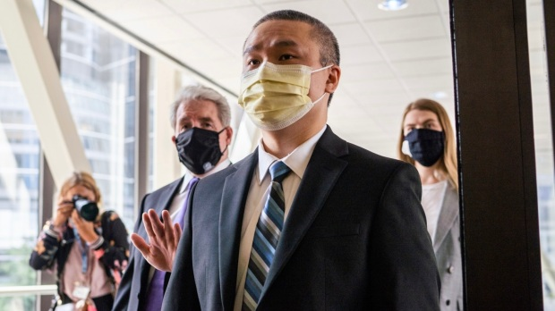](https://www.twincities.com/2022/02/15/3-officers-say-theyll-testify-about-george-floyds-killing/)](https://www.twincities.com/2022/02/15/3-officers-say-theyll-testify-about-george-floyds-killing/)

[FILE – Former Minneapolis Police Officer Tou Thao enters the Hennepin County Courthouse with his attorneys before a motions hearing in Minneapolis on July 21, 2020. Thao, who is charged with violating George Floyd’s civil rights when the Black man was killed under fellow Officer Derek Chauvin’s knee took the stand in federal court Tuesday, Feb. 15, 2022, testifying about academy training that included handcuffing drills in which knees were used to restrain people. (Evan Frost/Minnesota Public Radio via AP)](https://www.twincities.com/2022/02/15/3-officers-say-theyll-testify-about-george-floyds-killing/)

[By](https://www.twincities.com/2022/02/15/3-officers-say-theyll-testify-about-george-floyds-killing/)[**STEVE KARNOWSKI**](https://www.twincities.com/author/steve-karnowski-associated-press/) and [**TAMMY WEBBER**](https://www.twincities.com/author/tammy-webber/) | Associated Press

PUBLISHED: February 15, 2022 at 4:49 p.m. | UPDATED: February 16, 2022 at 8:08 a.m.

By STEVE KARNOWSKI and TAMMY WEBBER

ST. PAUL, Minn. (AP) — A former Minneapolis police officer charged in George Floyd’s killing testified Tuesday that he was relying on his fellow officers to care for Floyd’s medical needs while he controlled onlookers as police tried to arrest the Black man.

Tou Thao is one of three former officers charged in federal court in St. Paul with violating Floyd’s constitutional rights when Officer Derek Chauvin pressed his knee into Floyd’s neck for 9 1/2 minutes as the 46-year-old man was handcuffed, facedown on the street.

Thao held back bystanders, while J. Alexander Kueng knelt on Floyd’s back and Thomas Lane held his legs. Kueng and Lane also plan to testify.

Thao said that when he and Chauvin arrived, the other officers were struggling with Floyd. He said he took a position on the roadway to serve as “a human traffic cone” to keep traffic away from the other officers.

Thao said he heard onlookers becoming more anxious about Floyd’s condition and calling on officers to check his pulse. But he said his role was crowd control; there were about 15 bystanders.

Thao’s attorney, Robert Paule, asked Thao whether he saw any officers roll Floyd over and perform CPR. He said he did not, and presumed that meant Floyd was breathing.

“It indicated that Mr. Floyd was not in cardiac arrest,” said Thao, who later testified that he didn’t know there was anything seriously wrong with Floyd even as an ambulance took him away.

But prosecutor LeeAnn Bell noted video shows Thao looking at the other officers much of the time and suggested that the bystanders and traffic were not big threats. Thao acknowledged under cross-examination by Bell that he did nothing to provide medical care to Floyd or intervene to stop Chauvin even after it appeared to him that Floyd had stopped resisting.

Thao conceded he was standing near Floyd when he stopped speaking and moving.

“And you know that’s a red flag,” Bell said.

“Not always but you should take note,” Thao responded.

Thao, Kueng and Lane are accused of depriving Floyd of medical care. Kueng and Thao are also accused of failing to intervene to stop the May 25, 2020, killing, which triggered protests worldwide and a reexamination of racism and policing. The charges allege the officers’ actions resulted in Floyd’s death.

Prosecutors rested their case Monday after calling to the stand doctors, police officers and bystanders to build an argument that the officers should have intervened to stop Chauvin and that they violated their training by not rolling Floyd onto his side so he could breathe or giving him CPR.

Defense attorneys are seeking to show that the Minneapolis Police Department provided inadequate training and taught cadets to obey superiors. Chauvin, who was convicted of state murder and manslaughter charges last year, was the most senior officer at the scene.

Thao testified that he was taught that it sometimes was OK to use neck restraints to help handcuff someone. But under cross-examination by Bell, Thao agreed that using a knee to get someone under control is different from using it to restrain someone who’s already handcuffed — and that the neck should be avoided once someone is under control.

Asked if what Chauvin was doing was a trained neck restraint, Thao replied, “I don’t believe so.”

Police tried to arrest Floyd after responding to a 911 call that he used a counterfeit $20 bill at a corner store.

Thao said it was obvious to him, as the other officers struggled to put Floyd into a squad car, “that he was under the influence of some type of drugs.” He said it seemed clear that Floyd was in a state of “excited delirium” — a disputed condition in which someone is said to have extraordinary strength.

Thao also said that although he heard Floyd saying, “I can’t breathe,” he could not see anything from where he was standing that would have interfered with Floyd’s breathing. He also that on several occasions, he had heard someone say they couldn’t breathe but wasn’t sure they were being honest.

But he later agreed with the prosecutor that officers can’t ignore such pleas even if someone is lying.

Thao’s testimony was expected to continue Wednesday.

Lane, who is white; Kueng, who is Black; and Thao, who is Hmong American, also face a separate state trial in June on charges alleging that they aided and abetted murder and manslaughter.

Chauvin, who is white, pleaded guilty in December to a federal civil rights charge.

___

Webber contributed from Fenton, Michigan.

# Prosecutors question officer in Floyd killing about training

[[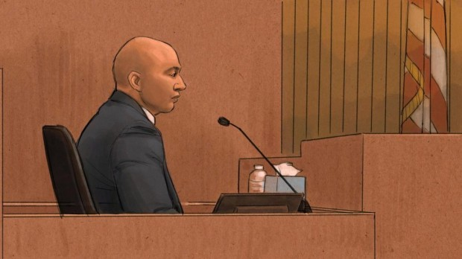](https://www.twincities.com/2022/02/17/prosecutors-question-officer-in-floyd-killing-about-training/)](https://www.twincities.com/2022/02/17/prosecutors-question-officer-in-floyd-killing-about-training/)

[In this courtroom sketch, former Minneapolis Police Officer J. Alexander Kueng testifies during his trial in the killing of George Floyd in federal court in St. Paul, Minn., on Wednesday, Feb. 16, 2022. Kueng is one of three former officers charged in federal court with violating Floyd’s constitutional rights when Officer Derek Chauvin pressed his knee into Floyd’s neck for 9 1/2 minutes as the 46-year-old man was handcuffed, facedown on the street. (Cedric Hohnstadt via AP)](https://www.twincities.com/2022/02/17/prosecutors-question-officer-in-floyd-killing-about-training/)

[By](https://www.twincities.com/2022/02/17/prosecutors-question-officer-in-floyd-killing-about-training/)[**ASSOCIATED PRESS**](https://www.twincities.com/author/associated-press/) | [info@ap.org](mailto:info@ap.org) |

PUBLISHED: February 17, 2022 at 10:38 a.m. | UPDATED: February 17, 2022 at 10:53 p.m.

By STEVE KARNOWSKI and TAMMY WEBBER

ST. PAUL, Minn. (AP) — A former Minneapolis police officer charged in George Floyd’s killing testified Thursday that he didn’t act on another officer’s suggestion to roll Floyd on his side after he stopped breathing, didn’t ask Officer Derek Chauvin to check for a neck pulse and didn’t try to get Chauvin off Floyd’s neck.

J. Alexander Kueng is one of three former officers charged in federal court with violating Floyd’s constitutional rights when Chauvin pressed his knee into Floyd’s neck for 9 1/2 minutes as the 46-year-old Black man was handcuffed, facedown on the street and pleading for air before going silent. Kueng knelt on Floyd’s back, Thomas Lane held his legs and Tou Thao kept bystanders back.

Prosecutor Manda Sertich peppered Kueng with questions about his training, including on material from an emergency medical responder course he took that said someone might not be breathing adequately even though they’re talking and then lists thing to check for.

She pointed out that Floyd stopped talking after about 4 ½ minutes and asked if it was a “red flag.”

“It is something to reassess, yes ma’am,” replied Kueng, who later agreed that he was trained to roll someone on their side to help them breathe when it was safe to do so.

But Kueng said he didn’t do so at Lane’s suggestion after Floyd passed out, or in the five minutes that officers kept him restrained afterward. Kueng said he checked Floyd’s wrist pulse twice and couldn’t find one, then told Chauvin, but didn’t try to check Floyd’s neck pulse himself.

All three officers are accused of depriving Floyd of his right to medical care. Prosecutors have argued that the officers violated their training by not rolling Floyd onto his side or giving him CPR.

Kueng and Thao are also accused of failing to intervene to stop Chauvin in the May 25, 2020, killing that triggered protests worldwide and a re-examination of racism and policing.

Defense attorneys contend the Minneapolis Police Department provided inadequate training and taught cadets and rookies to obey superiors. They have also said that Chauvin, who was convicted of state murder and manslaughter charges last year, called the shots that day.

A retired Springfield, Missouri, assistant police chief testified that the Minneapolis Police Department’s training on an officer’s duty to intervene to stop other officers from using excessive force was ineffective because it relied too heavily on lectures instead of hands-on training and testing to ensure that trainees learn the right lessons.

Steve Ijames, a use-of-force expert, also said that Kueng did not use unreasonable force to help hold down Floyd. But he said that Chauvin’s continued force after Floyd stopped fighting was unreasonable — “beyond question.”

He also said Kueng lacked the training and experience to recognize Chauvin’s inappropriate use of force and that it made sense for Kueng to defer to Chauvin, a 19-year veteran who had been his field training officer.

Kueng testified Wednesday that he deferred to Chauvin because he was his senior officer and that’s what he was trained to do. Kueng and Lane were both rookies, with just a few days working without a trainer.

“He was my senior officer and I trusted his advice,” said Kueng, who has said he feared he could be fired for disobeying a superior.

Under questioning from Sertich, Ijames said it’s conceivable Kueng could have walked around and checked the neck without moving or disturbing Chauvin.

A retired Minneapolis Police Department lieutenant and field training officer testified that it made sense that the other officers let Chauvin take charge of the scene, especially since Lane and Kueng were rookies. “Somebody needs to be in charge” and there isn’t always time to deliberate, Gary Nelson said.

Under cross-examination by prosecutor Samantha Trepel, Nelson agreed that officers aren’t obligated to follow clearly unlawful orders and that they’re accountable for both their actions and their inactions.

Thao testified this week that he relied on the other three officers scene to care for Floyd’s medical needs while he controlled the crowd and traffic and that he didn’t think Chauvin’s knee was on Floyd’s trachea.

Lane is also expected to testify.

Lane, who is white; Kueng, who is Black; and Thao, who is Hmong American, also face a separate state trial in June on charges alleging that they aided and abetted murder and manslaughter.

Chauvin, who is white, pleaded guilty in December to a federal civil rights charge.

# Former Minneapolis officer who restrained George Floyd says he deferred to Derek Chauvin

## **J. Alexander Kueng, a rookie officer, testified in the federal trial over Floyd’s death that he ‘trusted’ Chauvin, his former training officer**

**Error! Filename not specified.**

In this courtroom sketch, former Minneapolis police officer J. Alexander Kueng testifies during his trial in the killing of George Floyd in federal court in St. Paul, Minn., on Feb. 16. (Cedric Hohnstadt/AP)

By [Holly Bailey](https://www.washingtonpost.com/people/holly-bailey/)

Today at 8:40 p.m. EST

ST. PAUL, Minn. — A former Minneapolis police officer who helped Derek Chauvin restrain George Floyd testified in the federal trial over Floyd’s killing that he followed Chauvin’s lead at the scene because “it’s always the senior officer” who is in charge.

J. Alexander Kueng, one of three former Minneapolis officers on trial for [violating Floyd’s civil rights during the fatal 2020 arrest](https://www.washingtonpost.com/nation/2022/01/20/what-know-about-federal-trial-three-former-minneapolis-police-officers-charged-george-floyds-death/?itid=lk_inline_manual_4&itid=lk_inline_manual_4), testified in his own defense Wednesday that he had never been given scenario training on how to stop another officer from using excessive force.

Under defense questioning, Kueng said he wasn’t sure if Chauvin was violating policy by pressing his knee into Floyd’s neck because he hadn’t been explicitly trained on such maneuvers and couldn’t see how much pressure Chauvin was using.

During his testimony, Kueng recalled the struggle that ended up with Floyd handcuffed and facedown on the ground. Kueng, who was positioned at Floyd’s back, said another officer, Thomas K. Lane, asked Chauvin if they should shift the man into his side, which Chauvin quickly rejected.

“He was my senior officer, and I trusted his advice,” Kueng said, repeatedly telling the jury that he had been trained to defer to senior officers.

[*What to know about the federal trial of the three former Minneapolis police officers charged in George Floyd’s death*](https://www.washingtonpost.com/nation/2022/01/20/what-know-about-federal-trial-three-former-minneapolis-police-officers-charged-george-floyds-death/?itid=lk_interstitial_manual_10)

Chauvin, a 19-year veteran of the Minneapolis force, had been Kueng’s training officer for roughly half of his five months of field training, which had began in January 2020. Kueng testified [he was only on his third shift](https://www.washingtonpost.com/nation/2022/01/20/what-know-about-federal-trial-three-former-minneapolis-police-officers-charged-george-floyds-death/?itid=lk_inline_manual_11) as a full-time officer on May 25, 2020, when he and Lane, another rookie, struggled with Floyd as they tried to detain him as part of a counterfeit bill investigation.

Kueng recalled how Chauvin had suddenly appeared on the scene and injected himself into the struggle with Floyd — a show of power that he told the jury led him to believe “we were making a mistake or that he saw we were doing something incorrect.”

While Minneapolis officers are trained that the first responding officers are the ones in charge of a scene, Kueng said that was not “the practice.”

“In all my experience in policing … in the field, it’s always the senior officer. I’ve seen multiple officers defer to seniors on scenes, and the senior officer is the one that we go to as they have the most experience and are typically better equipped to handle situations,” Kueng said under defense examination, adding that this was his experience with Chauvin, whom he described as his “supervisor.”

“He was very quiet. But he had a high level; that experience was very vital. He was very knowledgeable of policy and law,” Kueng said of Chauvin. “He had a lot of respect from other officers … They would defer to him on what to do.”

In his first public recounting of the incident, Kueng recalled how [he and Lane were restraining Floyd on the other side](https://www.washingtonpost.com/nation/2022/02/15/george-floyd-trial-tou-thao/?itid=lk_inline_manual_20) of the squad car, separated from a growing crowd of bystanders who loudly urged the officers to get off an unconscious Floyd and to check the man’s pulse.

Kueng claimed he couldn’t hear the bystanders but had been monitoring Floyd’s vitals and said that he believed the man was still breathing, even as he went limp. He recalled how he at one point heard Chauvin unhook a snap from his duty belt and witnessed the officer take out a can of mace and shake it toward what he assumed was the crowd on the other side of the car.

Kueng testified that he subsequently looked for a pulse on Floyd’s wrist, and he couldn’t find one. He recalled twice telling Chauvin that he couldn’t detect Floyd’s pulse and said he assumed Chauvin would check the pulse on Floyd’s neck — which he had been trained to know was more reliable — but the senior officer didn’t check and kept his position.

The former officer recalled how a paramedic later arrived on the scene and reached around Chauvin’s knee to check the pulse on Floyd’s carotid artery and then walked “casually” back to the ambulance. Kueng said that led him to believe his not being able to detect a pulse had been wrong because he felt the paramedic would have shown “immediate concern.”

Kueng testified he did not realize Floyd might be in medical danger until after Lane had returned from performing chest compressions in the ambulance — though he did not elaborate on what Lane said to him. A prosecutor had only started questioning Kueng as the court recessed Wednesday. He is scheduled to be back on the stand tomorrow ahead of expected testimony from Lane.

Kueng’s testimony [came shortly after Thao returned](https://www.washingtonpost.com/nation/2022/02/15/george-floyd-trial-tou-thao/?itid=lk_inline_manual_29) to the stand for a second day of questioning and said he heard Floyd’s cries for breath getting weaker and that he observed the man go unconscious [but did nothing to intervene](https://www.washingtonpost.com/nation/2022/01/28/officers-charged-george-floyds-killing-had-been-taught-intervene-police-trainer-testifies/?itid=lk_inline_manual_29) or offer care.

Thao, who held back bystanders as they urged the officers to check Floyd’s pulse and “get off” the man, acknowledged under prosecution questioning that [he heard the concerns voiced by the onlookers](https://www.washingtonpost.com/nation/2022/01/28/officers-charged-george-floyds-killing-had-been-taught-intervene-police-trainer-testifies/?itid=lk_inline_manual_30)about Floyd’s health but said he did not say anything to Chauvin or the other officers.

“I think I would trust a 19-year veteran to figure it out,” Thao said, referring to Chauvin, who had been his partner that day.

“Even 19-year veterans can do something wrong, right?” responded LeeAnn Bell, an assistant U.S. attorney and one of the lead prosecutors in the case. “You are aware you have a duty to stop someone from committing a crime, right?”

Thao offered conflicting responses — repeating his claim that he was focused on his role of “crowd control” at the scene and relying on Chauvin and the other officers to monitor Floyd’s condition.

But Thao also admitted he was standing next to Floyd and the officers for six of the 9½ minutes that Chauvin pressed his knees into the man’s neck and back and suggested the force was justified in his view because he feared Floyd was suffering from “excited delirium,” a disputed medical term used by law enforcement and some health professionals to describe people who are under the influence of drugs and in a severely agitated state.

Thao said he feared Floyd might rear up and resist the officers with “superhuman strength” — one of the alleged symptoms that officers are trained to look for in excited delirium. A training PowerPoint introduced as evidence in the case instructs officers to stop force when a subject is no longer resisting, but Thao testified he thought the continued restraint of Floyd was necessary “to save his life” as they awaited the arrival of paramedics.

Thao also testified that he did not think Floyd was in danger from Chauvin’s use of the knee restraint because it was not on the front of his neck.

“So you're saying that if someone is in excited delirium, you get to ignore the rest of your training that you should not continue to use force on them?” Bell asked, prompting an objection from Robert Paule, Thao’s attorney.

A federal grand jury indicted Chauvin, Kueng, Lane and Thao in May 2021 on charges that they violated Floyd’s constitutional rights during the fatal 2020 arrest. Kueng and Thao were charged with violating Floyd’s right to be free from unreasonable seizure by not intervening as Chauvin knelt on Floyd’s neck. All three officers were charged with failing to render medical aid to Floyd. Kueng, Lane and Thao have each [pleaded not guilty](https://www.washingtonpost.com/nation/2021/09/14/former-minneapolis-police-officers-charged-with-violating-george-floyds-civil-rights-plead-not-guilty/?itid=lk_inline_manual_15&itid=lk_inline_manual_27&itid=lk_inline_manual_36&itid=lk_inline_manual_24&itid=lk_inline_manual_44).

Chauvin, who was convicted on state charges of second-degree unintentional murder, third-degree murder and second-degree manslaughter in Floyd’s death, pleaded guilty in December to federal charges in Floyd’s death. Chauvin, currently serving a 22½-year state sentence, is awaiting sentencing in the federal case.

Prosecutors [began presenting](https://www.washingtonpost.com/nation/2022/01/24/opening-statements-begin-federal-trial-over-george-floyds-killing/?itid=lk_inline_manual_26&itid=lk_inline_manual_46) their case Jan. 24 with a litany of video that captured Floyd’s death, including footage filmed by Frazier and other eyewitnesses. They called 21 witnesses over 13 days, including an off-duty firefighter who tried to get the officers to check Floyd’s pulse; other law enforcement officers; and medical experts.

Three Minneapolis police officers testified that Kueng, Lane and Thao [had been trained to stop force](https://www.washingtonpost.com/nation/2022/01/28/officers-charged-george-floyds-killing-had-been-taught-intervene-police-trainer-testifies/?itid=lk_inline_manual_29&itid=lk_inline_manual_48) when it was no longer necessary and to intervene when another officer used excessive force or a restraint that was not allowed under department policy.

Defense attorneys sought to discredit that testimony, repeatedly pointing out to the jury that the Minneapolis Police Department is facing state and federal investigations into its policies and training practices. They have argued that officers were given conflicting training on use of force and presented videos of academy training that showed a cadet placing his knee on someone’s neck without intervention by instructors.

Defense attorneys have sought to shift responsibility to Chauvin for the man’s death, arguing the 19-year veteran “took control” at the scene and became the “shot caller.” But the case could pit the former officers against one another as a jury determines whether officers broke federal law when they failed to push Chauvin off Floyd’s body and render medical aid.

U.S. District Judge Paul A. Magnuson has limited prosecutors from asking the former officers questions that would lead them to render judgment on their fellow defendants — though he has allowed questioning about what the officers observed.

On Tuesday, Thao countered a claim made by Lane and Kueng that they believed Chauvin was in charge of the scene because of his seniority.

Viet Thuyn:

I think the way to address polarization is for everyone to recognize the humanity and inhumanity in everyone. Many of the native born do not want to recognize their own inhumanity, but also pro immigrant people do not want to recognize that immigrants can do bad things, which is the sole focus of the anti-immigrant people.

I think the native-born do have some grounds for demanding that foreigners conform, but immigrants also have a right to be a critical of the society. Yet it really is up to the native-born to criticize because whenever immigrants do the response of the native born that I hear is often “love it or leave it.”

Carin (can interview again):

Many immigrants like us feel this gratitude toward US. For example, as a woman I faced much more sexism and discrimination in the workplace in South Africa than I do here. So we feel a sense of security here that we did not have in our home countries and therefore want to believe in the system. So when we see the system do terrible things to people like George Floyd and the hateful attacks on Asian immigrants, it really outrages us because it destroys the faith, almost like a betrayal.

<https://www.npr.org/sections/trial-over-killing-of-george-floyd/2021/03/30/982891954/firefighter-testifies-i-was-desperate-to-help-and-this-human-was-denied-that>

From Derek Chauvin trial:  
Instead, during an off-duty walk home from a community garden she heard a woman yelling that the police were killing the Black man, prone and in handcuffs, facedown in the street.

Hansen, who is a trained emergency medical technician and Minneapolis firefighter, testified that upon taking in the scene, she moved closer to the officers who were pinning Floyd on the asphalt and identified herself as a first responder.

In video footage played for the court, Hansen could be heard demanding that the officers check his pulse.

"I had already assessed that [Floyd] was in an altered state of consciousness. What I needed to know was if he had a pulse."

She described how Floyd was lying motionless: "He wasn't moving, and he was cuffed. And three grown men putting all of their weight on somebody is too much," she said. "The first thing that concerned me was his face was smushed into the ground. Swollen. It appeared swollen to me."

But rather than allow her to help, Hansen said, then-officer Tou Thao "said something along the lines of, 'If you really are a Minneapolis firefighter, you would know better than to get involved.' "

Her voice began to tremble when she recalled the impotence that overwhelmed her as Thao and the other officers blocked her from providing the kind of medical care she has been trained to give. "I got there and I could have given medical assistance. That's exactly what I should have done."

Assimilation's quiet tide

Article in The Public interest · January 1995

CITATIONS

57

READS

244

1 author:

Some of the authors of this publication are also working on these related projects:

Two things, mainly View project

Detroit Area Survey Study 1965-66 View project

Richard Alba

However, assimilation was, and is, a reality for the majority

of the descendants of earlier waves of immigration from Europe.

Of course, it does have its varieties and degrees. Among

Americans descended from the immigrants of the nineteenth

and early twentieth centuries, assimilation is better viewed as

a direction, rather than an accomplished end state.

We observe that Europeans have assimilated into the white middle class through inter-marriage, but it has been more difficult and less common for non whites, especially blacks

STATE OF THE ART

THE RACIAL UNCONSCIOUS OF

ASSIMILATION THEORY1

Moon-Kie Jung

Department of Sociology, University of Illinois

Shifting the focus from difference

to inequality and domination, the article concludes with a brief proposal for reorienting

our theoretical approach, from assimilation to the politics of national belonging.

Charles Hirschman observed

that “the assimilation model has been the dominant perspective in sociological

studies of ethnic relations.”

While acknowledging Hirschman’s

article in a footnote, Rogers Brubaker incongruously detected a “return of assimilation”

in U.S. sociology occurring at around the same time: “Since about 1985,

Foremost, the new theories no longer conceive of

assimilation as necessarily destined or desirable.

(^but they do not argue that they contribute to pathologies in the country)

Mainstream: @It# encompasses a core set of interrelated institutional structures and organizations

regulated by rules and practices that weaken, even undermine, the influence

of ethnic origins per se. . . . A useful way of defining the mainstream is as

that part of the society within which ethnic and racial origins have at most minor

impacts on life chances or opportunities. ~Alba and Nee, 2003, p. 12; emphasis in

original!

the mainstream comprises the entire range of social classes, from the

poor to the wealthy, and the obvious inequality of life chances they imply. Assimilation

therefore does not necessarily entail entry into the middle class, as many other

theorists suppose.

They also consciously seek to suppress the normative impulses of the “canonical”

literature—“assimilation without ‘assimilationism,’” as Brubaker ~2004, p. 125!

puts it.

In the aptly titled article

“Second-Generation Decline,” Herbert Gans worries “that a significant number of the children of poor immigrants, especially dark-skinned ones, might not obtain jobs

in the mainstream economy” ~1992, p. 173!.

Most likely among those migrants with substantial

human capital, consonant acculturation happens when both generations acquire the

language and customs of the “host” society and lose those of the “home” society at a

similarly rapid rate. In dissonant acculturation, the children substantially outpace their

parents. When both generations are “embedded in a co-ethnic community of sufficient

size and institutional diversity,” selective acculturation may occur, as the speed of

assimilation is slowed and the children retain some of the parents’ “culture.” Portes

and Rumbaut contend that dissonant acculturation undermines parental authority,

putting the second generation “at risk.” Consonant acculturation, on the other hand,

allows parents to maintain authority over their children and enables both generations

to face obstacles, like discrimination, together. Selective acculturation affords another

layer of support, as families can draw on the coethnic community of which they are

an integral part ~Portes and Rumbaut, 2001b, pp. 53–54!

Facilitated by entrepreneurial skills,

favorable policies, low levels of discrimination, and a large and cohesive coethnic

community, Cubans, particularly those who arrived before 1980 and their children,

exemplify upward assimilation through selective acculturation. Of unique importance

is an “institutionally diversified ethnic community” that can aid families in

shielding and fostering the second generation ~Portes and Rumbaut, 2001b, p. 275;

see also Portes and Stepick, 1993; Portes and Zhou, 1993!. Even

For all of their advances, however, assimilation

theories do not adequately account for race.

(^cite this)

Echoing past theories, practices, and policies

of assimilation, these transitive and organic meanings connote normative prescriptions,

advocating and even forcing assimilation, and ethnocentrism, evoking Angloconformist

images of complete conversion. Therefore, Brubaker calls for retaining

only the abstract, intransitive sense of the word: “to become similar” ~2004, pp. 119,

129!. It is in this sense, purged of unwanted denotations and connotations, that most

revivalists of assimilation now employ the concept.4

Nevertheless, I argue that it may not be much better

suited to contend with questions of race.

Inequality and

domination do produce and may even presuppose difference, but to examine inequality

and domination as difference risks mischaracterization or, worse, trivialization.

And if the sociological literature on race agrees on anything, it is that race is

fundamentally about inequality and domination.6 Assimilation, then, would seem to

be a mismatched conceptual tool with which to dissect racial dynamics. To be clear,

I am not arguing that assimilation theories wholly ignore race or that they do not at

all address inequality and domination. Rather, the concept of assimilation instills

analytical tendencies to approach racial inequality and domination from an oblique

angle that misses and distorts, as well as illuminates.

(^build upon this)

Then, overlaying the historical difference coterminously with

the difference in origin, European versus non-European, renders the comparison

dubious: what meaningful inferences could be derived from such a conflated research

design?

three analytical choices that, through the application of the assimilation

concept, obfuscate racial inequalities and domination. First, Alba and Nee’s focus on

East Asians is crucial for whom it omits. It leaves out the third major stream of

prewar migration from Asia: Filipinos.10 Although the history of Filipinos is less well

documented, what we do know indicates that its “master trend” was hardly assimilation

~e.g., Azuma 2005; Friday 1994; Fujita-Rony 2003; Jung 2006; Ngai 2004!.

Racialized as more inferior than other Asians and indefinitely relegated to mostly

unskilled labor, particularly in agriculture, prewar Filipino migrants did not undergo

the upward social mobility that their Chinese and Japanese counterparts did.

If we were to begin at the beginning, the “master

trend” of assimilation would be far from evident. A cursory glance at just the formal

practices enacted or sanctioned by the state, for example, would quickly reveal the qualitatively

harsher treatments of the Chinese and the Japanese based on race that affected

each and every aspect of “assimilation” until as late as the 1960s: segregated schools,

denial of naturalized citizenship, alien land laws, mass internment in concentration

camps, restrictive covenants, antimiscegenation laws, and so on. While third- and fourthgeneration

Chinese and Japanese may now resemble their European-origin counterparts

in many respects, retrofitting a common “assimilation” narrative necessarily

minimizes the racial inequalities and oppression the Chinese and the Japanese endured

and resisted and necessarily confounds what were racially disparate historical trajectories.

11 It is a subtle, unregistered form of teleology.

The historical formation of Whiteness

thus serves as an example of how racial boundaries can fall away, from which they

derive a direct implication for today’s non-White migrants: “We see no a priori

reason why a shift in the perception of racial difference could not take place for some

contemporary immigrant groups and some segments of others. . . . @namely# new

Asian groups and light-skinned Latinos.” In this way, White racial formation is

smoothly folded into the narrative of assimilation: “as these @disparaged European#

groups climbed the socioeconomic ladder and mixed residentially with other whites,

their perceived distinctiveness from the majority faded” ~Alba and Nee, 2003, p. 132!.

But, precisely because they read the scholarship on Whiteness through the concept

of assimilation, they blunt one of its cardinal points: Whiteness has been, above all,

a racial formation that presupposed and reproduced relations of inequality and

domination between “Whites” and their racial others ~e.g., Guglielmo 2003; Jacobson

1998; Roediger 1991, 2005; Saxton 1971!. The point is not that European

migrants and native-born Whites became similar, which they did, but that becoming

similar, including “climb@ing# the socioeconomic ladder and mix@ing# residentially

with other whites” ~Alba and Nee, 2003, p. 132!, entailed perpetuating racial inequality

and domination in relation to Blacks, Chinese, and others.14

On

the whole, assimilation theory, now ensconced in the sociology of immigration, no

longer encompasses native-born Blacks within its purview. Yet African Americans,

through their absence, continue to shape and haunt assimilation theory.

(^which is weird given the potential impact that black immigrnats can have on racial hierarcies)

Whether intentionally or not, neoclassical assimilation

theory salvages assimilation by pushing out nonmigrant Blacks and focusing on

“immigration,” a notion capacious enough to accommodate many generations of

native-born descendants of non-Black migrants.16 In other words, whereas assimilation

theory used to squeeze African Americans into the scope of analysis, it now

squeezes them out.

Neither do they seriously consider the possibility

that outsiders’ becoming a part of the mainstream may require them to participate in

keeping out others, foremost Blacks. These possibilities are precisely the aspect of

the historical scholarship on Whiteness that assimilation theories neglect.

The exclusion of native-born Blacks from the analysis is symptomatic of neoclassical

assimilation theory’s inattention to the unequal relations between the mainstream

and the nonmainstream.

(^this is of course in the US context—the framework might be more applicable where you do not have a native born subaltern class, although many countries of immigration have such a group. But the author also fails to admit First Nations being an even more common omitted non-immigrant subaltern class across countries of immigration both in the New World (e.g. maori in NZ, aboriginals in Aus, eskimos in Canada) and in old world (e.g Sami in Finland, Tibetans and Uighurs in China),

The “institutional mechanisms” that

ostensibly facilitate assimilation—state enforcement of antidiscrimination policies

and a steep decline in racism’s “public legitimacy”—were brought about by the

Black-led civil rights movement but have been least effective for Blacks ~Alba and

Nee, 2003, p. 57!.

(^they arguably have not been beneficial for first nations either)

The second irony is a reproduction of the first at the analytical

level: neoclassical assimilation theory is aware of the significance of Blacks in forcing

the institutional changes and the cruel injustice of Blacks’ not benefiting from those

changes as fully as others but, instead of placing this inequality at the center of its

inquiry, excludes Blacks from the analysis.18 Finally, although it was a mass social

movement of those outside the mainstream—Blacks above all—that compelled the

pivotal institutional changes, neoclassical assimilation theory has no conceptual room

within it for explaining such movements or transformations; they are, in effect,

historically unique dei ex machina.

Segmented assimilation theory, as

Roger Waldinger and Cynthia Feliciano point out, is not always forthright about

who exactly belongs to this “underclass,” but “it is not difficult to infer” ~2004,

p. 377!. At its core, the native-born “underclass” refers to poor urban Blacks, sometimes

expanding to include similarly positioned Puerto Ricans and Mexicans.

Here, segmented assimilation

theory aligns with and draws on the anthropology of education of John Ogbu

and colleagues.22 Owing to the original “involuntary incorporation of Blacks into

American society” through enslavement and their “subsequent subordination and

discriminatory treatment” by Whites, African Americans, characteristic of “involuntary

minorities,” are subjected to inferior education, housing, and employment.23

Discrimination does not, however, fully explain the “low school performance” of

Blacks, which also results from how they respond to their oppression. They develop

an “oppositional identity and cultural frame of reference” that devalue academic

achievement and consequently simply do not try hard enough ~Ogbu 1991a, pp. 249,

259, 267!. Ogbu argues that, although this oppositional stance partly reflects Black

students’ realistic perception of limited future opportunities, it takes on a “life of @its#

own” ~1991b, p. 446, as quoted in Gould 1999, p. 177!.

(^note here that the theory of Ogbu assumes that oppositional identity is misguided and results in worst outcomes, when much of the creativity, innovation, critical faculty, and revival is rooted in this oppositional culture, from the revolutionary civil disobedience of the Founders like Thomas Jefferson, Thomas Paine, and George Washington to the nonviolent anti-war, abolitionist and civil rights leaders like Henry David Thoreau, Harriet Tubman, Malcolm X, Delorio, Harvey Milk, Cesar Chavez and Martin Luther King.)

^Assimilationist theories, as Jung points out, rely on omitted residual categories of people that derail people from the beneficial assimliationist path, categories like “underclass” with “deviant lifestyles,” “maladaption, and “pathologies” that often implicitly refer to blacks.

In contrast, the target of the assimilation-bound migrants is referred to as “the middle class,” “the mainstream,” or more perhaps more accurately “the white society,” rather than more critical but structurally accurate terms like “the white supremacist hierarchy,” “upper strata of the racial caste system,” and “the racial capitalist system that thrives on the exploitation of immigrants.” Although both types of terms are normatively laden, a mix of them is probably the best antidote we have from guarding against the perhaps dangerous assumption that assimilation is an unalloyed good or bad. Toggling between the two normative perspective might enable both natives and immigrants to more objectively evaluate the benefits and costs of assimilation for both parties. This incidentally was one of Derrida’s poststructuralist insights about why hegemonic euro-centric heteropatriarchal white supremacist were so problematic: not that a society where dominated by straight European-descendent Christian men is necessarily worse than any other (though one might easily make a strong case of why it is based on historical evidence) but that relying on a language that obfuscates this structural reality weakens anyone’s ability to question the legitimacy of this social structure.)

“for all of their discussion of “oppositional culture,” proponents of segmented

assimilation theory conceptualize and discuss it in unwaveringly disapproving terms

and fail to contemplate how it could offer a valuable critique of the status quo and

how interactions between working-class and poor migrants and Blacks could be bidirectional and politically productive and transformative.27”

But the

general approach of centering politics, including racial politics, to reveal the relations

of power involved in the making, remaking, and even unmaking of the nation

seems preferable to assimilation theories that take the nation and its structures of

inequality and domination for granted.

27. In many other subfields of sociology concerned with inequality and domination, characterizing

“oppositional culture” as wholly undesirable and counterproductive would be

received with much more skepticism and even bafflement.

The productive and transformative potential of “oppositional culture” could be seen

in the participation of migrants and their children in the labor movement of the New

Deal era ~Waldinger 2003, pp. 267–268!. The revitalization of unions and other political

organizations with traditionally African American bases by recent migrants of color and

their children points in a similar direction ~Kasinitz et al., 2002!.







(^important point about what makes Americans distinct in their disavowal of ethnic identity)  


















(^cite this as a turning point)













(^I do not agree that this is about choice)